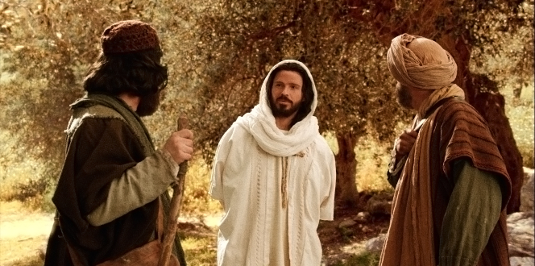

A Worship Service
(for use in the Christian household)

The Third Sunday of Easter
26 April 2020

Trinity Lutheran Church
The Lutheran Church-Missouri Synod
1415 South Holland
Springfield, Missouri 65807

417-866-5878
TLCOFFICE@TRINITYLUTHERANSPFD.ORG
WWW.TRINITY-SPRINGFIELD.ORG
Prelude (Organ)

Welcome

Opening Hymn “Alleluia! Jesus Is Risen” (Music LSB 474) verses 1, 2, 4

- Alleluia! Jesus is risen! Trumpets resounding in glorious light!
Splendor the Lamb, Heaven forever
Oh, what a miracle God has in sight!

Refrain
Jesus is risen and we shall arise: Give God the glory! Alleluia!

- Walking the way, Christ in the center Telling the story to open our eyes
Breaking our bread, Giving us glory
Jesus, our blessing, our constant surprise
Refrain

- Weeping, be gone; Sorrow be silent; Death put asunder, and Easter
is bright
Cherubim sing: “O grave, be open!”
Clothe us in wonder, adorn us in light
Refrain

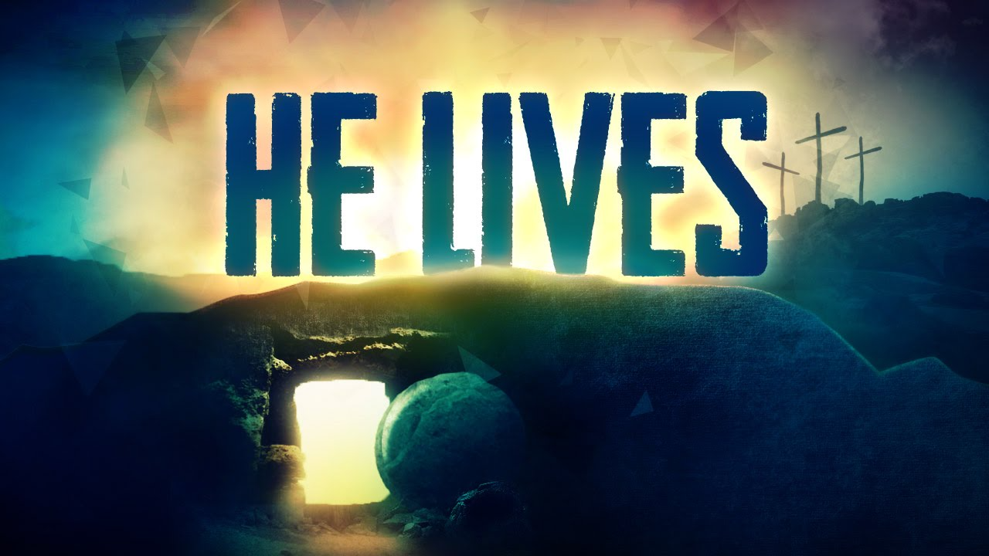

CONFESSION AND ABSOLUTION

P: In the Name of the Father and of the Son and of the Holy Spirit.
C: AMEN

P: Our help is in the name of the Lord
C: Who made heaven and earth

P: If You, O Lord, kept a record of sins, O Lord, who could stand?
C: But with You there is forgiveness; therefore You are feared
2
P: Since we are gathered in spirit and purpose to hear God’s Word and to call upon
Him in prayer and praise, let us first consider our unworthiness and confess
before God and one another that we have sinned in thought, word, and deed,
and that we cannot free ourselves from our sinful condition. Together as His
people let us take refuge in the infinite mercy of God, our heavenly Father,
seeking His grace for the sake of Christ, and saying: God, be merciful to me,
a sinner
C: Almighty God, have mercy upon us, forgive us our sins, and lead us to
everlasting life. Amen.

P: Almighty God in His mercy has given His Son to die for you and for His sake
forgives you all your sins. As a called and ordained servant of Christ, and by
His authority, I therefore forgive you all your sins in the name of the Father
and of the Son and of the Holy Spirit
C: Amen.

The Psalmody

P: I will extol You, my God and King, and bless Your name forever and ever.
Every day I will bless you and praise Your name forever and ever
C: Great is the Lord, and greatly to be praised, and His greatness is
unsearchable. One generation shall commend Your works to another,
and shall declare Your mighty acts

P: The Lord is gracious and merciful, slow to anger and abounding in steadfast
love. The Lord is good to all, and His mercy is over all that He has made.
C: The Lord is faithful in all His words and kind in all His works. The Lord
upholds all who are falling and raises up all who are bowed down.

P: The eyes of all look to You, and You give them their food in due season. You
open Your hand; You satisfy the desire of every living thing
C: The Lord is righteous in all His ways and kind in all His works. The Lord
is near to all who call on Him, to all who call upon Him in truth

P: He fulfills the desire of those who fear Him; He also hears their cry and saves
them. The Lord preserves all who love Him, but all the wicked He will destroy.
C: My mouth will speak the praise of the Lord, and let all flesh bless His
holy name forever and ever

All: Glory be to the Father and to the Son and to the Holy Spirit; as it was in the
beginning, is now, and will be forever. Amen.
[Selected verses from Psalm 145]

3

The Collect of the Day

P: Let us pray:
Oh God, through the humiliation of Your Son You raised up the fallen
world. Grant to Your faithful people, rescued from the peril of everlasting
death, perpetual gladness and eternal joys; through Jesus Christ, Your Son, our Lord, who lives and reigns, with You and the Holy Spirit, one God, now and forever.​
C: Amen.

The First Reading:

P: The First Reading for the Third Sunday of Easter is from the Book of Acts,
the second chapter:

And [the believers] devoted themselves to the apostles’ teaching and the
fellowship, to the breaking of bread and prayers. And awe came upon
every soul, and many wonders and signs were being done through the
apostles. And all who believed were together and had all things in common.
And they were selling their possessions and belongings and distributing the
proceeds to all, as any had need. And day by day, attending the Temple
together and breaking bread in their homes, they received their food with
glad and generous hearts, praising God and having favor with all the people.
And the Lord added to their number day by day those who were being saved. [Acts 2:42-47]

P: This is the Word of the Lord
All: Thanks be to God!

The Epistle:

P: The Epistle is from First Peter, the first chapter:

And if you call on Him as Father who judges impartially according to each
one’s deeds, conduct yourselves with fear throughout the time of your exile,
knowing that you were ransomed from the futile ways inherited from your
forefathers, not with perishable things such as silver or gold, but with the
precious blood of Christ, like that of a lamb without blemish or spot. He was
foreknown before the foundation of the world but was made manifest in the
last times for the sake of you who through Him are believers in God, who
raised Him from the dead and gave Him glory, so that your faith and hope
are in God. Having purified your souls by your obedience to the truth for a
sincere brotherly love, love one another earnestly from a pure heart, since
you have been born again, not of perishable seed but of imperishable, through
the living and abiding Word of God;
4
for “all flesh is like grass and all its glory like the flower of the grass. The grass
withers, and the flower falls, but the Word of the Lord remains forever.”
And this Word is the Good News that was preached to you. [1 Peter 1:17-25]

P: This is the Word of the Lord
C: Thanks be to God!

The Holy Gospel

P: The Holy Gospel according to Saint Luke, the twenty-fourth chapter:
G: Glory to You, O Lord!

That very day two of them were going to a village named Emmaus, about
seven miles from Jerusalem, and they were talking with each other about all these things that had happened. While they were talking and discussing
together, Jesus himself drew near and went with them. But their eyes were
kept from recognizing him. And he said to them, “What is this conversation
that you are holding with each other as you walk?” And they stood still,
looking sad. Then one of them, named Cleopas, answered him, “Are you the
only visitor to Jerusalem who does not know the things that have happened
there in these days?” And he said to them, “What things?” And they said to
him, “Concerning Jesus of Nazareth, a man who was a prophet mighty in
deed and word before God and all the people, and how our chief priests and rulers delivered him up to be condemned to death, and crucified him. But wehad hoped that he was the one to redeem Israel. Yes, and besides all this, it isnow the third day since these things happened. Moreover, some women of
our company amazed us. They were at the tomb early in the morning, and
when they did not find his body, they came back saying that they had even
seen a vision of angels, who said that he was alive. Some of those who were with us went to the tomb and found it just as the women had said, but him
they did not see.” And he said to them, “O foolish ones, and slow of heart to
believe all that the prophets have spoken! Was it not necessary that the
Christ should suffer these things and enter into his glory?” And beginning
with Moses and all the Prophets, he interpreted to them in all the Scriptures the things concerning himself.

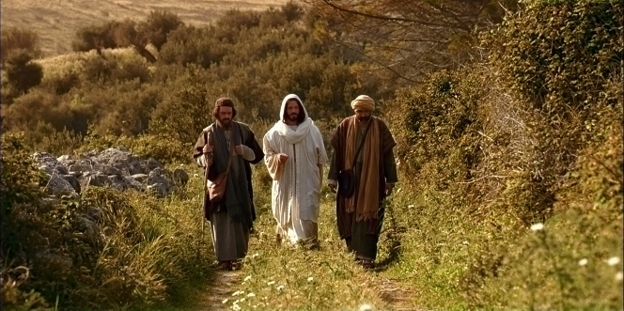
5
So they drew near to the village to which they were going. He acted as if he were going farther, but they urged him strongly, saying, “Stay with us, for it is toward evening and the day is now far spent.” So he went in to stay with
them.

When he was at table with them, he took the bread and blessed and broke it and gave it to them. And their eyes were opened, and they recognized him.
And he vanished from their sight. They said to each other, “Did not our
hearts burn within us while he talked to us on the road, while he opened to
us the Scriptures?”

And they rose that same hour and returned to Jerusalem. And they found theeleven and those who were with them gathered together, saying, “The Lord has risen indeed, and has appeared to Simon!” Then they told what had
happened on the road, and how he was known to them in the breaking of thebread.

P: This is the Gospel of the Lord
C: Praise to You, O resurrected Christ!

P: Christ is risen!
C: He is risen indeed! Alleluia!

The Apostles Creed

All: I believe in God the Father Almighty, maker of heaven and earth.
And in Jesus Christ, His only Son, our Lord, who was conceived by the Holy Spirit, born of the virgin Mary, suffered under Pontius Pilate, was crucified, died and was buried. He descended into hell. The third day He rose again from the dead. He ascended into heaven and sits at the right hand of God the Father Almighty. From thence He will come to judge the living and the dead. I believe in the Holy Spirit, the holy Christian Church, the communion of saints, the forgiveness of sins, the resurrection of the body, and the life everlasting. Amen.

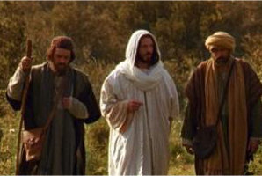

6
The Hymn of the Day “Who Are You Who Walk in Sorrow?” (music LSB 476)

The Soloist will sing verses 1-3; please sing along when you are comfortable with the melody

- Who are you who walk in sorrow down Emmaus’ barren road,
Hearts distraught and hopes defeated, bent beneath grief’s crushing
load?
Nameless mourners, we will join you, we who also mourn our dead;
We have stood by graves unyielding, eaten death’s bare, bitter bread

- Who is this who joins our journey, walking with us stride by stride?
Unknown Stranger, can you fathom depths of grief for one who died?
Then the wonder! When we told You how our dreams to dust have turned
Then You opened wide the Scriptures till our hearts within us burned

- Who are You? Our hearts are opened in the breaking of the bread
Christ the victim, now the victor living, risen from the dead!
Great companion on our journey, still surprise us with Your grace!
Make each day a new Emmaus; on our hearts Your image trace!

Children’s Lesson “The Stranger on the Road”

- Who are we who travel with You on our way through life to death?
Women, men, the young, the aging, wakened by the Spirit’s breath
At the font You claim and name us, born of water and the Word
At the table still You feed us, host us as our risen Lord!

- “Alleluia! Alleluia!” is the Easter hymn we sing!
Take our life, our joy, our worship as the gift of love we bring
You have formed us all one people called from ev’ry land and race
Make the Church Your servant body, sent to share Your healing
grace

Sermon “The Hidden Savior”

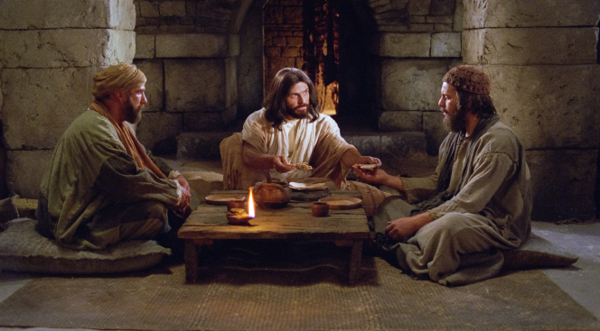
7
Anthem of the Day “Stay With Us” Solo

Stay with us, till night has come: our praise to You this day be sung
Bless our bread, open our eyes: Jesus, be our great surprise
Walk with us, our spirits sigh: hear when our weary spirits cry
Feel again our loss, our pain: Jesus, take us to Your side
Walk with us, the road will bend: make all our weeping, wailing end
Wipe our tears, forgive our fears: Jesus, lift the heavy cross
Talk with us, till we behold a joyful life You will unfold:
Heal our eyes to see the prize: Jesus, take us to the light
Stay with us, till day is done: no tears nor dark shall dim the sun
Cheer the heart, Your grace impart: Jesus, bring eternal life

The Prayers

P: Let us join our minds and hearts in prayer to our Lord

All: I thank You, my Heavenly Father, through Jesus Christ, Your dear Son,
that You have kept me this night from all harm and danger; and I pray that
You would keep me this day also from sin and every evil, that all my
doings and life may please You. For into Your hands I commend myself,
my body and soul, and all things. Let Your holy angel be with me, that the
evil foe may have no power over me. Amen

P: Be present with us, merciful God, and protect us, so that we who are wearied by
the changes and chances of life may find our rest in You through Jesus Christ,
our Lord
All: Amen.

P: Lord Jesus, we beg You to stay also with us, for both life and death stalk us in
this fallen world both night and day. Be our constant Companion on the journey, daily kindle our hearts and awaken hope with each new morning You allow for us to wake up here on this earth. Help us always to seek You and to recognize You in the Holy Scriptures and in the breaking of bread. Lord, in Your mercy
C: Hear our prayer

P: Almighty God, merciful Father, we thank You for caring for the planet You
created and for our human kingdom that You placed here to have dominion.
We are amazed at Your majesty, that You can see it all at once, and yet can see,
love, and care for each part, great and small, and each one of us. We thank You
for Your presence in our present dilemma, and for blessing us with competent
and dedicated health care workers, called to Your service. We thank You for
those gifts of leadership and governance that have helped us, using the authority
that comes from You. According to Your will, destroy the deadly threat of this
virus, and ease the pandemic so that we do not suffer more death, loss of
livelihood, and even more cultural division among us. We also lift up to You;
8
[Here special intercessions and thanksgivings may be offered by name]
P: Lord in Your mercy C: Hear our prayer

All: Lord God, You have called Your servants to ventures of which we cannot
see the ending, by paths as yet untrodden, through perils unknown. Give
us faith to go out with good courage, not knowing where we go but only
that Your hand is leading us and Your love supporting us, through Jesus
Christ, our Lord. Amen.

P: Taught by our Lord and trusting in His promises, we are bold to pray:
All: Our Father who art in heaven, Hallowed be Thy name,
Thy kingdom come, Thy will be done on earth as it is in heaven;
Give us this day our daily bread;
And forgive us our trespasses as we forgive those who trespass
against us;
And lead us not into temptation, but deliver us from evil.
For Thine is the kingdom and the power and the glory forever and ever.
Amen.

Benedicamus and Benediction

P: Let us bless the Lord
C: Thanks be to God

P: The Lord is risen!
C: He is risen indeed! Alleluia!

P: The Lord bless you and keep you;
The Lord make His face shine on you and be gracious to you
The Lord look upon you with favor and give you peace
C: Amen.

The Closing Hymn “Jesus Lives! The Victory’s Won!” vv. 1, 3, 4
(music LSB 490. . .TLH 201)

- Jesus lives! The vict’ry’s won! Death no longer can appall me
Jesus lives! Death’s reign is done! From the grave Christ will recall me
Brighter scenes will then commence; This shall be my confidence

- Jesus lives! For me He died Hence will I, to Jesus living
Pure in heart and act abide Praise to Him and glory giving
All I need God will dispense; This shall be my confidence

- Jesus lives! I know full well Nothing me from Him shall sever
Neither death nor pow’rs of hell Part me now from Christ forever
God will be my sure defense; This shall be my confidence

9
Thanks to those serving us in the production of this service:

Organist Mr. Doyle Richter
Vocalist Ms. Katherine Wise
Videographer Mr. Clate Baker

And to the assistance of:

Director of Music Ministry Dr. Grace St. Pierre
Office Manager Mrs. Angela Bruton

God bless and keep our Trinity family—
+healthy in this time of pandemic;
+growing in the Word and in faith during this time of challenge;
+hope-filled (positive and optimistic) in a time when many people
face doubt and unbelief; and
+united in our fellowship and love during this time of separation

Resources for daily devotions, Bible classes, and other spiritual growth opportunities can be found on our home page:
WWW.TRINITY-SPRINGFIELD.ORG

Join our Trinity Facebook page!

