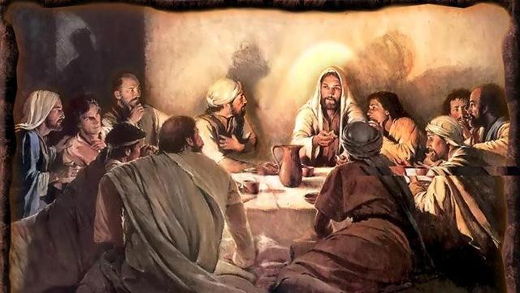

Household Worship Service for
Maundy Thursday

Trinity Lutheran Church
Springfield, Missouri

9 April 2020

As our Trinity family continues to gather together through means of various social media and electronic communication, let us pray to the Lord: first, that He will bless the sick and the suffering with healing, and the bereaved with comfort in the midst of this global pandemic; second, that He would have mercy on us and bring us quickly to the end of this threat; third, that He would help us in the time of restoration to be thankful, humble, and patient; and fourth, that He would preserve and strengthen faith among us.

We also welcome all our visitors joining this video worship service!

Along with Good Friday and Easter Sunday, Maundy Thursday is one of three great days in Holy Week known as the Triduum. On this night Jesus instituted a “memorial” of His Passion in the Lord’s Supper. Among the historic and traditional features preserved in this Service are: (a) a harmony of the four Gospels to capture the fullness of that first night when Jesus celebrated with His disciples the final Jewish Passover (the fulfillment of God’s Holy Meal given to His people of the First Covenant) and the first New Testament Holy Meal (the beginning of God’s Second and last Covenant, a global enterprise); (b) the confession/absolution reflecting the ancient use of this day as a ceremony of reconciling the inactive members who were returning to the Church in time for Easter; and, (c) the Collect for the Day written by St. Thomas Aquinas in 1264 for the then newly authorized Festival of Corpus Christi. What we are unable to do in this state of quarantine is to see the procession of the “emblems” of the night, including the basin and towel, host, and chalice, and to perform the stripping of the altar and chancel in preparation for Good Friday.

Let our hearts and minds tonight consider both the reality of the sin and of the grace present among us. Let us sincerely acknowledge the serious nature of our sin that we may learn to beg for God’s pardon through Christ. Our Pastor will address in the sermon the very strange and painful paradox we Christians face this day—a celebration of the Sacrament of The Lord’s Supper on the twenty-fifth day since we were able to receive it together, with uncertainty about when we will again gather as a church family.

This Worship Service may be read in your household, along with the Sermon manuscript for Maundy Thursday. Both have been e-mailed and posted on the Trinity home page—WWW.TRINITY-SPRINGFIELD.ORG. Also posted on the home page is the complete video of this Worship Service and the Sermon, which is the best way to participate, if you are able. Parents, also posted on the home page, is a Children’s Message for Maundy Thursday, that may be used with your children before or after the Worship Service.

May God bless all and each of your households on this Holy Day. Be assured He is as present in your homes in His Word as He is when we are gathered in corporate worship.
2
Call To Worship—

Now on the first day of Unleavened Bread, the day on which they must sacrifice the Passover Lamb, the disciples came to Jesus, saying, “Where will You have us go and prepare for You to eat the Passover?” And He sent two of His disciples, Peter and John, and said to them, “Go into the city to a certain man, a man carrying a jar of water, who will meet you. Follow him into the house that he enters. Say to the master of the house, ‘The Teacher says, My time is at hand. I will keep the Passover at your house with My disciples. Where is the guest room?’ He will show you a large upper room furnished and ready; there, prepare for us.” And the disciples did as Jesus had directed them, setting out for the city. And they found it just as He had told them, and they prepared the Passover.

CONFESSION AND ABSOLUTION
Invocation
P: In the Name of the Father and of the Son and of the Holy Spirit
C: AMEN

Confession
When it was evening, Jesus came with the twelve and reclined at table with them. During
the supper, when the devil had already put it into the heart of Judas Iscariot, Simon’s
son, to betray Him, Jesus rose, laid aside his outer garments, and took a towel and tied it
to His waist. Then He poured water into a basin and began to wash the disciples’ feet
and to wipe them with the towel that was wrapped around Him. He came to Simon Peter,
who said to Him, “Lord, do you wash my feet?” Jesus answered him, “What I am doing
you do not understand now, but afterward you will understand.” Peter said to Him, “No,
You shall never wash my feet.” Jesus answered him, “If I do not wash you, you have no
share with Me.” Simon Peter said to Him, “Lord, not my feet only but also my hands
and my head!”

P: God has sent His Son to serve us by living the perfect and holy life, on our behalf, that
we could not live; and, by suffering and dying the death we were sentenced to die,
all to pay for our sins, and to redeem us of our sin. Therefore, still today, when Jesus
comes to us in Word and Sacrament, He is coming as with basin and towel to wash
to serve, to wash us and make us clean, and to prepare us to receive His gifts.
Let us then acknowledge, repent, and confess our sin that we might receive His grace:

C: O Lord, I confess before You that I was conceived and born into sin;
I have sinned against Your commandments, not loving You and
and not loving my fellow human beings according to Your will. These
sins are not only of actions and words, but permeate my thoughts
and desires. I deserve Your punishment, now and forever;
forgive me for the sake of Your love and mercy in Jesus, and wash
me clean in His holy blood and righteousness.

Absolution
P: As a called and ordained servant of Christ, by His authority alone, and according to
God’s Word and design, I announce His grace to all of you, and in His stead, I forgive
you all your sins in the name of the Father and of the Son and of the Holy Spirit

C: AMEN!
3

When Jesus had washed their feet, put on His outer garments, and resumed His place, He
said to them, “Do you understand what I have done to you? You call Me Teacher and Lord,
and you are right, for so I am. If I, then, your Lord and Teacher, have washed your feet, you
also ought to wash one another’s feet. For I have given you an example, that you should also
do just as I have done to you. Truly, truly I say to you, a servant is not greater than his
master, nor is a messenger greater than the one who sent him. If you know these things, blessed are you if you do them”. . . When Judas Iscariot had gone out, Jesus said, “. . .a new commandment I give to you, that you love one another; just as I have loved you. By this all people will know that you are My disciples, if you have love for one another.”

C: Send Your Holy Spirit to increase our love for You, dear Father,
and to show us the ways You would have us show Your love in words
and deeds to our neighbors. In the Name of Your Son, Jesus, and
in the way of His own love shown to us. Amen.

SERVICE OF THE WORD

Salutation and Collect of the Day
P: The Lord be with you
C: AND ALSO WITH YOU.

P: Let us pray:
O Lord, in the wondrous Sacrament You have left us a remembrance of Your
passion. Grant that we may so receive the sacred mystery of Your Body and
Blood that the fruits of Your redemption may continually be manifest in us;
for You live and reign with the Father and the Holy Spirit, one God, now and
forever.
C: AMEN!

The Reading of the Holy Scriptures

The Old Testament Reading: Exodus 12:1-15a, 17

The Lord said to Moses and Aaron in the land of Egypt, “This month shall be for you the
beginning of months. It shall be the first month of the year. Tell all the congregation of
Israel that on the tenth day of this month every man shall take a lamb according to their
fathers’ houses, a lamb for a household. And if the household is too small for a lamb,
then he and his nearest neighbor shall take according to the number of persons; according
to what each can eat you shall make your count for the lamb. Your lamb shall be without
blemish, a male a year old. You may take it from the sheep or from the goats, and you
shall keep it until the fourteenth day of this month, when the whole assembly of the
congregation of Israel shall kill their lambs at twilight.

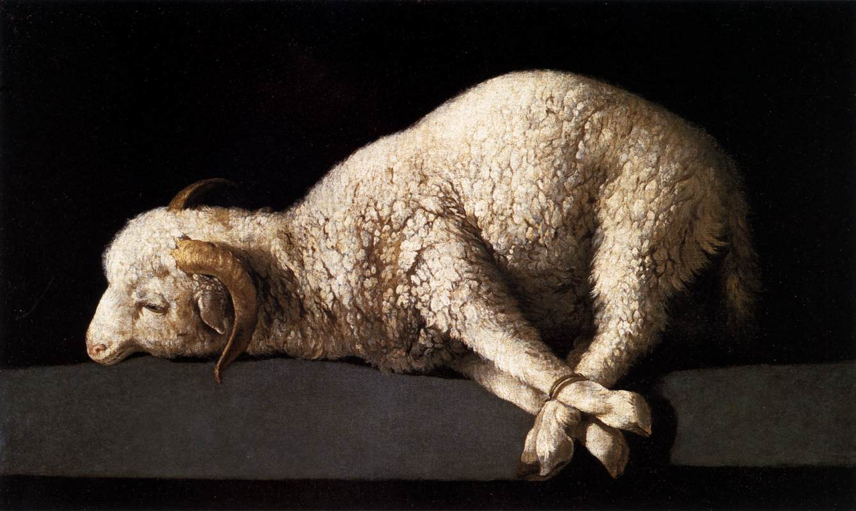

4

Then they shall take some of the blood and put it on the two doorposts and the lintel of
the houses in which they eat it. They shall eat the flesh that night, roasted on the fire;
with unleavened bread and bitter herbs they shall eat it. Do not eat any of it raw or boiled
in water, but roasted, its head with its legs and its inner parts. And you shall let none of it
remain until the morning; anything that remains until the morning you shall burn. In this
manner you shall eat it: with your belt fastened, your sandals on your feet, and your staff
in your hand. And you shall eat in haste. It is the Lord’s Passover. For I will pass
through the land of Egypt that night, and I will strike all the firstborn in the land of Egypt,
both man and beast; and on all the gods of Egypt I will execute judgments; I am the Lord.
The blood shall be a sign for you, on the houses where you are. And when I see the
blood, I will pass over you, and no plague will befall you to destroy you, when I strike
the land of Egypt.

This day shall be for you a memorial day, and you shall keep it as a feast to the Lord,
throughout your generations, as a statute forever, you shall keep it as a feast. Seven days
you shall eat unleavened bread. . .you shall observe the Feast of Unleavened Bread, for
on this very day I brought your hosts out of the land of Egypt. Therefore you shall
observe this day, throughout your generations, as a statute forever.

[Following the reading:]
P: This is the Word of the Lord
C: Thanks be to God!

The Epistle: 1 Corinthians 10:16-17; 11:17-29

The cup of blessing that we bless, is it not a participation in the Blood of Christ? The
bread that we break, is it not a participation in the Body of Christ? Because there is one
bread, we who are many are one body, for we all partake of the one Bread. . .

But in the following instructions I do not commend you, because when you come
together it is not for the better, but for the worse. For, in the first place, when you come
together as a church, I hear that there are divisions among you. And I believe it is in part.
For there must be factions among you in order that those who are genuine among you
may be recognized. When you come together, it is NOT the Lord’s Supper that you eat.
For in eating, each one goes ahead with his own meal. One goes hungry, another gets
drunk! What! Do you not have houses to eat and drink in? Or do you despise the Church
of God and humiliate those who have nothing? What shall I say to you? Shall I
commend you in this? No, I will not!

For I received from the Lord what I also delivered to you, that the Lord Jesus on the night
when He was betrayed took bread, and when He had given thanks, He broke it, and said,
“This is My Body, which is for you. Do this in remembrance of Me.” In the same way
also He took the cup, after supper, saying, “This cup is the New Covenant in My Blood.
Do this, as often as you drink it, in remembrance of Me.:” For as often as you eat this
Bread and drink the cup, you proclaim the Lord’s death until He comes.

Whoever, therefore, eats the bread or drinks the cup of the Lord in an unworthy manner
will be guilty concerning the Body and Blood of the Lord. Let a person examine himself,
then, and so eat of the bread and drink of the cup. For anyone who eats and drinks
without discerning the Body eats and drinks judgment on himself.
5
[Following the reading:]

P: This is the Word of the Lord
C: Thanks be to God

The Holy Gospel

P: The Holy Gospel continues according to Saints Matthew, Mark, Luke,
and John:
C: GLORY TO YOU, O LORD

As they were reclining at table and eating, Jesus said, “I have earnestly desired to eat this Passover with you before I suffer. For I tell you I will not eat it until it is fulfilled in the kingdom of God.” And He took a cup, and when He had given thanks He said, “Take this and divide it among yourselves. For I tell you that from now on I will not drink again of this fruit of the vine until that day when I drink it new with you in My Father’s kingdom.”

After saying these things, Jesus was troubled in His spirit, and testified, “Truly I say to you, one of you will betray Me, one who is eating with Me.” And they were very sorrowful, looking at one another, uncertain of whom He spoke, and began to say to Him one after another, “Is it I, Lord?” He answered, “It is one of the twelve; one who has dipped his hand in the dish with Me will betray Me. For the Son of Man goes as it is written of Him, but woe to that man by whom the Son of Man is betrayed! It would have been better for that man if he had not been born.” One of Jesus’ disciples, whom Jesus loved, was reclining at table close to Jesus, so Simon Peter motioned to him to ask Jesus of whom He was speaking. So that disciple leaning against Jesus said to Him, “Lord, who is it?” Jesus answered, “It is he to whom I will give this morsel of bread when I have dipped it.” So when Jesus had dipped the morsel, He gave it to Judas, the son of Simon Iscariot. Judas, who would betray Him, answered, “Is it I, Rabbi?” Jesus said to him, “You have said so.” Then after he had taken the morsel, Satan entered into Judas. Jesus then said to him, “What you are going to do, do quickly.” Now no one at the table knew why he said this to him. Some thought that, because Judas had the moneybag, Jesus was telling him, “Buy what we need for the feast,” or that he should give something to the poor. So after receiving the morsel of bread, Judas immediately went out. And it was night.

When Judas had gone out, Jesus said, “Now is the Son of Man glorified, and God is glorified in Him. If God is glorified in Him, God will also glorify Him in Himself, and glorify Him at once.”

Now as they were eating, Jesus took bread, and after blessing it, broke it and gave it to the disciples, and said, “Take, eat; this is My Body, which is given for you. Do this in remembrance of me.” And after they had eaten He took a cup, and when He had given thanks He gave it to them, saying, “Drink of it, all of you, for this cup that is poured out for you is My Blood of the New Covenant, which is poured out for many for the forgiveness of sins.”

And when they had sung a hymn, they went out to the Mount of Olives

P: This is the Gospel of the Lord.
C: PRAISE TO YOU, O CHRIST!

6

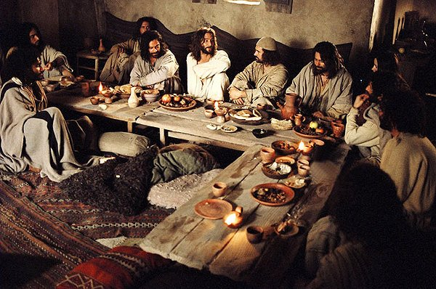

The Hymn of the Day “Jesus Comes Today With Healing”
Music to accompany this hymn is in the hymnal, Lutheran Service Book #620

1. Jesus comes today with healing Knocking at my door appealing
Off’ring pardon, grace and peace
He Himself makes preparation, And I hear His invitation:
“Come and taste the blessed feast.”

3. Under bread and wine, though lowly, I receive the Savior holy,
Blood and Body, giv’n for me
Very Lamb of God from heaven, Who to bitter death was given
Hung upon the cursed tree

6. Now have I found consolation, Comfort in my tribulation
Balm to heal the troubled soul
God, my shield from ev’ry terror, Cleanses me from sin and error
Makes my wounded spirit whole.

Sermon “Missing The Meal” 1 Corinthians 10:16-17
The cup of blessing that we bless, is it not a participation in the Blood of Christ? The
bread that we break, is it not a participation in the Body of Christ? Because there is one bread, we who are many are one body, for we all partake of the one Bread. . .

Hymn of Response “Let All Mortal Flesh Keep Silence”
(Music to accompany this hymn is in the hymnal, Lutheran Service Book #621)

- Let all mortal flesh keep silence And with fear and trembling stand
Ponder nothing earthly minded, For with blessing in His hand
Christ our God to earth descending Comes our homage to demand

- King of kings, yet born of Mary As of old on earth He stood
Lord of lords in human vesture, In the Body and the Blood
He will give to all the faithful his own self for heav’nly food
7
- Rank on rank the host of heaven Spreads it vanguard on the way
As the Lord of Light descending From the realms of endless day
Comes the pow’rs of hell to vanquish As the darkness clears the way

- At His feet the six-winged seraph, Cherubim with sleepless eye
Veil their faces to the presence As with ceaseless voice they cry
Alleluia, alleluia! Alleluia, Lord Most High!”

Apostles Creed

All: I believe in God the Father Almighty, maker of heaven and earth. And
in Jesus Christ, His only Son, our Lord, who was conceived by the
Holy Spirit, born of the virgin Mary, suffered under Pontius Pilate,
was crucified, died and was buried. He descended into hell. The third
day He rose again from the dead. He ascended into heaven and sits at
the right hand of God the Father Almighty. From thence He will
come to judge the living and the dead. I believe in the Holy Spirit, the
holy Christian Church, the communion of saints, the forgiveness of
sins, the resurrection of the body, and the life everlasting. Amen.

The Prayers

All: I thank You, my Heavenly Father, through Jesus Christ, Your dear Son,
that You have graciously kept me this day; and I pray that You would forgive me all my sins where I have done wrong, and graciously keep me this night. For into Your hands I commend myself, my body and soul, and all things. Let Your holy angel be with me, that the evil foe may have no power over me. Amen

P: Be present with us, merciful God, and protect us, so that we who are
wearied by the changes and chances of life may find our rest in You,
through Jesus Christ, our Lord
All: Amen.

P/L: Almighty God, merciful Father, Your thoughts are not our thoughts, Your
ways are not our ways. In Your wisdom You have permitted this threat
of pandemic disease to befall us. We implore You, let not the hearts of
Your people despair nor our faith fail us, but sustain and comfort us.
Direct all efforts to attend to those most in need and protect the helpless.
Bring hope and healing that we may find relief and restoration, through
Jesus Christ our Lord
All: Amen.

All: Lord God, You have called Your servants to ventures of which we
cannot see the ending, by paths as yet untrodden, through perils
unknown. Give us faith to go out with good courage, not knowing
where we go but only that Your hand is leading us and Your love
supporting us, through Jesus Christ, our Lord. Amen.
8
Maundy Thursday Hymn “Go To Dark Gethsemane”
(Music to accompany the lyric may be found in LSB #436)

1. Go to dark Gethsemane, All who feel the tempter’s power
Your Redeemer’s conflict see, Watch with Him one bitter hour
Turn not from His griefs away; Learn from Jesus Christ to pray

3. Calv’ry’s mournful mountain climb There adoring at His feet
Mark that miracle of time God’s own sacrifice complete
“It is finished,” hear Him cry Learn from Jesus Christ to die

4. Early hasten to the tomb Where they laid His breathless clay
All is solitude and gloom Who has taken Him away?
Christ is ris’n! He meets our eyes Savior, teach us so to rise

Across the Kidron Valley, on the way to the Mount of Olives, Jesus said to them, “You will all fall away because of Me this night. For it is written, ‘I will strike the Shepherd, and the sheep of the flock will be scattered.’ But after I am raised up, I will go before you to Galilee.” Peter answered Him, “Though they all fall away because of you, I will never fall away.” Jesus said to Him, “Truly, I tell you, this very night, before the rooster crows, you will deny Me three times.” Peter said to Him, “Even if I must die with You, I will not deny You!” And all the disciples said the same. Then Jesus went with them to a place called Gethsemane. (Now Judas, who would betray Him, also knew this place.)

Jesus said to His disciples, “Sit here, while I go over there and pray.” And taking with Him Peter and the two sons of Zebedee, James and John, He began to be sorrowful and troubled. He said to them, “My soul is very sorrowful, even to death; remain here, and watch with Me.” And going a little farther He fell on His face and prayed, saying, “My Father, if it be possible, let this cup pass from Me; nevertheless, not as I will, but as You will.” And He returned to the disciples and found them sleeping, and He said to Peter, “Could you not watch with Me one hour? Watch and pray that you may not enter into temptation. The spirit indeed is willing, but the flesh is weak.”

P: Trusting in His Word and Promises, we are bold to pray:
All: Our Father who art in heaven, Hallowed be Thy name,
Thy kingdom come, Thy will be done on earth as it is in heaven;
Give us this day our daily bread;
And forgive us our trespasses as we forgive those who trespass against
us;
And lead us not into temptation, but deliver us from evil.
For Thine is the kingdom and the power and the glory forever and ever.
Amen.
9
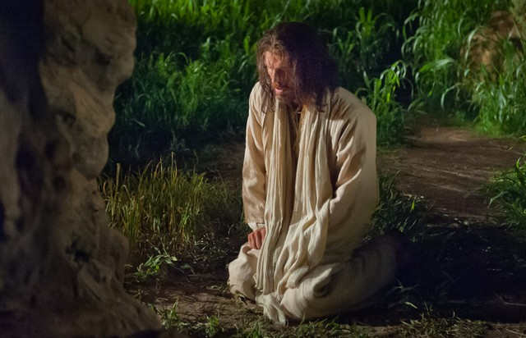

Again, for the second time, Jesus went away and prayed, “My Father, if this cannot pass unless I drink of this cup, Your will be done.” And again He came and found them sleeping, for their eyes were heavy. So leaving them again, He went away and prayed for the third time, saying the same words again. Then He came to the disciples and said to them, “Sleep and take your rest later on. Behold, the hour is at hand, and the Son of Man is betrayed into the hands of sinners. Rise, let us go; see, my betrayer is at hand.” While He was still speaking, Judas came, one of the twelve; he had procured a band of soldiers and some officers from the chief priests and the Pharisees, who came with lanterns and torches, swords and clubs. Now Judas had given them a sign, saying, “The one I kiss is the Man; seize Him.” And Judas came up to Jesus at once and said, “Greetings, Rabbi!” And he kissed Him. Jesus said to him, “Do you betray Me with a kiss? Friend, do what you came to do.”

Then they came up and laid hands on Jesus and seized Him. Then Jesus, knowing all that would happen to Him, stepped forward and said to the crowd, “Whom do you seek?” And they said, “Jesus of Nazareth.” And Jesus answered, “I am He,” and when He said this, they all drew back and fell to the ground. Judas was still standing with them. Jesus asked them again, “Whom do you seek?” And they said again, “Jesus of Nazareth.” And Jesus said, “I told you that I am He. So if it is me you seek, let these other men go.” (This was to fulfill the Word that He had spoken: ‘Of those whom You gave Me, I lost not one.’)

And those who were with Jesus saw what was happening; they asked Him, “Lord, shall we strike with the sword?” Peter stretched out his hand and drew his sword and struck the servant of the high priest (his name was Malchus) and cut off his right ear. Jesus said to Peter, “No more of this! Put your sword back into its place. For all who take the sword will perish by the sword. Do you think that I cannot appeal to My Father, and He will at once send Me more than twelve legions of angels? But how then should the Scriptures be fulfilled, that it must be so? Shall I not drink the cup the Father has given Me?”

And Jesus touched the servant’s ear and healed him.

At that hour Jesus said to the crowds, “Have you come out as against a robber, with swords and clubs to capture Me? Day after day I sat in the Temple teaching, and you did not seize Me. But all this has taken place that the Scriptures of the prophets might be fulfilled.” (And a young man who had followed Jesus, with nothing but a linen cloth about his body, when they seized him, left the linen cloth and ran away naked.) Then all the disciples left Him and fled.
10
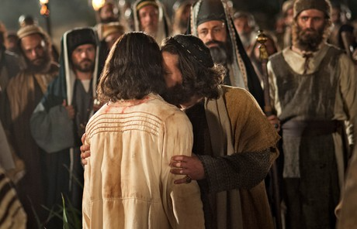

The Dismissal

P: The grace of our Lord Jesus Christ and the love of God and the
communion of the Holy Spirit be with you all
C: Amen.

11

