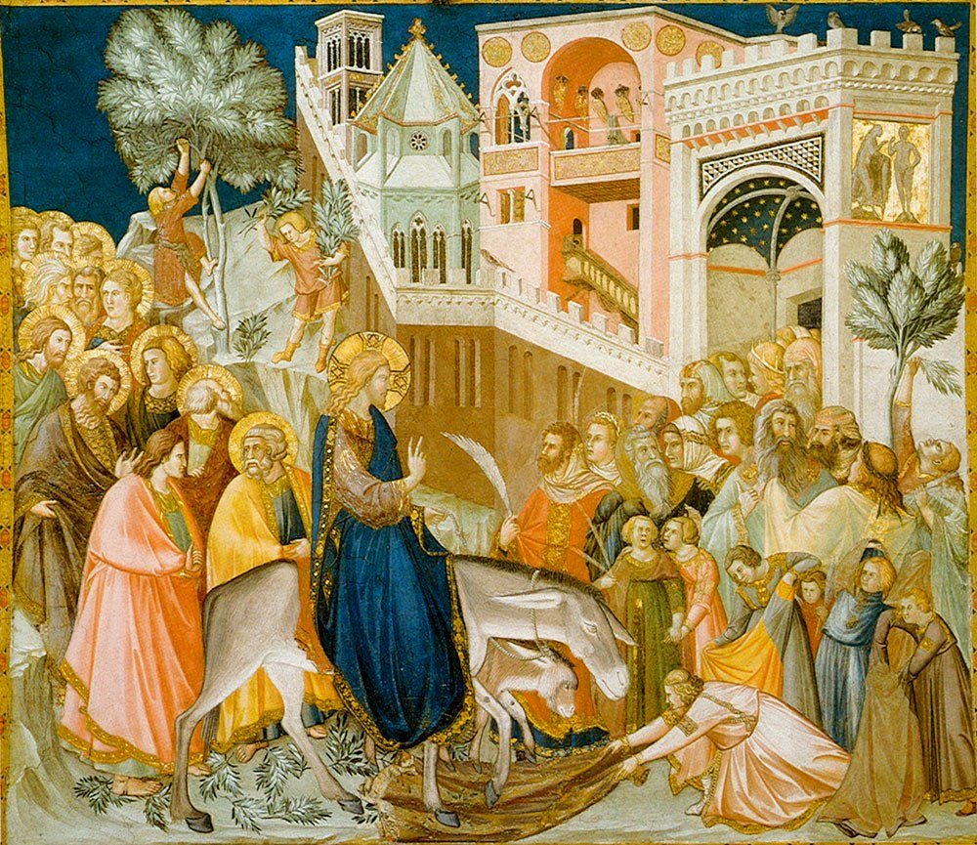

Trinity Lutheran Church
The Lutheran Church—Missouri Synod
1415 S. Holland
Springfield, MO 65807
417-866-5878

tlcoffice@trinitylutheranspfd.org
www.trinity-springfield.org

Divine Services: 8:15 a.m. and 11:00 a.m.
Sunday School and Bible Classes: 9:45 a.m.

Palm Sunday
April 5, 2020
Greeting
L The grace of our Lord T Jesus Christ and the love of God and the communion of the Holy Spirit be with you all.
C Amen.

L Blessed is He who comes in the name of the Lord.
C Hosanna to the Son of David.

Introit
L Blessèd is he who comes in the name of the Lord!
We bless you from the house of the Lord.
C Lift up your heads, O gates! And be lifted up, O ancient doors,
that the King of glory may come in.
L Who is this King of glory?
The Lord, strong and mighty, the Lord, mighty in battle!
C Lift up your heads, O gates! And lift them up, O ancient doors,
that the King of glory may come in.
L Who is this King of glory?
The Lord of hosts, he is the King of glory!
C Blessèd is he who comes in the name of the Lord!
We bless you from the house of the Lord.

Collect
L Let us pray.
Most merciful God, as the people of Jerusalem, with palms in their hands, gathered to greet Your dearly beloved Son when He came into His Holy City, grant that we may ever hail Him as our King and, when He comes again, may go forth to meet Him with trusting and steadfast hearts and follow Him in the way that leads to eternal life; through the same Jesus Christ, our Lord, who lives and reigns with You and the Holy Spirit, one God, now and forever.
C Amen.

Holy Gospel John 12:12–19
L The Holy Gospel according to St. John, the twelfth chapter.
C Glory to You, O Lord.

The next day the large crowd that had come to the feast heard that Jesus was coming to Jerusalem. So they took branches of palm trees and went out to meet him, crying out, “Hosanna! Blessed is he who comes in the name of the Lord, even the King of Israel!” And Jesus found a young donkey and sat on it, just as it is written,
“Fear not, daughter of Zion;
behold, your king is coming,
sitting on a donkey’s colt!”
His disciples did not understand these things at first, but when Jesus was glorified, then they remembered that these things had been written about him and had been done to him. The crowd that had been with him when he called Lazarus out of the tomb and raised him from the dead continued to bear witness. The reason why the crowd went to meet him was that they heard he had done this sign. So the Pharisees said to one another, “You see that you are gaining nothing. Look, the world has gone after him.”

L This is the Gospel of the Lord.
C Praise to You, O Christ.

Opening Hymn -- All Glory, Laud, and Honor LSB 442
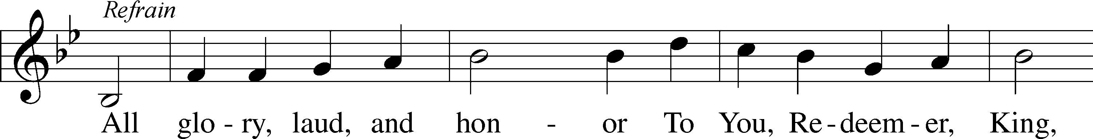
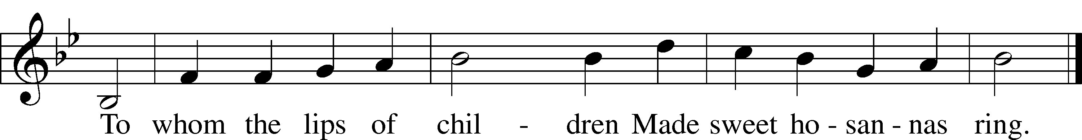
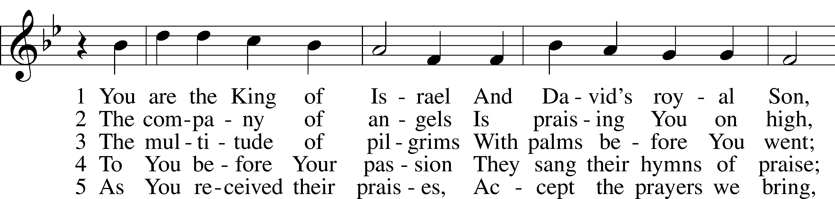
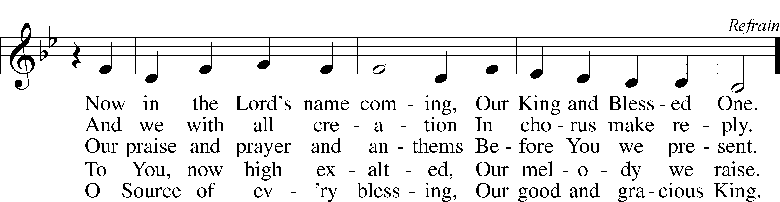
Tune and text: Public domain

L Blessed is He who comes in the name of the Lord.
C Hosanna in the highest.

Collect of the Day Palm Sunday / Sunday of the Passion
L Let us pray.
Almighty and everlasting God, You sent Your Son, our Savior Jesus Christ, to take upon Himself our flesh and to suffer death upon the cross. Mercifully grant that we may follow the example of His great humility and patience and be made partakers of His resurrection; through the same Jesus Christ, our Lord, who lives and reigns with You and the Holy Spirit, one God, now and forever.
C Amen.

Old Testament Reading Isaiah 50:4–9a
The Lord God has given me
the tongue of those who are taught,
that I may know how to sustain with a word
him who is weary.
Morning by morning he awakens;
he awakens my ear
to hear as those who are taught.
The Lord God has opened my ear,
and I was not rebellious;
I turned not backward.
I gave my back to those who strike,
and my cheeks to those who pull out the beard;
I hid not my face
from disgrace and spitting.
But the Lord God helps me;
therefore I have not been disgraced;
therefore I have set my face like a flint,
and I know that I shall not be put to shame.
He who vindicates me is near.
Who will contend with me?
Let us stand up together.
Who is my adversary?
Let him come near to me.
Behold, the Lord God helps me;
who will declare me guilty?

L This is the Word of the Lord.
C Thanks be to God.

Gradual
L [Christ] entered once for all into the holy places, by means of his own blood,
thus securing an eternal redemption.
Therefore he is the mediator of a new covenant,
so that those who are called may receive the promised eternal inheritance.
He sent redemption to his people;
he has commanded his covenant forever.

Epistle Philippians 2:5–11
Have this mind among yourselves, which is yours in Christ Jesus, who, though he was in the form of God, did not count equality with God a thing to be grasped, but made himself nothing, taking the form of a servant, being born in the likeness of men. And being found in human form, he humbled himself by becoming obedient to the point of death, even death on a cross. Therefore God has highly exalted him and bestowed on him the name that is above every name, so that at the name of Jesus every knee should bow, in heaven and on earth and under the earth, and every tongue confess that Jesus Christ is Lord, to the glory of God the Father.

L This is the Word of the Lord.
C Thanks be to God.

Verse
C He humbled himself by becoming obedient to the point of death, even death on a cross.

Holy Gospel John 12:20–43
L The Holy Gospel according to St. John, the twelfth chapter.
C Glory to You, O Lord.

Now among those who went up to worship at the feast were some Greeks. So these came to Philip, who was from Bethsaida in Galilee, and asked him, “Sir, we wish to see Jesus.” Philip went and told Andrew; Andrew and Philip went and told Jesus. And Jesus answered them, “The hour has come for the Son of Man to be glorified. Truly, truly, I say to you, unless a grain of wheat falls into the earth and dies, it remains alone; but if it dies, it bears much fruit. Whoever loves his life loses it, and whoever hates his life in this world will keep it for eternal life. If anyone serves me, he must follow me; and where I am, there will my servant be also. If anyone serves me, the Father will honor him.
“Now is my soul troubled. And what shall I say? ‘Father, save me from this hour’? But for this purpose I have come to this hour. Father, glorify your name.” Then a voice came from heaven: “I have glorified it, and I will glorify it again.” The crowd that stood there and heard it said that it had thundered. Others said, “An angel has spoken to him.” Jesus answered, “This voice has come for your sake, not mine. Now is the judgment of this world; now will the ruler of this world be cast out. And I, when I am lifted up from the earth, will draw all people to myself.” He said this to show by what kind of death he was going to die. So the crowd answered him, “We have heard from the Law that the Christ remains forever. How can you say that the Son of Man must be lifted up? Who is this Son of Man?” So Jesus said to them, “The light is among you for a little while longer. Walk while you have the light, lest darkness overtake you. The one who walks in the darkness does not know where he is going. While you have the light, believe in the light, that you may become sons of light.”
When Jesus had said these things, he departed and hid himself from them. Though he had done so many signs before them, they still did not believe in him, so that the word spoken by the prophet Isaiah might be fulfilled:
“Lord, who has believed what he heard from us,
and to whom has the arm of the Lord been revealed?”
Therefore they could not believe. For again Isaiah said,
“He has blinded their eyes
and hardened their heart,
lest they see with their eyes,
and understand with their heart, and turn,
and I would heal them.”
Isaiah said these things because he saw his glory and spoke of him. Nevertheless, many even of the authorities believed in him, but for fear of the Pharisees they did not confess it, so that they would not be put out of the synagogue; for they loved the glory that comes from man more than the glory that comes from God.

L This is the Gospel of the Lord.
C Praise to You, O Christ.

Hymn of the Day -- Hosanna, Loud Hosanna LSB 443
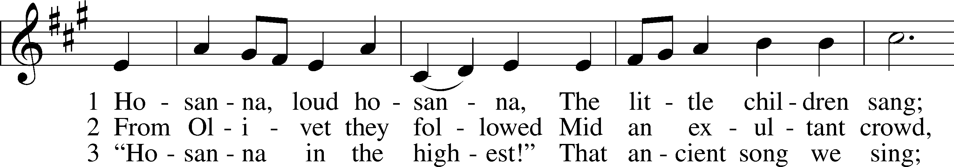
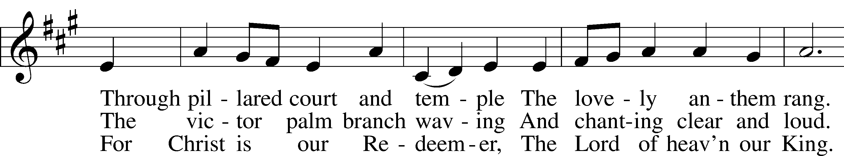
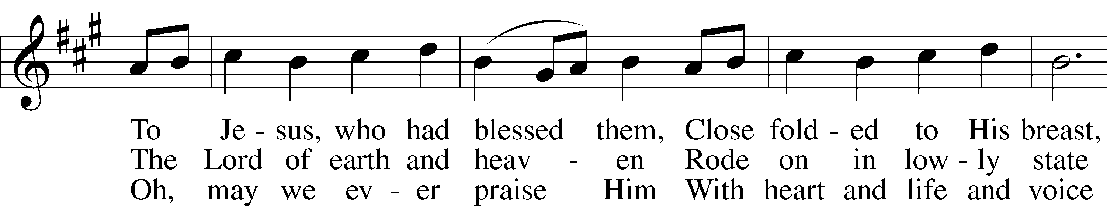
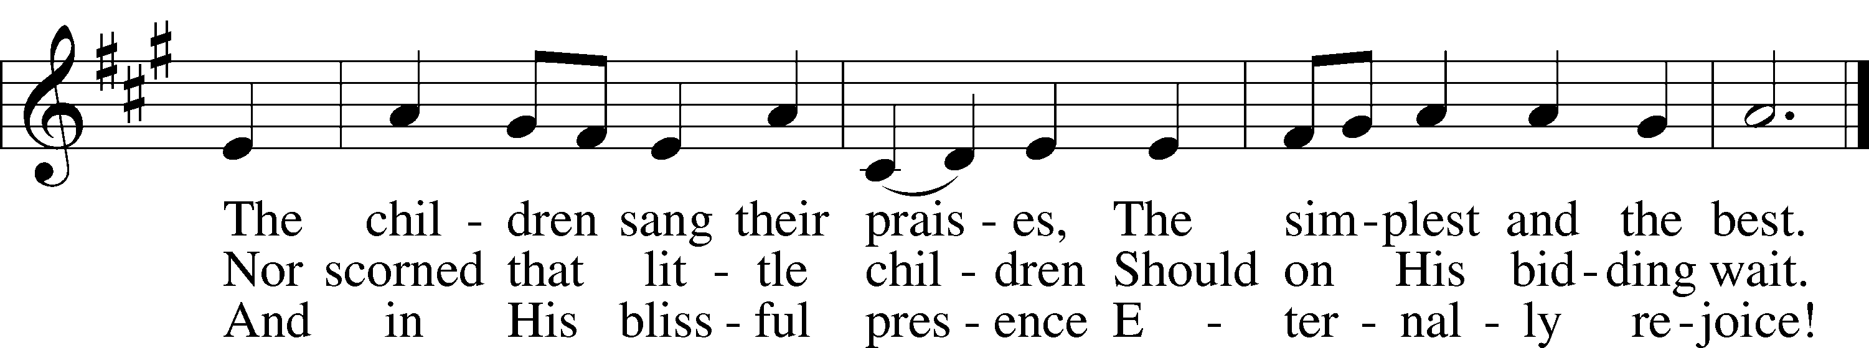
Tune and text: Public domain

Sermon (See Video)

Apostles’ Creed
C I believe in God, the Father Almighty,
maker of heaven and earth.

And in Jesus Christ, His only Son, our Lord,
who was conceived by the Holy Spirit,
born of the virgin Mary,
suffered under Pontius Pilate,
was crucified, died and was buried.
He descended into hell.
The third day He rose again from the dead.
He ascended into heaven
and sits at the right hand of God the Father Almighty.
From thence He will come to judge the living and the dead.

I believe in the Holy Spirit,
the holy Christian Church,
the communion of saints,
the forgiveness of sins,
the resurrection of the body,
and the life T everlasting. Amen.

Prayer of the Church

L Let us pray for the Church, that the Lord would defend her against all her enemies and keep her true to Jesus Christ by the power of Your Word and Spirit:

Gracious Lord, keep Your Church in Your mercy, that she may endure the assaults of the evil one and remain faithful for the sake of those numbered within Your Kingdom and those who have not yet heard the Gospel and been brought to faith; through Jesus Christ, our Lord.
C Amen.

L Let us pray for all pastors, for all church-work vocations and for all the baptized in their vocation as God’s people:

Almighty God, by Your Spirit You have established us as Your Church and granted to us particular vocations within the Church, home and community in which to serve You. Grant to us every gift and blessing needful, that we may honor our calling and serve You to the best of our ability; through Jesus Christ, our Lord.
C Amen.

L Let us pray for those preparing for Baptism, for the newly baptized, for those being catechized as children and adults, and for those joining our congregation:

Almighty Father, Your Word will not return to You empty but will accomplish Your purpose. Hear us on behalf of those who have heard Your Word, who are being baptized into Christ and joining the fellowship of our congregation, that they may keep the faith with holy and joyful hearts trusting in Christ as their Savior; through Jesus Christ, our Lord.
C Amen.

L Let us pray for the government, for all in authority over us, and for our own lives as citizens and neighbors:

O mighty Lord, You have established the kingdom of the left and hold accountable all those who govern in this and every place. Guide our president; the members of Congress; the governor of this state; and all who make, administer and judge our laws, that they would serve nobly and wisely, pursuing the path of justice and protecting those least able to protect themselves; through Jesus Christ, our Lord.
C Amen.

L Let us pray for an end to violence and terror, for those imprisoned, for the troubled in mind, and for those who suffer any afflictions of the body:

Merciful Lord, Your grace is sufficient for all our needs, and You have promised to be the strength of the weary, the hope of those who fear, the healing of the ill, the fullness of those disabled, and the peace of all who are distressed. Hear us on behalf of (list Trinity members and friends) and all whom we name in our hearts, that they may be well supplied by Your grace in their time of trouble; through Jesus Christ, our Lord.
C Amen.

L Let us pray for those not yet of the Kingdom, that God would make us bold to speak the faith to them and that hearing, they might believe:

Everlasting Father, it is Your will that all should be saved and come to the knowledge of Your Son by faith. Give to Your Word success and deliver from error all those who live in darkness, that they may walk in the light of the Lord Jesus; through Jesus Christ, our Lord.
C Amen.

L Let us pray for the earth to be fruitful, and for our good use of all the fruits of the earth:

Blessed Lord, You give food to the hungry and provide for all our needs in this mortal life. Grant to us a grateful heart and knowledge to use wisely and well all that You have entrusted to our care; through Jesus Christ, our Lord.
C Amen.

L Let us pray for our unity of doctrine and faith, and for our right reception of the Word of God:

Holy Lord, as once Your Son was welcomed with palms and hosannas, help us to welcome Him who comes to us this day in His holy Word. Guard us against false teaching and help us to discern truth from error, that none may be led astray or lost from the fellowship of Your Son; through Jesus Christ, our Lord.
C Amen.

L Let us pray for the safety of our families, community, nation, and world in this time of global pandemic:

Lord Jesus Christ, our Great Physician, mercifully protect us from the virus that now threatens our physical health and our lives. Allow us to escape this pandemic unscathed. Give healing to those who are ill, and graciously preserve those whose lives are threatened. Send your angel of protection especially to doctors, nurses, and other health care workers who courageously expose themselves to this disease in order to tend to others. Grant wisdom and discernment to all governments and officials throughout the world, that they may act in the best interests of the people they lead. Give hope to those who have lost jobs or are experiencing financial difficulties, that they may trust that all of their needs will be provided by You. Give us patience as we remain isolated from one another, that we may endure the loneliness and boredom of these days and look forward to the time when this crisis will have passed. Above all else, preserve us all in faith in your Son and His promises to those who trust in Him; through Jesus Christ our Lord.
C Amen.

Lord’s Prayer LSB 162
C Our Father who art in heaven,
hallowed be Thy name,
Thy kingdom come,
Thy will be done on earth
as it is in heaven;
give us this day our daily bread;
and forgive us our trespasses
as we forgive those
who trespass against us;
and lead us not into temptation,
but deliver us from evil.
For Thine is the kingdom
and the power and the glory
forever and ever. Amen.

Benediction
P The grace of our Lord Jesus Christ and the love of God and the communion of the Holy Spirit be with us all.
C Amen.

Closing Hymn -- Ride On, Ride On in Majesty LSB 441
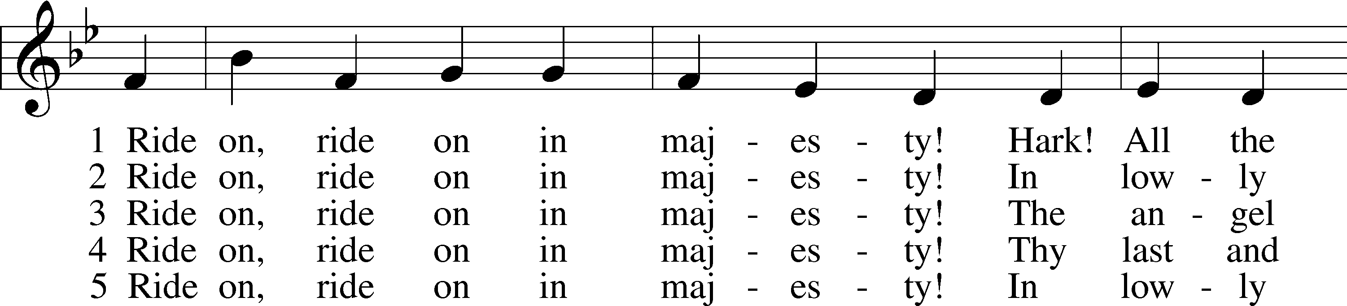
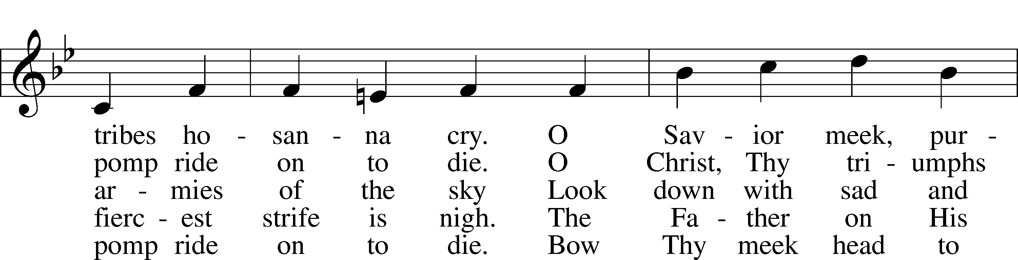
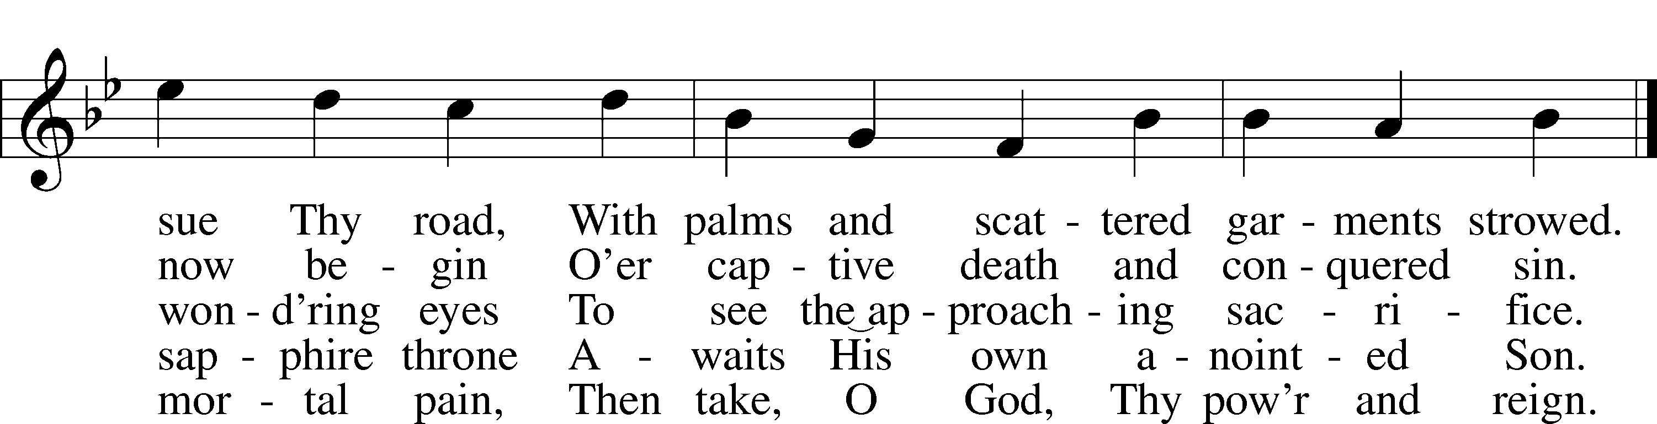
Tune and text: Public domain

Trinity Family Prayer Page
Week of April 5-11, 2020

Name | Information
Carol Etherton | Prayers for strength
Sharon Hackley | Prayers for strength & comfort, completed chemo treatments
Loretta Morelock | Fell at home, recovering from several fractures & broken hip
Pam Phillips | Suffering from a compression fracture in her back
Nathan Rader | Prayers for strength; diagnosed with leukemia & undergoing treatments; in remission
Dr. Grace St. Pierre | Recovering at home following a stroke
Friends and Family:
Eli Applegate | Grandson of Ben & Deb Schroeder, treatments for Aplastic Anemia
Marvin Bachtold | Brother of Bernie Zeigler, thyroid cancer and now lung cancer
Charlyn Badley | Friend of Amy (Travis) Rich, fell & severed her spine, paralyzed from the waist down
Matt Baugher | Friend of Carl & Linda Oughton, brain cancer returned, chemo treatments
Peggy Beatty | Sister of Rhonda Penn, stage 1 non-small cell lung cancer
Sandy Crews | Friend of Bette Davis, diagnosed with Thyroid cancer, successful surgery
Debbie Curtis | Friend of Doug & Michelle Powell, stage 4 lung cancer
Lisa Dok | Childhood friend of Laura Snow, stage 4 ovarian cancer
Matt Ford | Friend of Lu Crabtree, Polycystic Kidney Disease, recovering from surgery, transplant in April
Josh Gaede | Son of Candace Gaede, prayers for healing
Heidi Hartman | Cousin of Beth Ghanem, cancer has returned, resumed chemo treatments
Jeril Heine | Son of Carol Etherton for healing & strength
Scott Henry | Friend of Carol Dawson, diagnosed with prostate cancer
Cheryl Hernes | Cousin of Katherine Marler, positive test results from chemo treatments
Renee Holmgren | Friend of many Trinity members, stage 4 renal cancer
Tom Holmgren | Friend of many Trinity members, diagnosed with Non-Hodgkin's Lymphoma
Ashley Humphries | Niece of Zeke & Linda Young, continued chemo treatments in Springfield
Mark Johnson | Brother of Diane Lewis, diagnosed with cancer, chemo treatments
Charlie Jones | Father in law of Leslie Jones, diagnosed with throat cancer, undergoing treatments
Mike Jones | Friend of Carl & Linda Oughton, liver cancer, chemo treatments
Mark Klinkerman | Son of Stella Klinkerman, ALS progressing
Elmer Lindeman | Uncle of Ben Brown, has been placed on hospice care
Scott Mattlage | Son of Marian Mattlage, in the hospital with pneumonia, complications with diabetes
Georgia Ohly | Friend of Nancy Servis, undergoing treatment for kidney disease
Melissa Potter | Friend of Ruth Seboldt, at home, continues extensive rehab program following a stroke
David Westmeyer | Brother of Karen Vaughan, prayers for comfort/strength, late stage Parkinson's Disease
Shelby Winton | Sister of Sheila Ankrom, diagnosed with colon cancer, undergoing chemo treatments
Military: | Chris Adams, deployed to Iraq, (and for wife Malissa and family here at home.)
 | Major Robert Stillings, deployed to South Korea

Birthdays
April 5 | Mark Freiert, Stephen Mattlage, Mickey Moore
April 6 | Tim Parr, Bill Peck
April 8 | Jessica Carroll, Weston Cline
April 9 | Billy Thompson
April 11 | Ann Marie Baker
Anniversaries
No Anniversaries this week
Baptism Remembrance
April 5 | Nora Schultz
April 6 | Colin Hambrick, Paul Hambrick, Diane Lewis
April 7 | Will Brand, Jeff Flattem, Eleanor Halterman, Joni Sommerer
April 9 | Alfred Edling, Greyson Newman
Tomorrow Fund
Donations have been made through memorial contributions for James Kollmeyer, Harold Pfieffer, and Marcella Gieseke

Acknowledgments
Divine Service, Setting One from Lutheran Service Book
Unless otherwise indicated, Scripture quotations are from the ESV® Bible (The Holy Bible, English Standard Version®), copyright © 2001 by Crossway, a publishing ministry of Good News Publishers. Used by permission. All rights reserved.
Created by Lutheran Service Builder © 2018 Concordia Publishing House.

