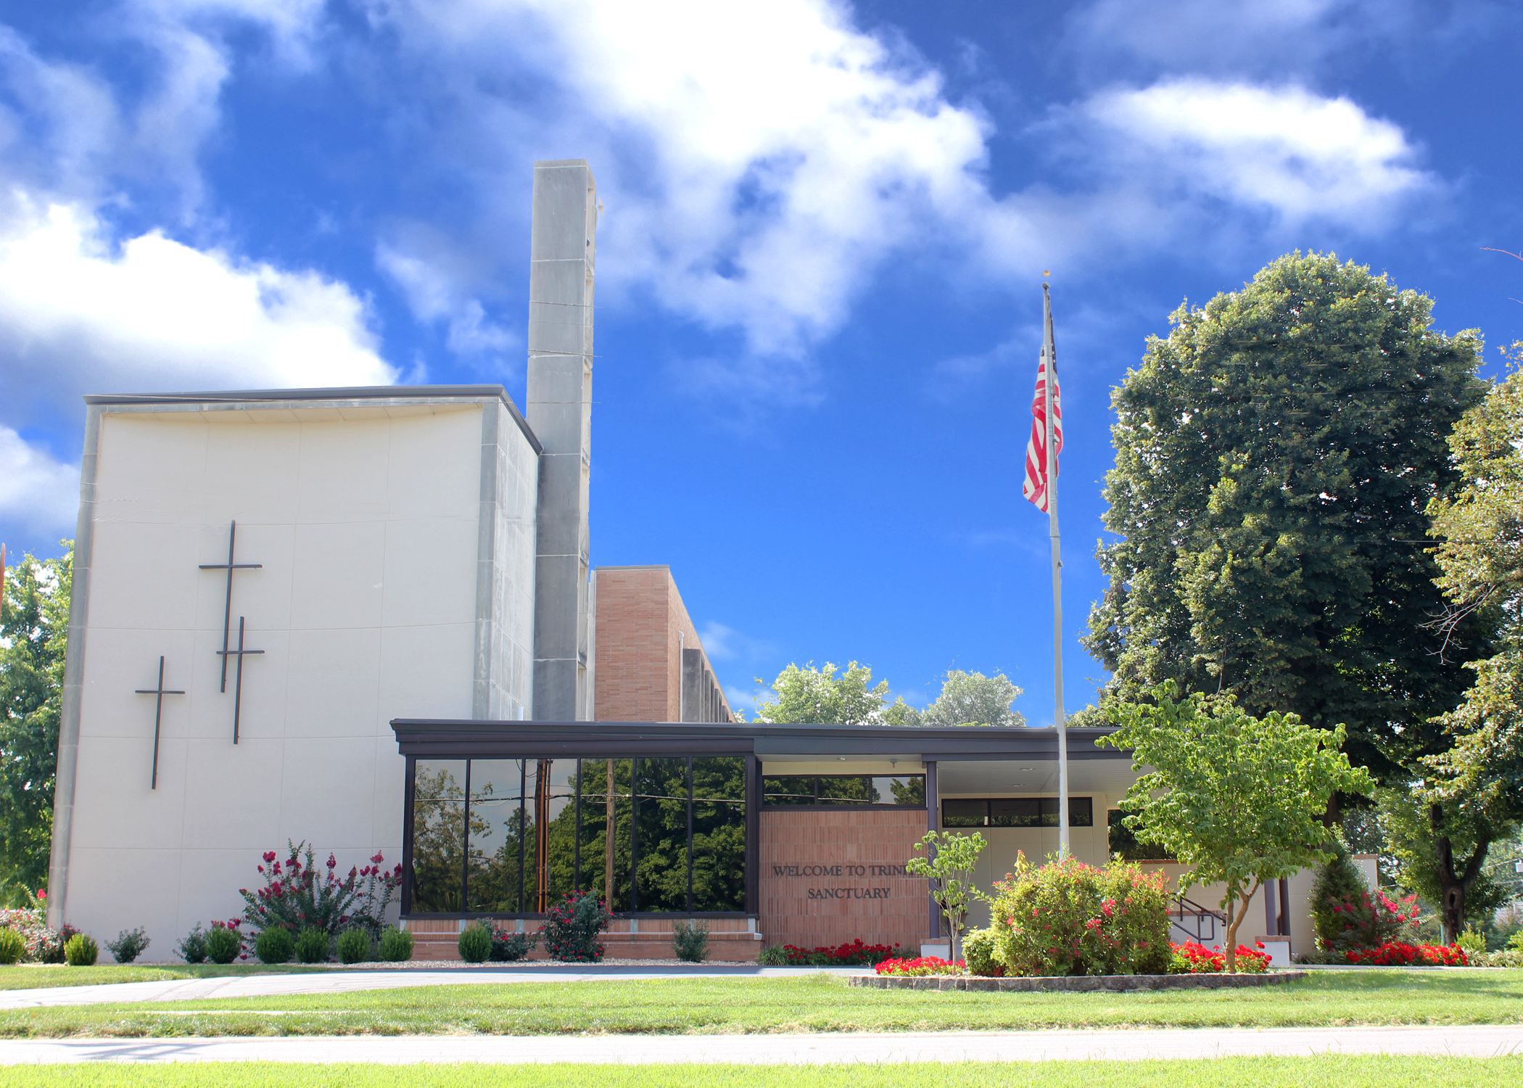

Trinity Lutheran Church
The Lutheran Church—Missouri Synod
1415 S. Holland
Springfield, MO 65807
417-866-5878

tlcoffice@trinitylutheranspfd.org
www.trinity-springfield.org

Divine Services:
8:15 a.m.
11:00 a.m.
4:00 p.m.

The Twenty-Third Sunday after Pentecost
November 8, 2020
WELCOME TO TRINITY LUTHERAN CHURCH!
_________________________________________________
A Congregation of The Lutheran Church - Missouri Synod

Pastor Rev. Nicholas Hagerman
Director of Music Ministry Dr. Grace St. Pierre
Office Manager Angela Bruton
Director of Family Life Intern Hannah Knehans
Custodian Ron Shepard
Nursery Attendant Emily Jones

Serving in Today’s Divine Services

Organist Doyle Richter

Vocalist Michael Payne

Elders 8:15 Zack Peters
11:00 Grant McCune
4:00 Curt Brand

Ushers 8:15 Jim Maggi, Ed Dorris
11:00 Ray Meyer
4:00 Daniel Straw

Acolytes 8:15 Myles Lozano
11:00 Reese Lawler, Ava Lawler
Video Chris Straw
Altar Guild Amy Viets-Cooper, Sherry Jones

CLOSE COMMUNION AT TRINITY
Trinity congregation practices close Communion in accordance with what the Holy Scriptures teach about the administration of the Sacrament of the Lord’s Body and Blood. Confirmed members of Trinity and of other congregations of The Lutheran Church-Missouri Synod and of denominations in declared doctrinal fellowship with the LCMS are welcome to the Lord’s Table. Visitors and guests are asked to speak to one of our Pastors or Elders. Our Pastors also encourage visitors desiring to commune at Trinity to make an appointment with one of them before your next visit. A brief statement of our church’s doctrinal confession on the Lord’s Supper may be found in the narthex.

Welcome and Announcements

Ringing of the Bells
Calling the Baptized People of God to the Hour of Divine Service

Prelude

Opening Hymn -- Wake, Awake, for Night Is Flying LSB 516

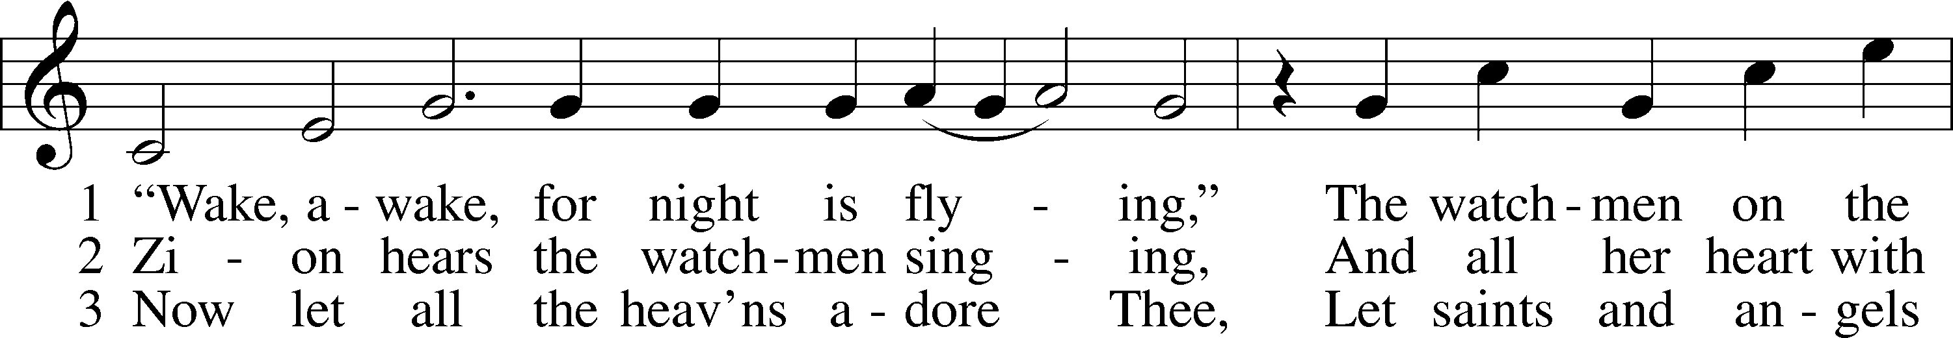
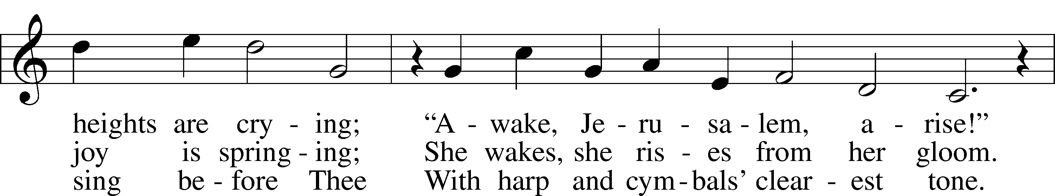
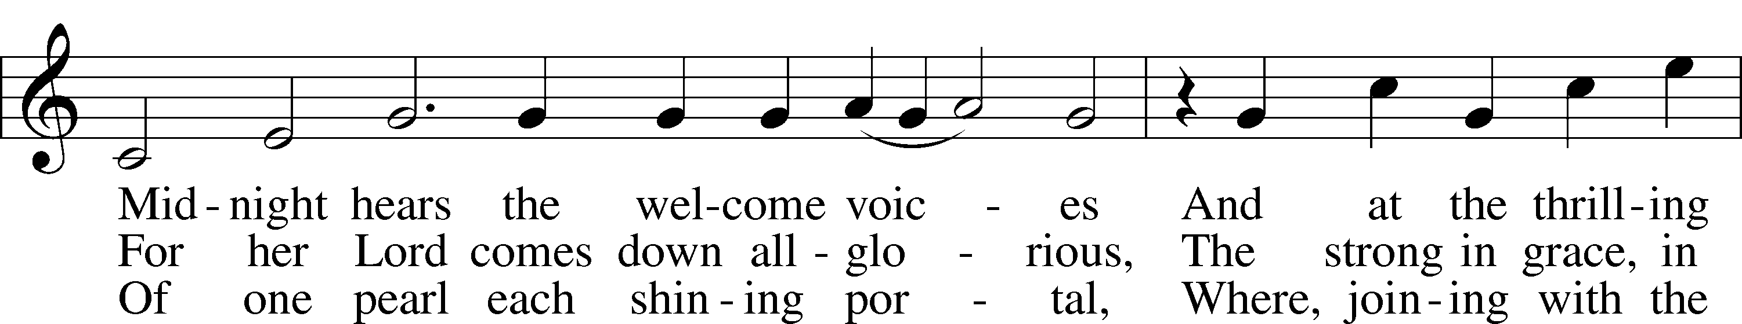
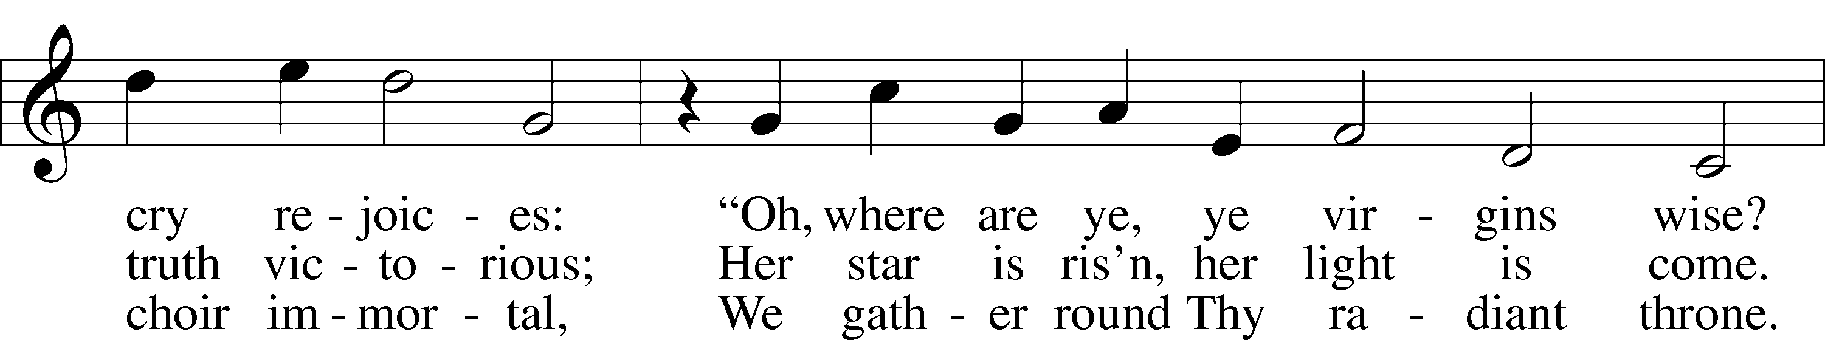
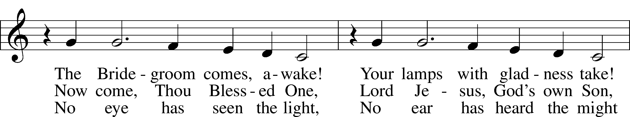
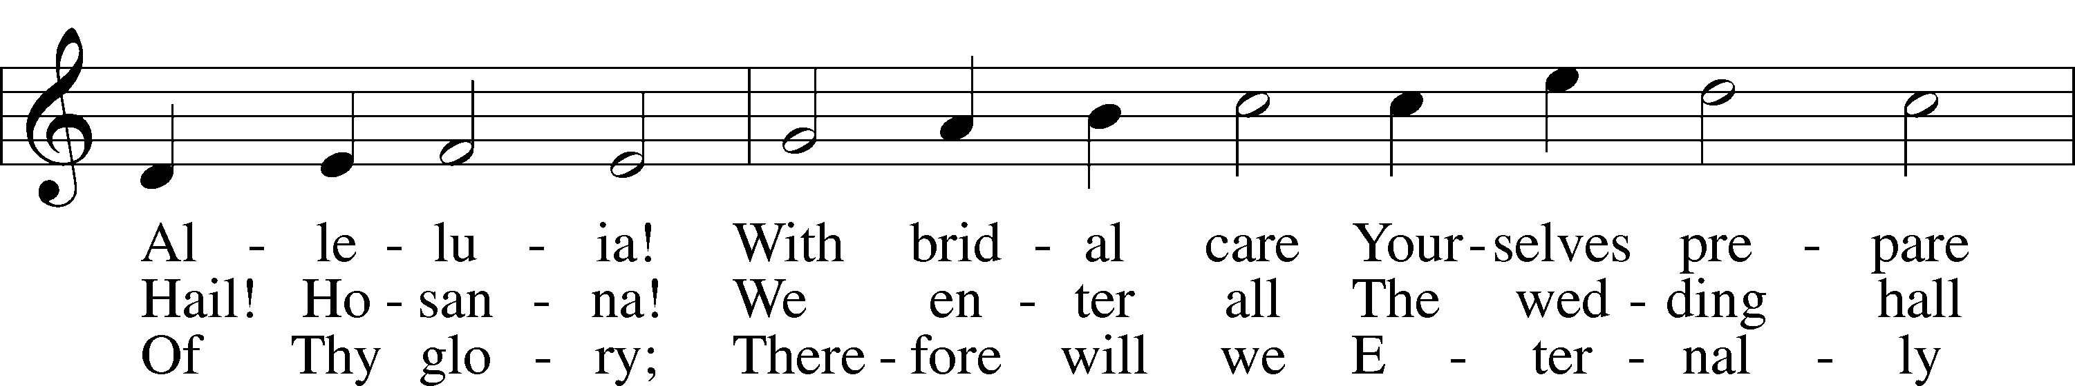
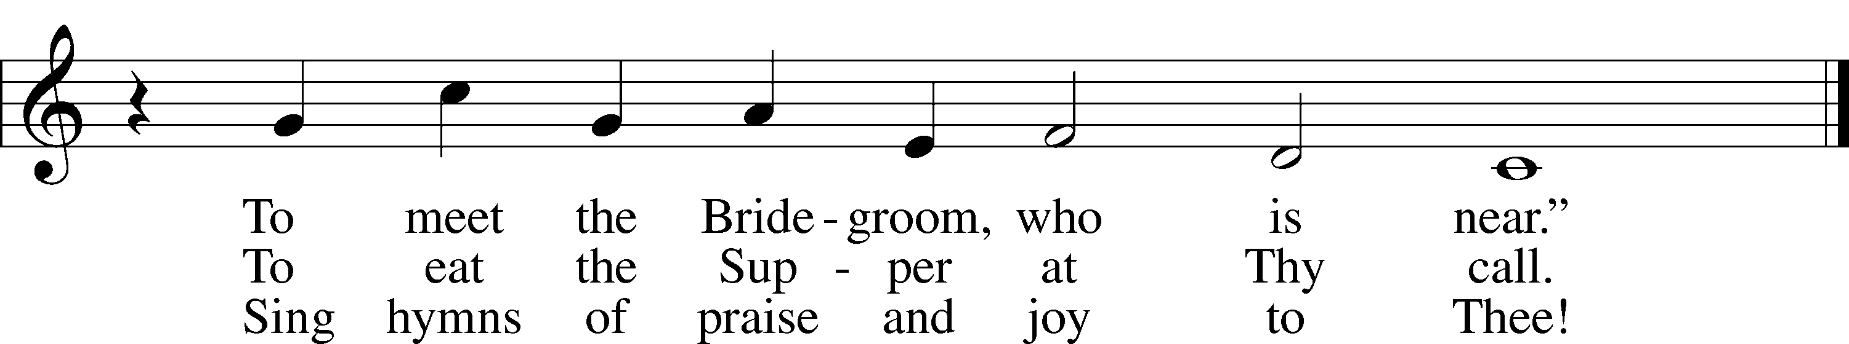
Stand

Confession and Absolution
The sign of the cross may be made by all in remembrance of their Baptism.

P In the name of the Father and of the T Son and of the Holy Spirit.
C Amen.

P If we say we have no sin, we deceive ourselves, and the truth is not in us.
C But if we confess our sins, God, who is faithful and just, will forgive our sins and cleanse us from all unrighteousness.

P Let us then confess our sins to God our Father.
C Most merciful God, we confess that we are by nature sinful and unclean. We have sinned against You in thought, word, and deed, by what we have done and by what we have left undone. We have not loved You with our whole heart; we have not loved our neighbors as ourselves. We justly deserve Your present and eternal punishment. For the sake of Your Son, Jesus Christ, have mercy on us. Forgive us, renew us, and lead us, so that we may delight in Your will and walk in Your ways to the glory of Your holy name. Amen.

P Almighty God in His mercy has given His Son to die for you and for His sake forgives you all your sins. As a called and ordained servant of Christ, and by His authority, I therefore forgive you all your sins in the name of the Father and of the T Son and of the Holy Spirit.
C Amen.

Service of the Word

Introit
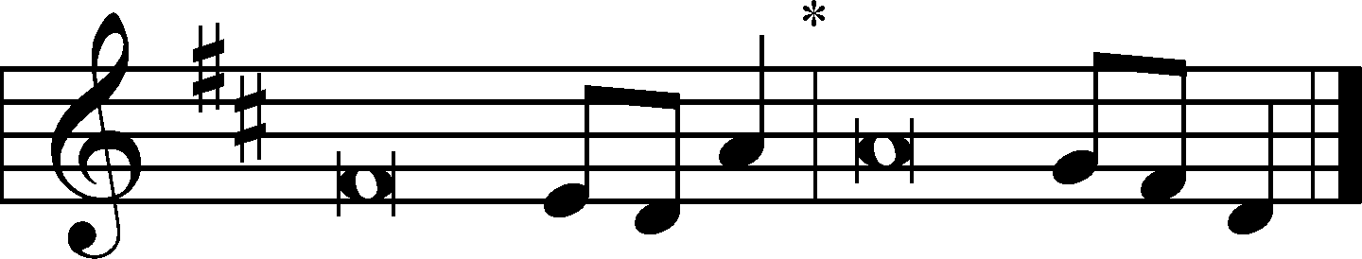
P Even the sparrow finds a home, and the swallow a nest for herself, where she may | lay her young,*
at your altars, O Lord of hosts, my King | and my God.
C How lovely is your | dwelling place,*
O | Lord of hosts!
P Behold our shield, | O God;*
look on the face of your a- | nointed!
C For a day in your courts is better than a thousand | elsewhere.*
I would rather be a doorkeeper in the house of my God than dwell in the tents of | wickedness.
P For the Lord God is a sun and shield; the Lord bestows favor and | honor.*
No good thing does he withhold from those who walk up- | rightly.
C O | Lord of hosts,*
blessèd is the one who | trusts in you!
All: Glory be to the Father and | to the Son*
and to the Holy | Spirit;
as it was in the be- | ginning,*
is now, and will be forever. | Amen.
P Even the sparrow finds a home, and the swallow a nest for herself, where she may | lay her young,*
at your altars, O Lord of hosts, my King | and my God.

Kyrie LSB 168
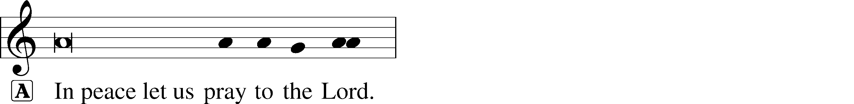
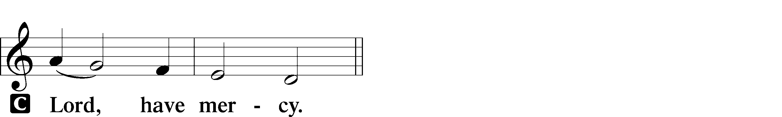

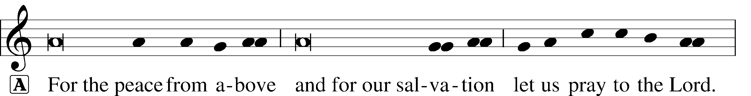
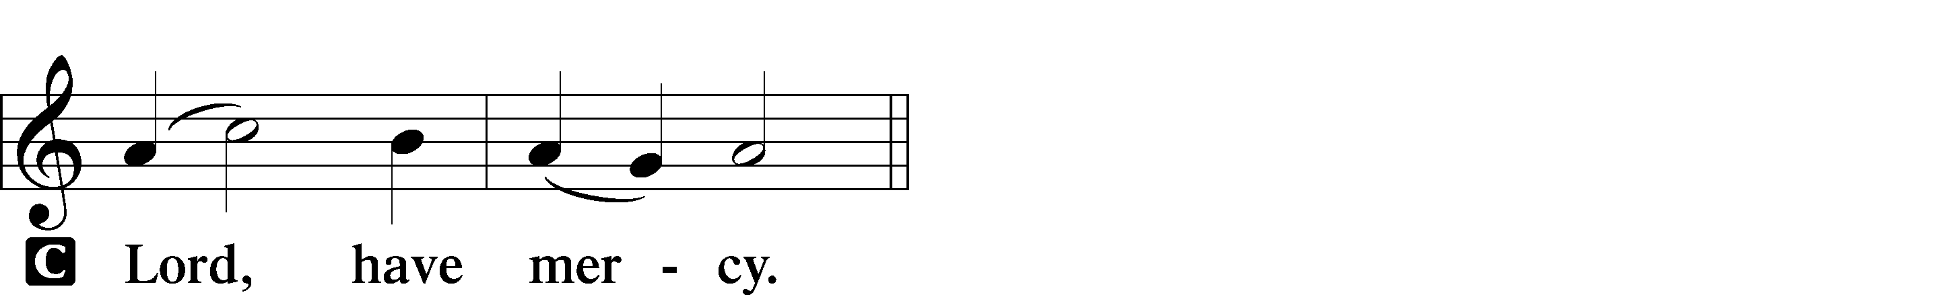

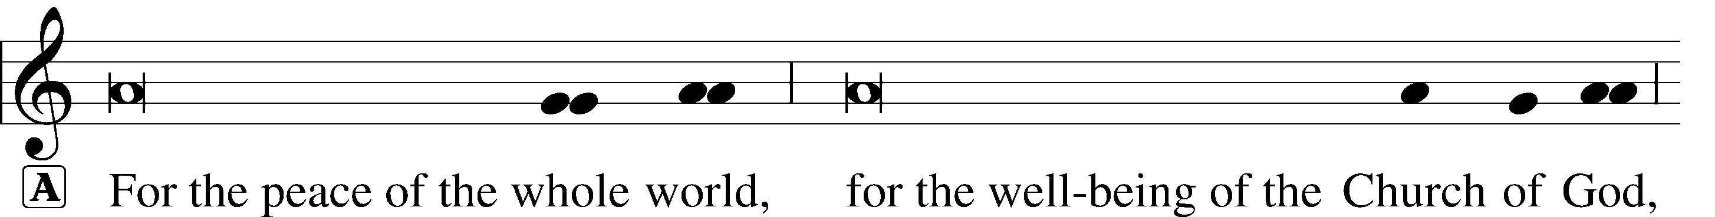
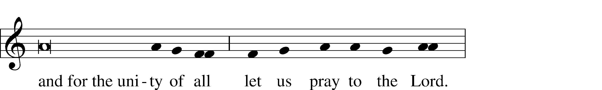
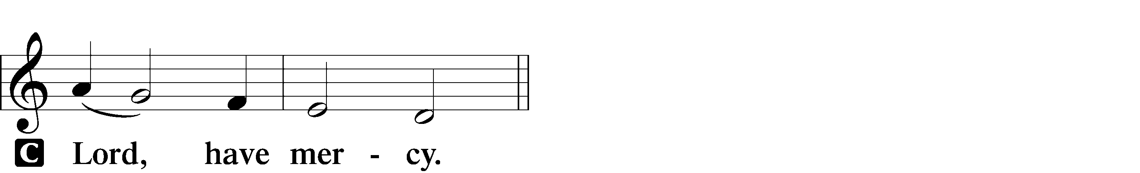

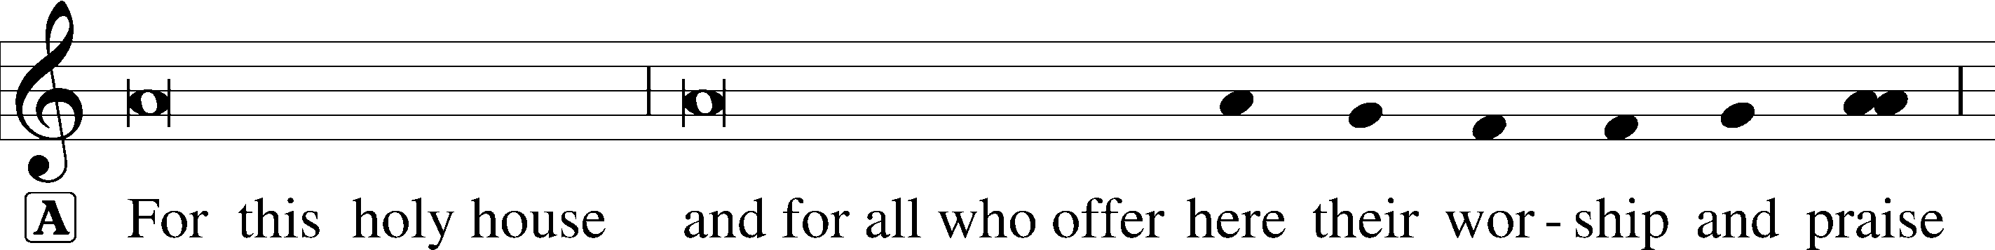
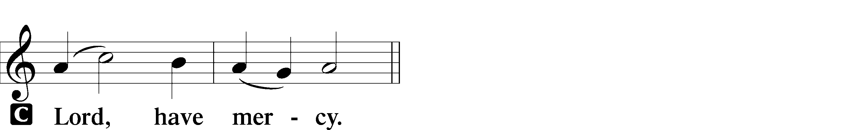

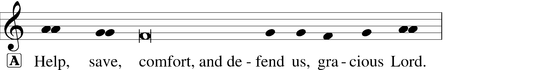
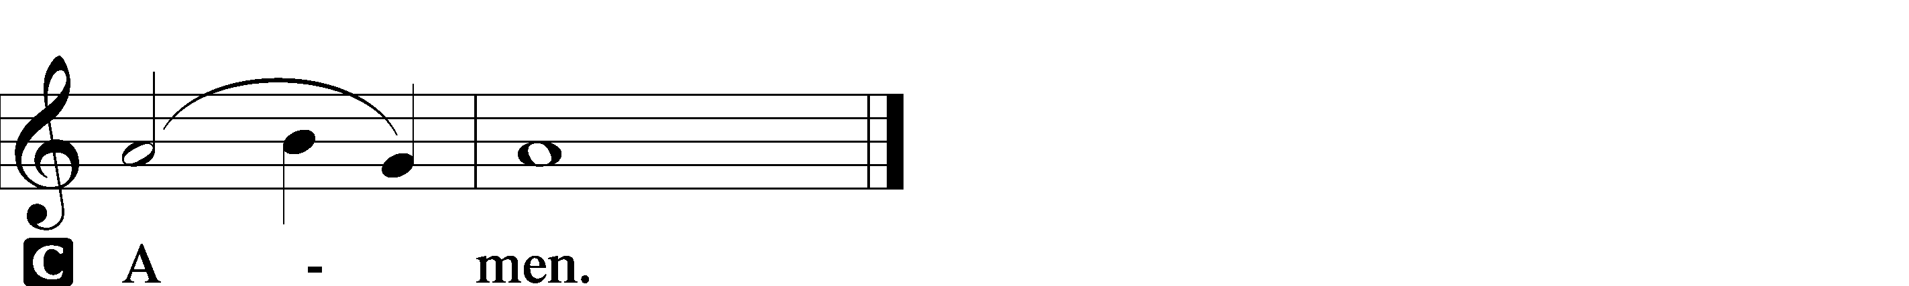

This Is the Feast LSB 171

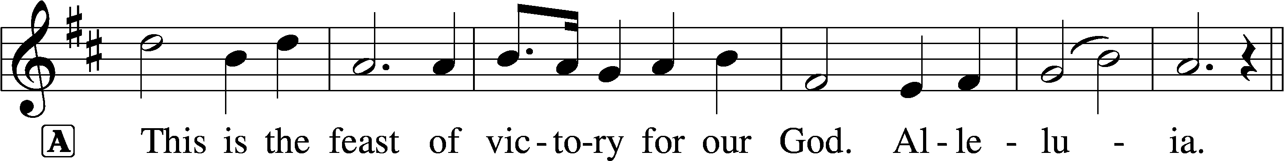
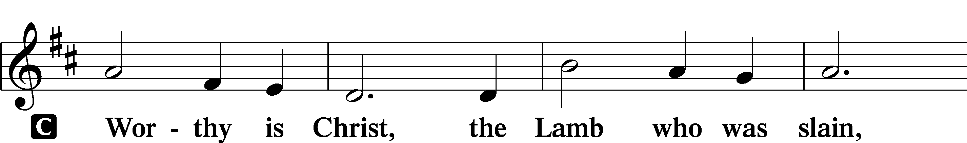
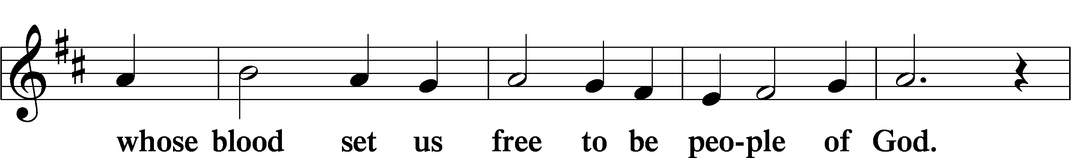
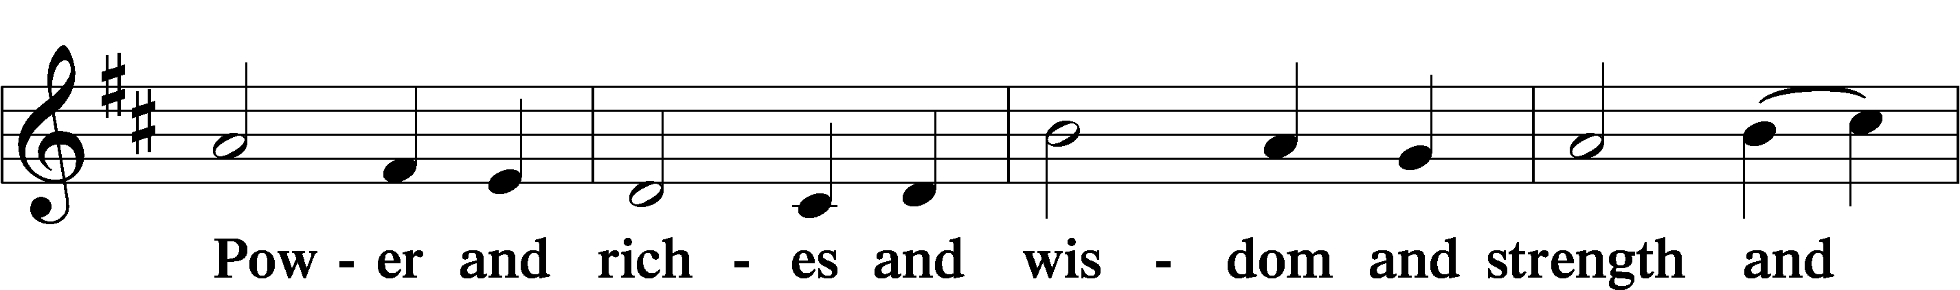
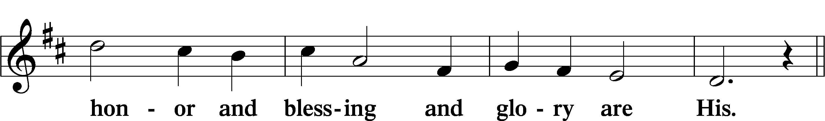
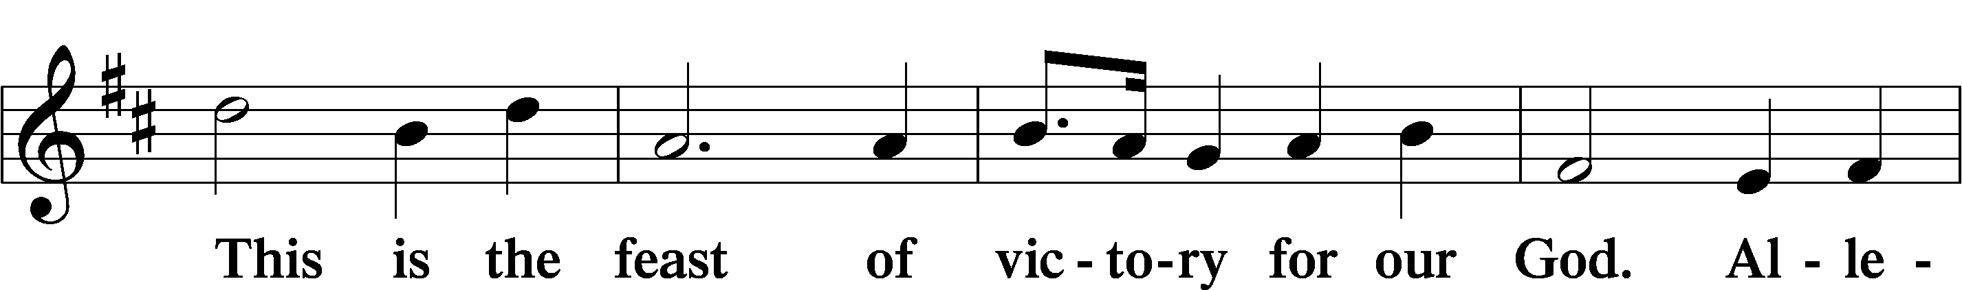
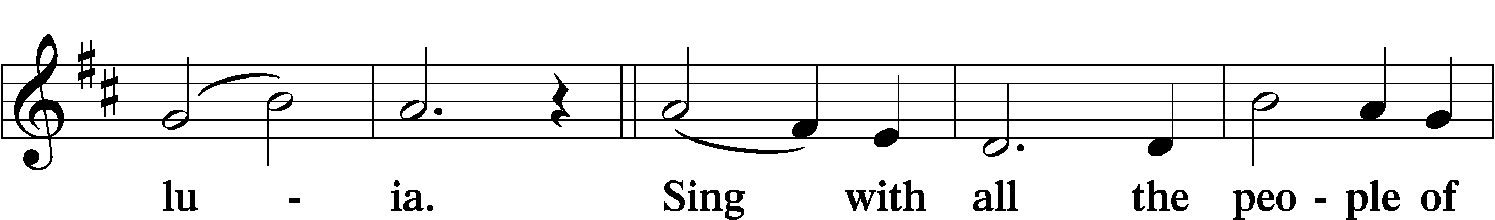
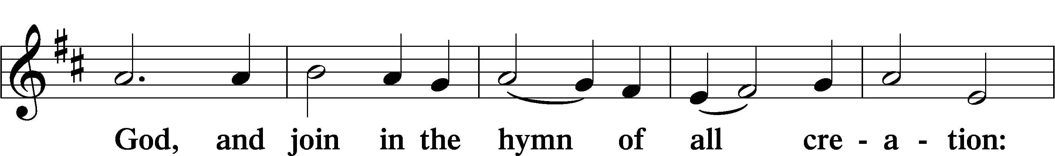
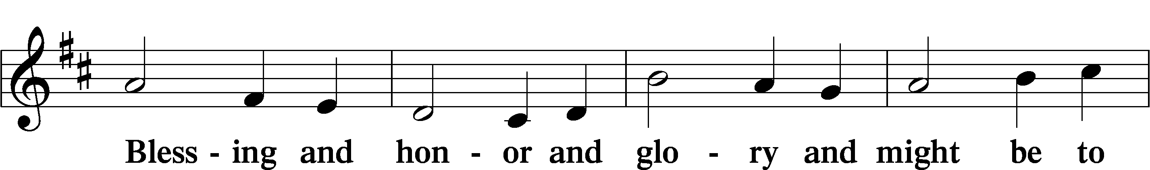
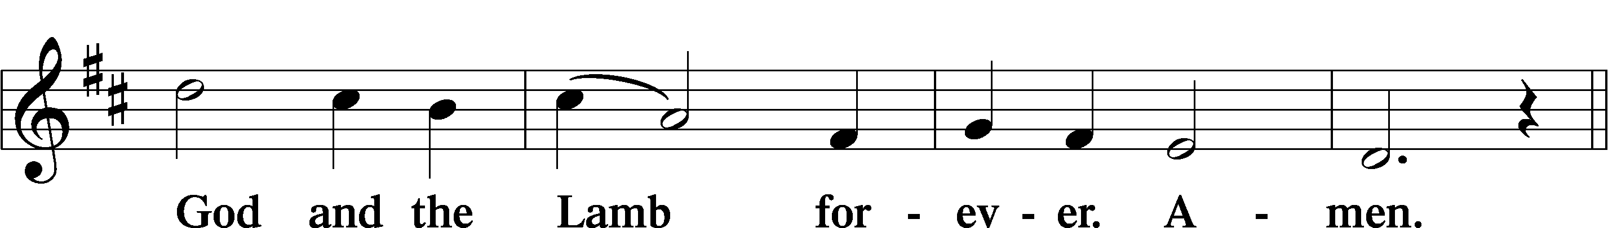
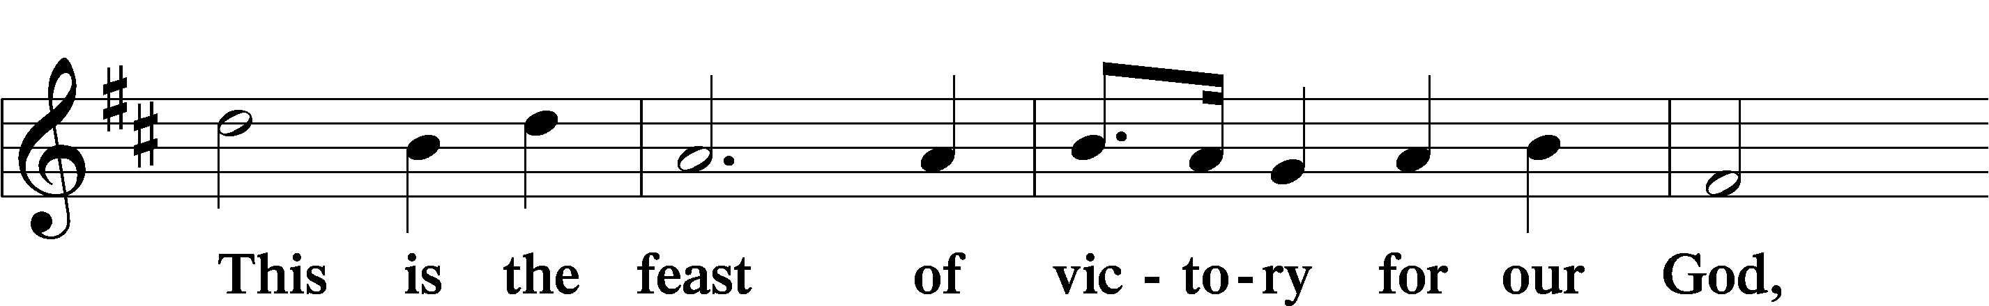
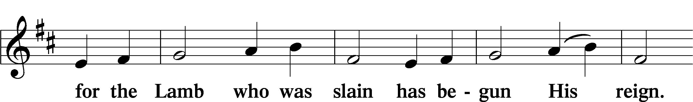
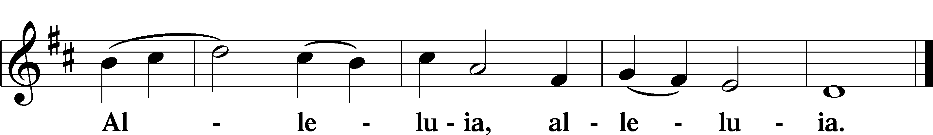

Salutation and Collect of the Day

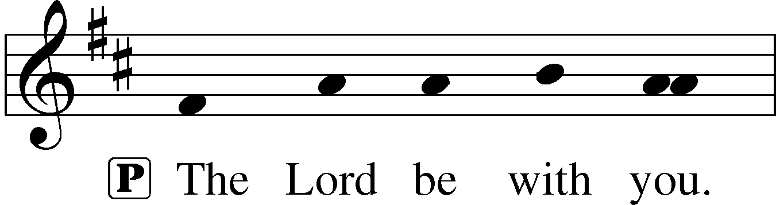
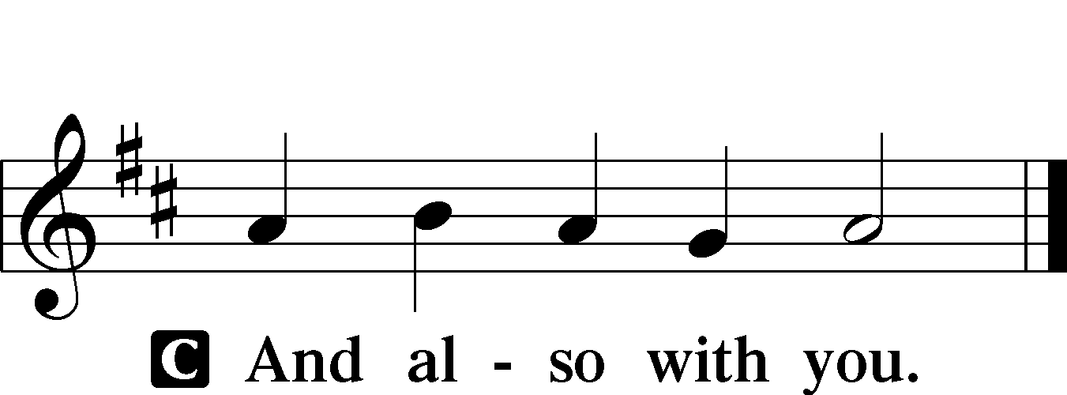

P Let us pray.
Lord God, heavenly Father, send forth Your Son to lead home His bride, the Church, that with all the company of the redeemed we may finally enter into His eternal wedding feast; through the same Jesus Christ, our Lord, who lives and reigns with You and the Holy Spirit, one God, now and forever.

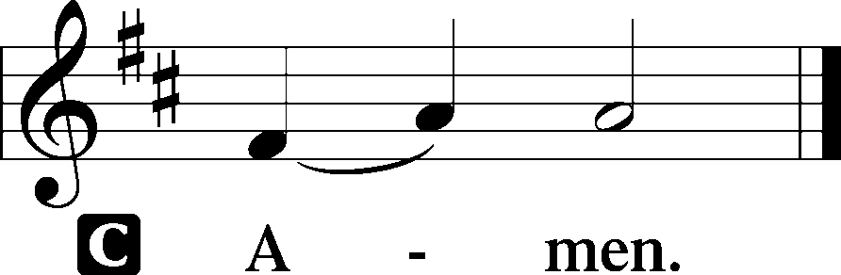

Sit

Old Testament Reading Amos 5:18–24
Woe to you who desire the day of the Lord!
Why would you have the day of the Lord?
It is darkness, and not light,
as if a man fled from a lion,
and a bear met him,
or went into the house and leaned his hand against the wall,
and a serpent bit him.
Is not the day of the Lord darkness, and not light,
and gloom with no brightness in it?
“I hate, I despise your feasts,
and I take no delight in your solemn assemblies.
Even though you offer me your burnt offerings and grain offerings,
I will not accept them;
and the peace offerings of your fattened animals,
I will not look upon them.
Take away from me the noise of your songs;
to the melody of your harps I will not listen.
But let justice roll down like waters,
and righteousness like an ever-flowing stream.”
A This is the Word of the Lord.
C Thanks be to God.

Gradual
P These are the ones coming out of the great tribu- | lation.*
They have washed their robes and made them white in the blood | of the Lamb.
Blessèd are those whose strength is | in you,*
in whose heart are the highways to | Zion.

Epistle 1 Thessalonians 4:13–18
But we do not want you to be uninformed, brothers, about those who are asleep, that you may not grieve as others do who have no hope. For since we believe that Jesus died and rose again, even so, through Jesus, God will bring with him those who have fallen asleep. For this we declare to you by a word from the Lord, that we who are alive, who are left until the coming of the Lord, will not precede those who have fallen asleep. For the Lord himself will descend from heaven with a cry of command, with the voice of an archangel, and with the sound of the trumpet of God. And the dead in Christ will rise first. Then we who are alive, who are left, will be caught up together with them in the clouds to meet the Lord in the air, and so we will always be with the Lord. Therefore encourage one another with these words.

A This is the Word of the Lord.
C Thanks be to God.

Stand

Alleluia and Verse LSB 173

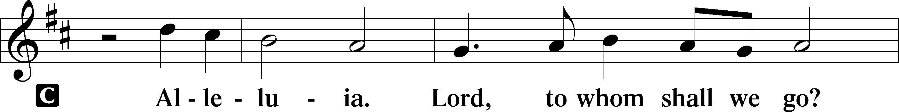
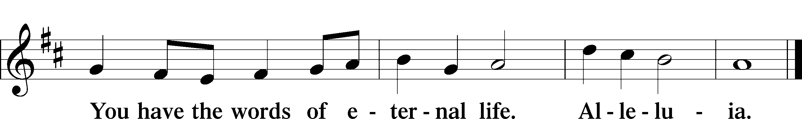

Holy Gospel Matthew 25:1–13

P The Holy Gospel according to St. Matthew, the twenty-fifth chapter.

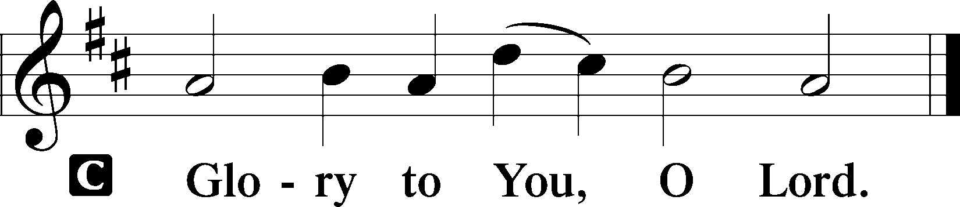

[Jesus said:] “The kingdom of heaven will be like ten virgins who took their lamps and went to meet the bridegroom. Five of them were foolish, and five were wise. For when the foolish took their lamps, they took no oil with them, but the wise took flasks of oil with their lamps. As the bridegroom was delayed, they all became drowsy and slept. But at midnight there was a cry, ‘Here is the bridegroom! Come out to meet him.’ Then all those virgins rose and trimmed their lamps. And the foolish said to the wise, ‘Give us some of your oil, for our lamps are going out.’ But the wise answered, saying, ‘Since there will not be enough for us and for you, go rather to the dealers and buy for yourselves.’ And while they were going to buy, the bridegroom came, and those who were ready went in with him to the marriage feast, and the door was shut. Afterward the other virgins came also, saying, ‘Lord, lord, open to us.’ But he answered, ‘Truly, I say to you, I do not know you.’ Watch therefore, for you know neither the day nor the hour.”

P This is the Gospel of the Lord.

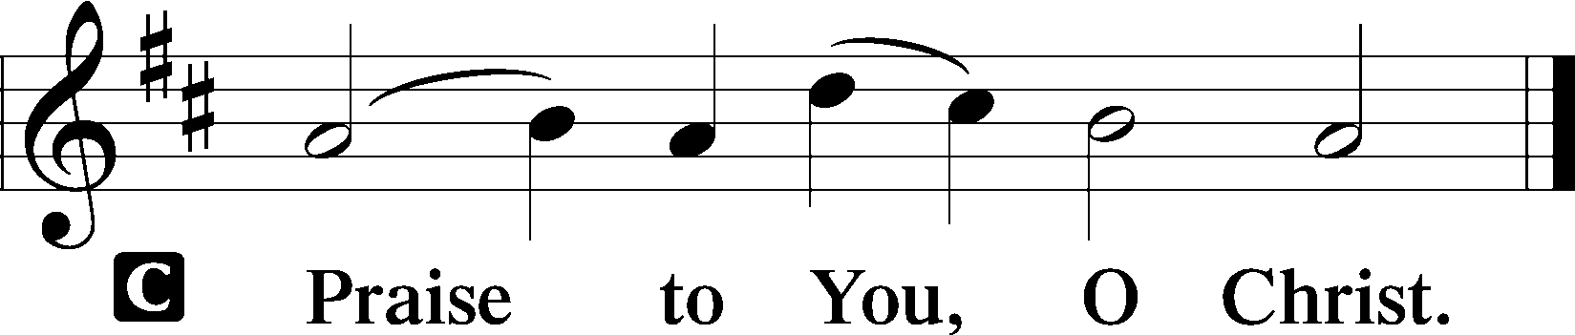

Sit

Hymn of the Day -- The Bridegroom Soon Will Call Us LSB 514
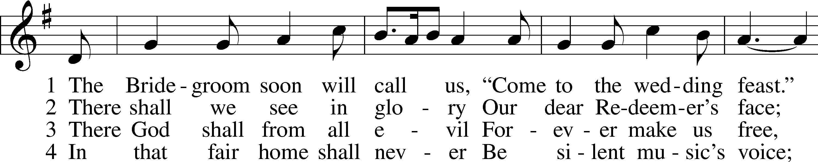
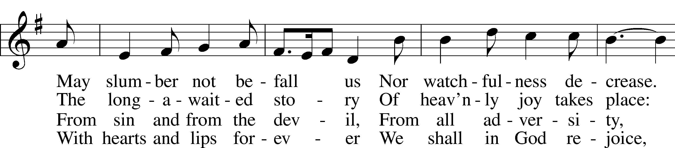
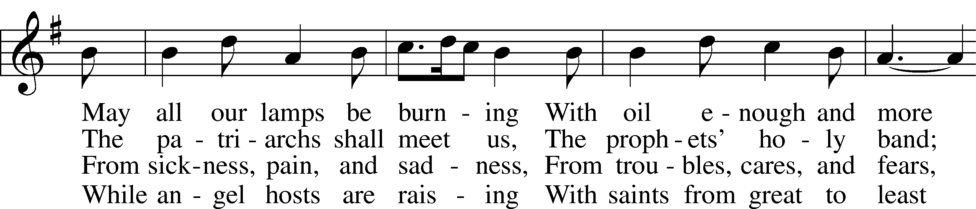
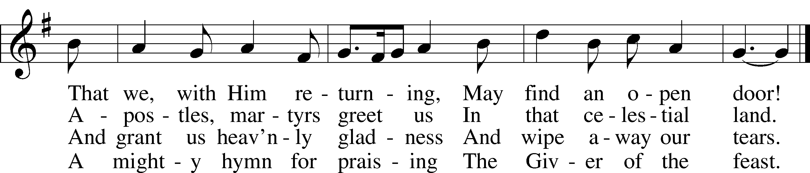
Tune and text: Public domain
Text (st. 1): © 1982 Concordia Publishing House. Used by permission: LSB Hymn License no. 110003539

Sermon

Stand

Nicene Creed
C I believe in one God,
the Father Almighty,
maker of heaven and earth
and of all things visible and invisible.

And in one Lord Jesus Christ,
the only-begotten Son of God,
begotten of His Father before all worlds,
God of God, Light of Light,
very God of very God,
begotten, not made,
being of one substance with the Father,
by whom all things were made;
who for us men and for our salvation came down from heaven
and was incarnate by the Holy Spirit of the virgin Mary
and was made man;
and was crucified also for us under Pontius Pilate.
He suffered and was buried.
And the third day He rose again according to the Scriptures
and ascended into heaven
and sits at the right hand of the Father.
And He will come again with glory to judge both the living and the dead,
whose kingdom will have no end.

And I believe in the Holy Spirit,
the Lord and giver of life,
who proceeds from the Father and the Son,
who with the Father and the Son together is worshiped and glorified,
who spoke by the prophets.
And I believe in one holy Christian and apostolic Church,
I acknowledge one Baptism for the remission of sins,
and I look for the resurrection of the dead
and the life T of the world to come. Amen.

Prayer of the Church
P Lord, You are our help and deliverer and to You we bring the prayers and petitions of Your people, that You may grant to us all things good and needful and guard us against all things evil and harmful.

Brief silence

That the Lord would rule over the darkness and shine His light over all the earth, that those from many nations may be united as one people through Baptism and live together in faith, by the power of the Holy Spirit, let us pray to the Lord:
C Lord, have mercy.

P That the Lord would grant us wisdom and courage, that we may be prepared at all times to receive Him when He comes in His glory and that we may not be distracted by earthly glories that fade away or disillusioned by earthly disappointments, which will come to an end, let us pray to the Lord:
C Lord, have mercy.

P That the Lord would give courage to all pastors as they preach and teach the Word of the Lord, that all those who hear may believe, and that believing, they may live in righteousness and godliness before the world and be kept to the day when Christ returns as Lord and Judge of all, let us pray to the Lord:
C Lord, have mercy.

P That the governments of the world and our leaders would act justly and with mercy, that we may be spared war and violence, and that we may use wisely and for the Lord’s glory His gift of liberty and the abundant blessings He has poured out on our land, let us pray to the Lord:
C Lord, have mercy.

P That the Lord would give aid and comfort to the sick, the suffering and those in their last days, that He may grant healing according to His will and strength to bear up under the weight of loneliness or affliction, [we pray especially for _____________,] let us pray to the Lord:
C Lord, have mercy.

P That we may not grieve as those who have no hope, that we may rejoice in the promise of the resurrection to life everlasting, and that we may encourage one another with these words, [especially the families of _____________,] let us pray to the Lord:
C Lord, have mercy.

P That we may find a home within the house of the Lord here on earth, that we may rejoice in the Lord’s Word and Sacraments by which we are brought to faith and nurtured in this faith, and that we may be sustained in the days of waiting, serving the Lord in anticipation of His return, let us pray to the Lord:
C Lord, have mercy.

P That the Lord would prepare our hearts by His Spirit for this Holy Communion upon the body and blood of our Savior, Jesus Christ, and that we may keep in holy hearts and live out in holy lives what we have received here upon holy lips, let us pray to the Lord:
C Lord, have mercy.

P That we may be ready to receive the Lord when He comes again in glory, that the Lord may open the hearts of those who have wandered away from the faith, and that the Lord may restore those caught up in error’s maze, let us pray to the Lord:
C Lord, have mercy.

P That the Lord may hear and answer the prayers of His people and that we may be content with His answer, trusting in His Fatherly will and wisdom to grant us all that we need and all that will profit our salvation, let us pray in the name of our Savior, Jesus Christ, our Lord.
C Amen.

Offertory LSB 176

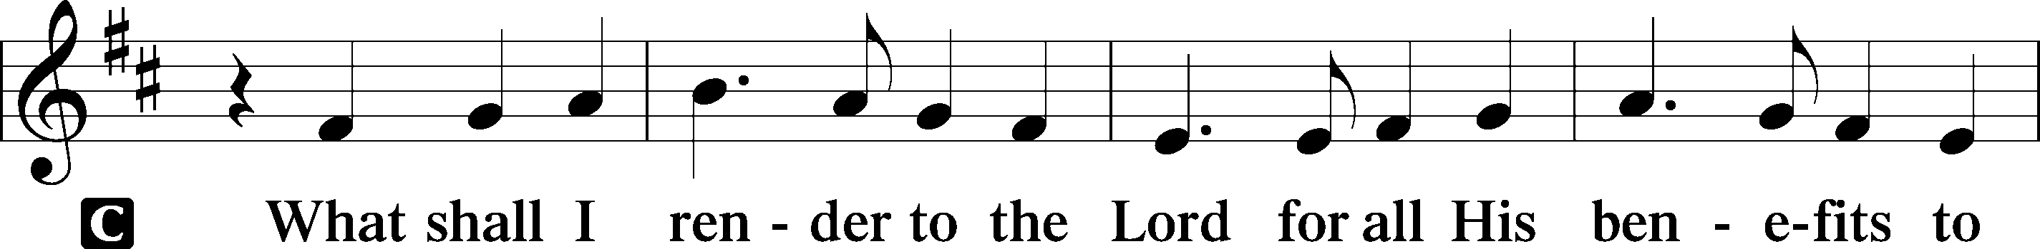
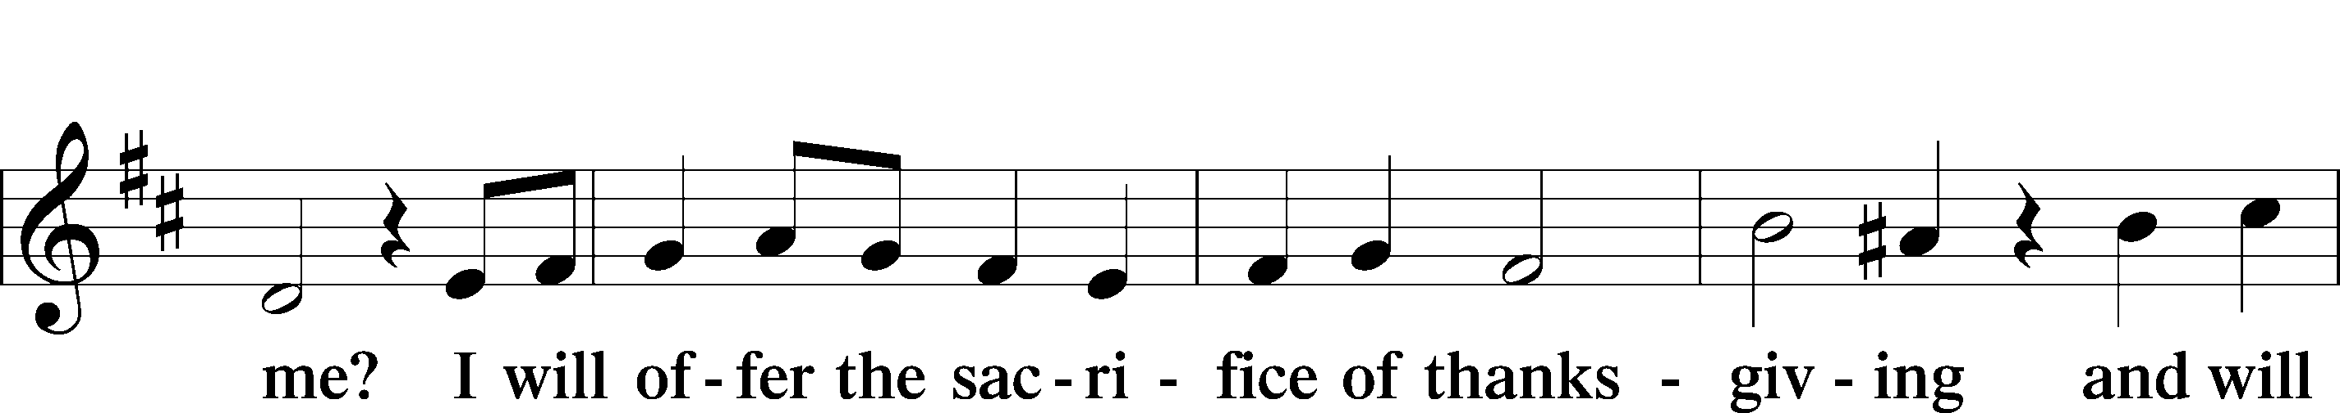
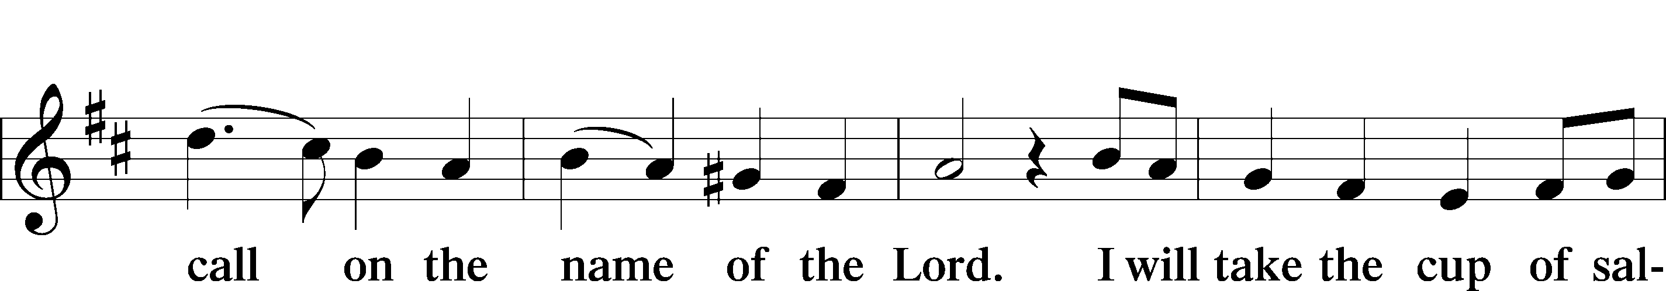
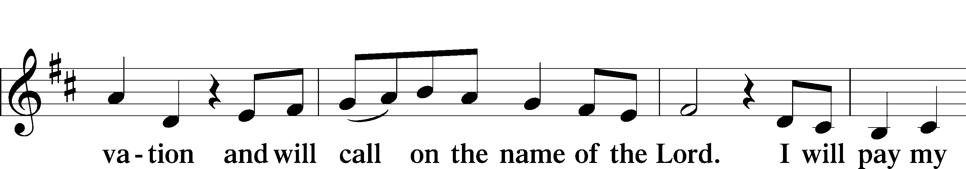
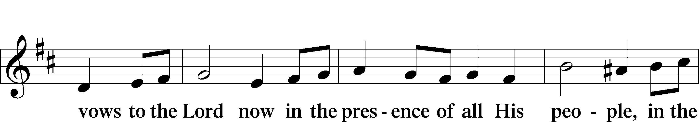
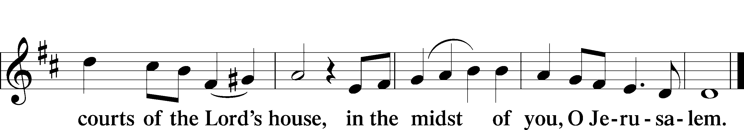

Service of the Sacrament

Preface LSB 177

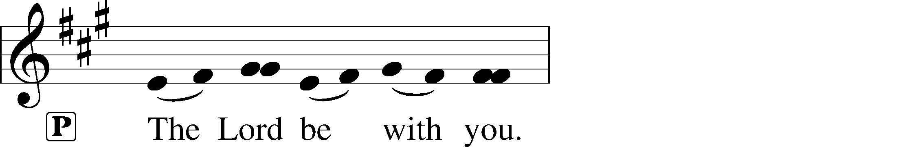
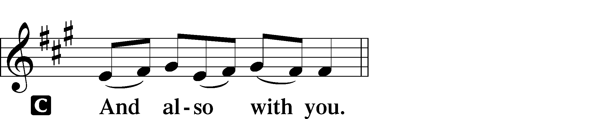

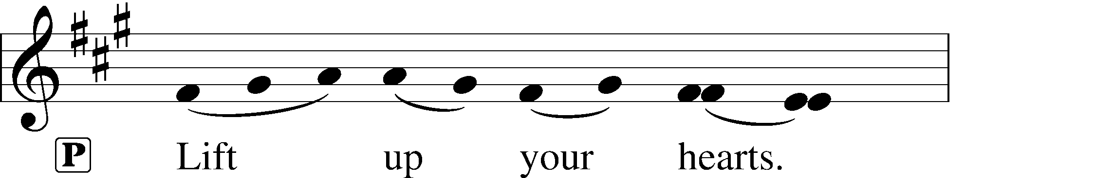
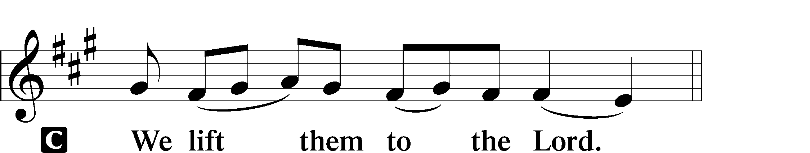

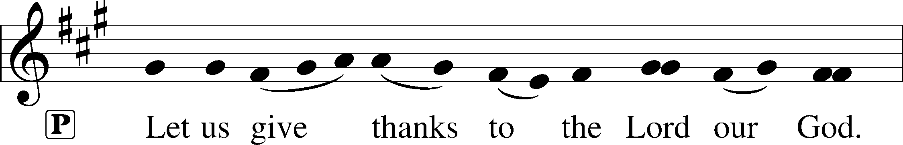
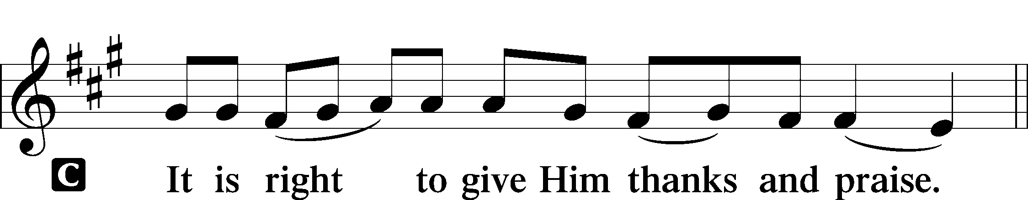

P It is truly good, right, and salutary that we should at all times and in all places give thanks to You, holy Lord, almighty Father, everlasting God, through Jesus Christ, our Lord, who on this day overcame death and the grave and by His glorious resurrection opened to us the way of everlasting life. Therefore with angels and archangels and with all the company of heaven we laud and magnify Your glorious name, evermore praising You and saying:

Sanctus LSB 178

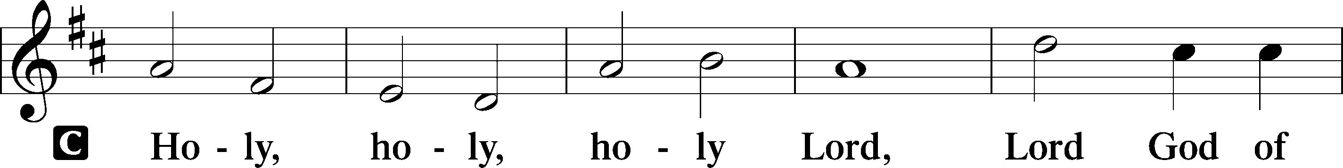
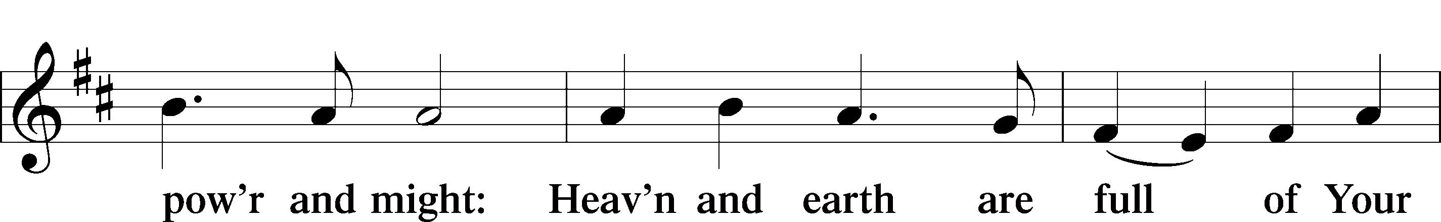
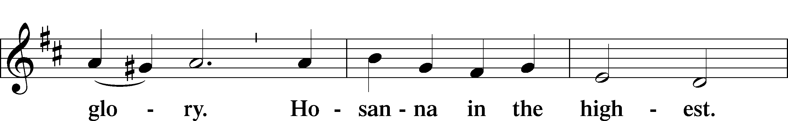
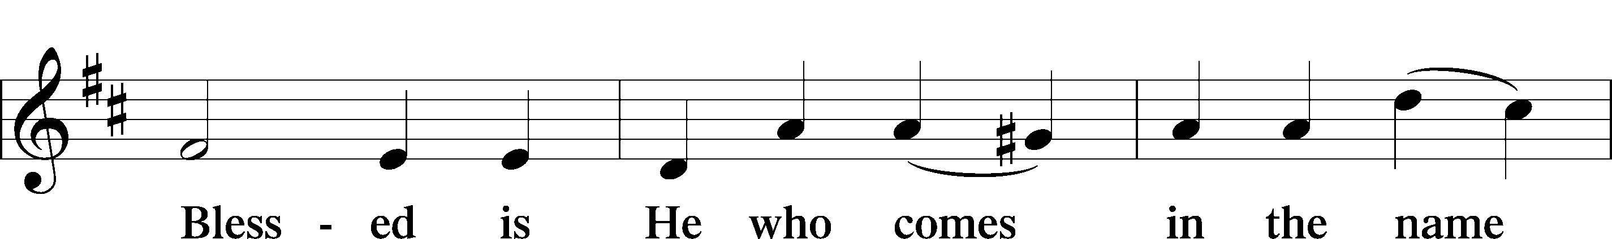
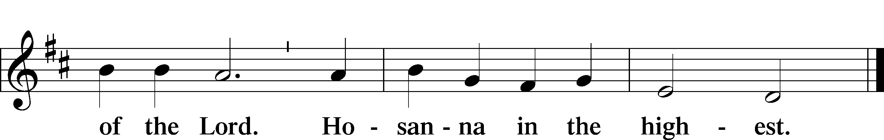

Prayer of Thanksgiving LSB 178

P Blessed are You, Lord of heaven and earth, for You have had mercy on those whom You created and sent Your only-begotten Son into our flesh to bear our sin and be our Savior. With repentant joy we receive the salvation accomplished for us by the all-availing sacrifice of His body and His blood on the cross.

Gathered in the name and the remembrance of Jesus, we beg You, O Lord, to forgive, renew, and strengthen us with Your Word and Spirit. Grant us faithfully to eat His body and drink His blood as He bids us do in His own testament. Gather us together, we pray, from the ends of the earth to celebrate with all the faithful the marriage feast of the Lamb in His kingdom, which has no end. Graciously receive our prayers; deliver and preserve us. To You alone, O Father, be all glory, honor, and worship, with the Son and the Holy Spirit, one God, now and forever.
C Amen.

Lord’s Prayer LSB 179
P Lord, remember us in Your kingdom and teach us to pray:
C Our Father who art in heaven,
hallowed be Thy name,
Thy kingdom come,
Thy will be done on earth
as it is in heaven;
give us this day our daily bread;
and forgive us our trespasses
as we forgive those
who trespass against us;
and lead us not into temptation,
but deliver us from evil.
For Thine is the kingdom
and the power and the glory
forever and ever. Amen.

The Words of Our Lord
P Our Lord Jesus Christ, on the night when He was betrayed, took bread, and when He had given thanks, He broke it and gave it to the disciples and said: “Take, eat; this is My T body, which is given for you. This do in remembrance of Me.”

In the same way also He took the cup after supper, and when He had given thanks, He gave it to them, saying: “Drink of it, all of you; this cup is the new testament in My T blood, which is shed for you for the forgiveness of sins. This do, as often as you drink it, in remembrance of Me.”

Pax Domini LSB 180

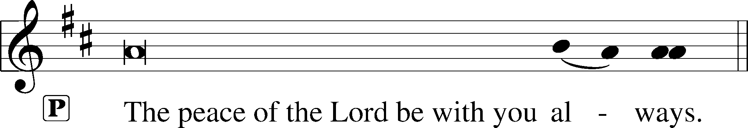
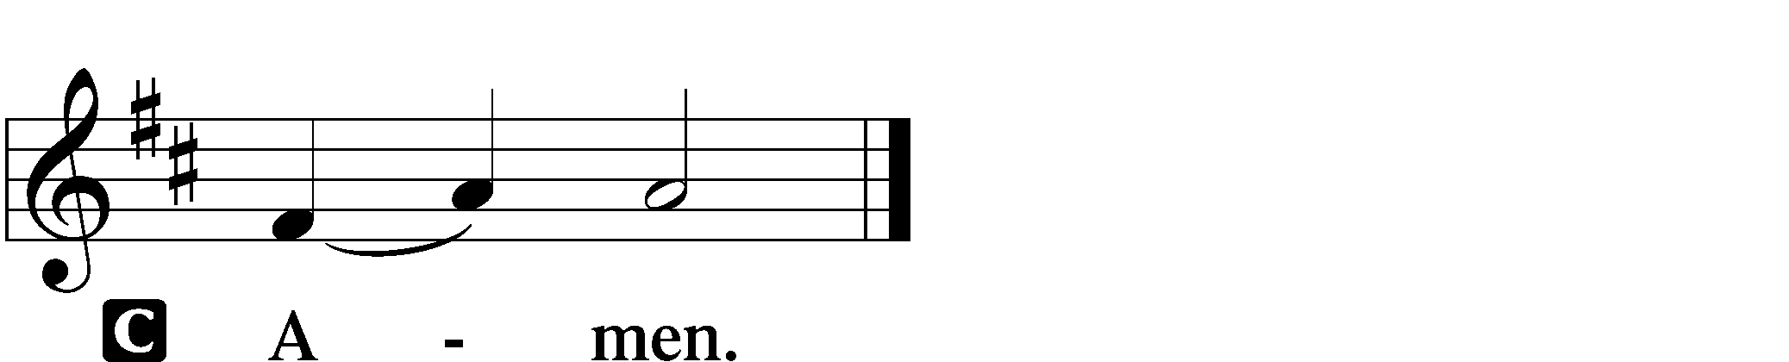

Agnus Dei LSB 180

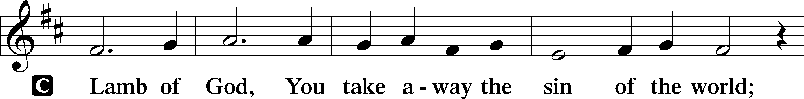
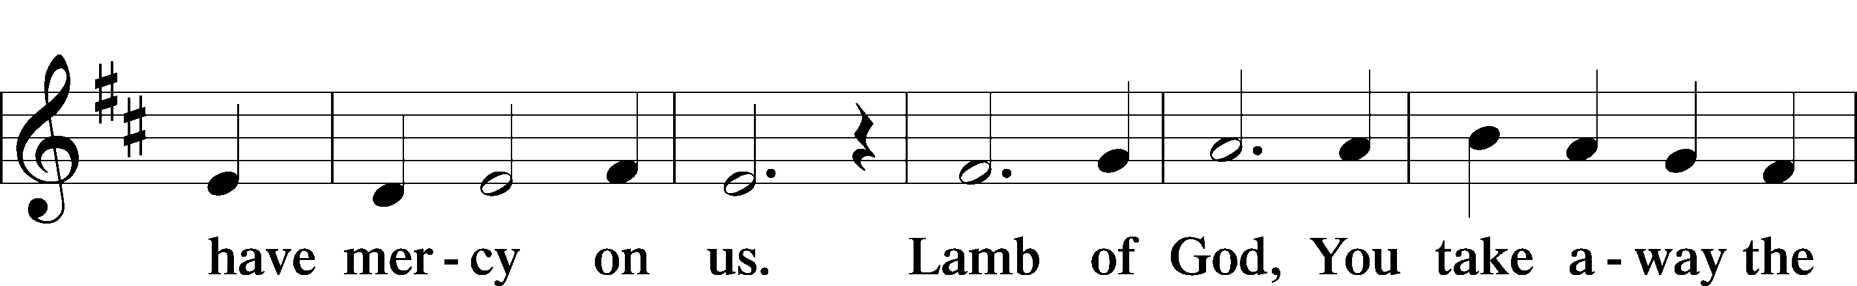
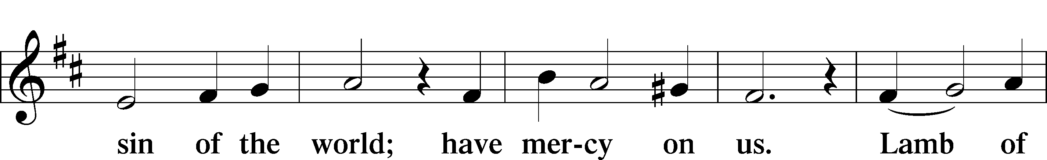
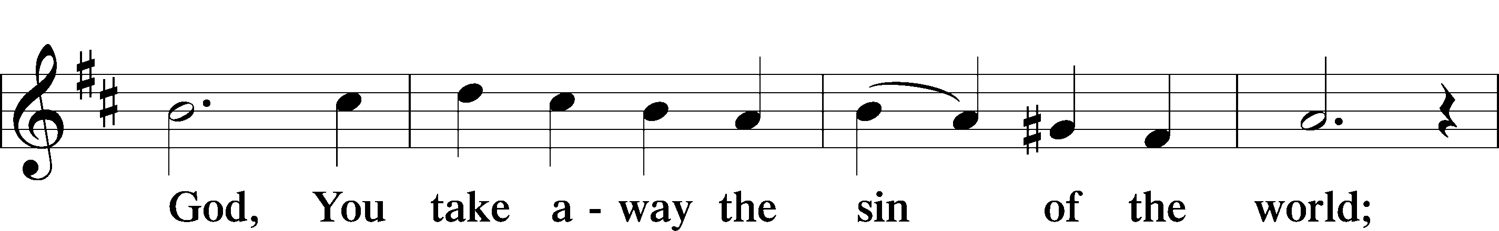
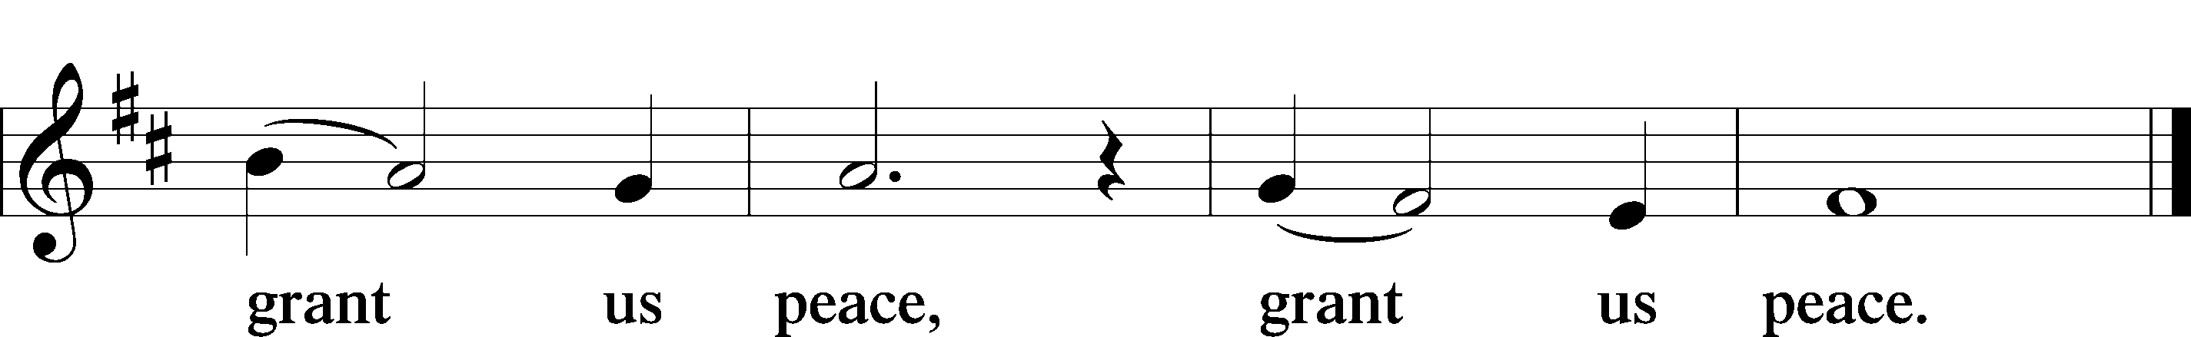

Sit

Distribution

Rejoice, Rejoice, Believers LSB 515

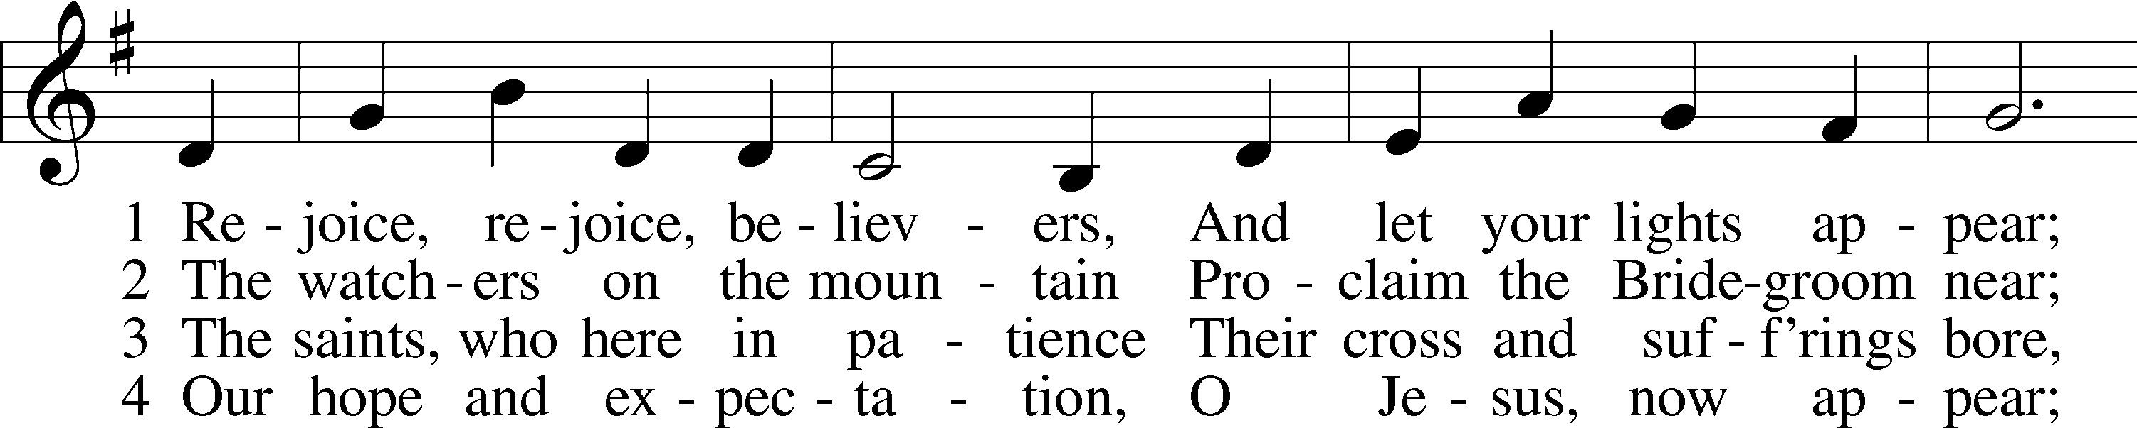
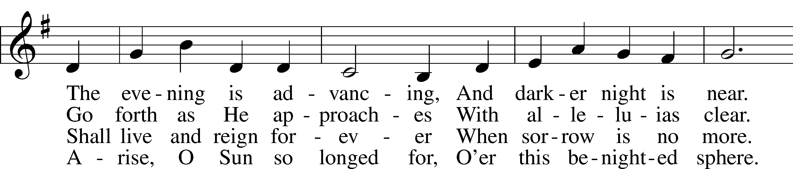
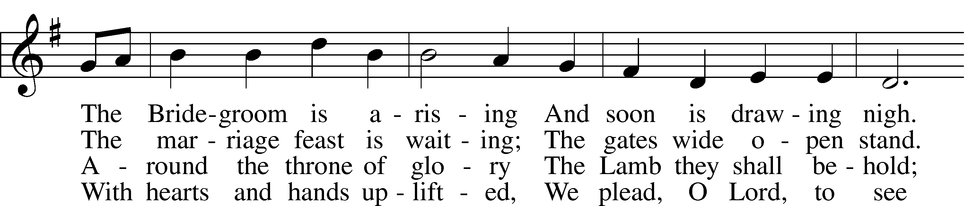
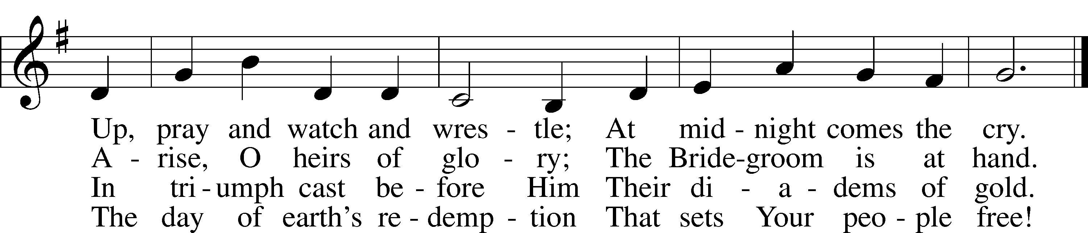
Text and tune: Public domain

Rise, My Soul, to Watch and Pray LSB 663

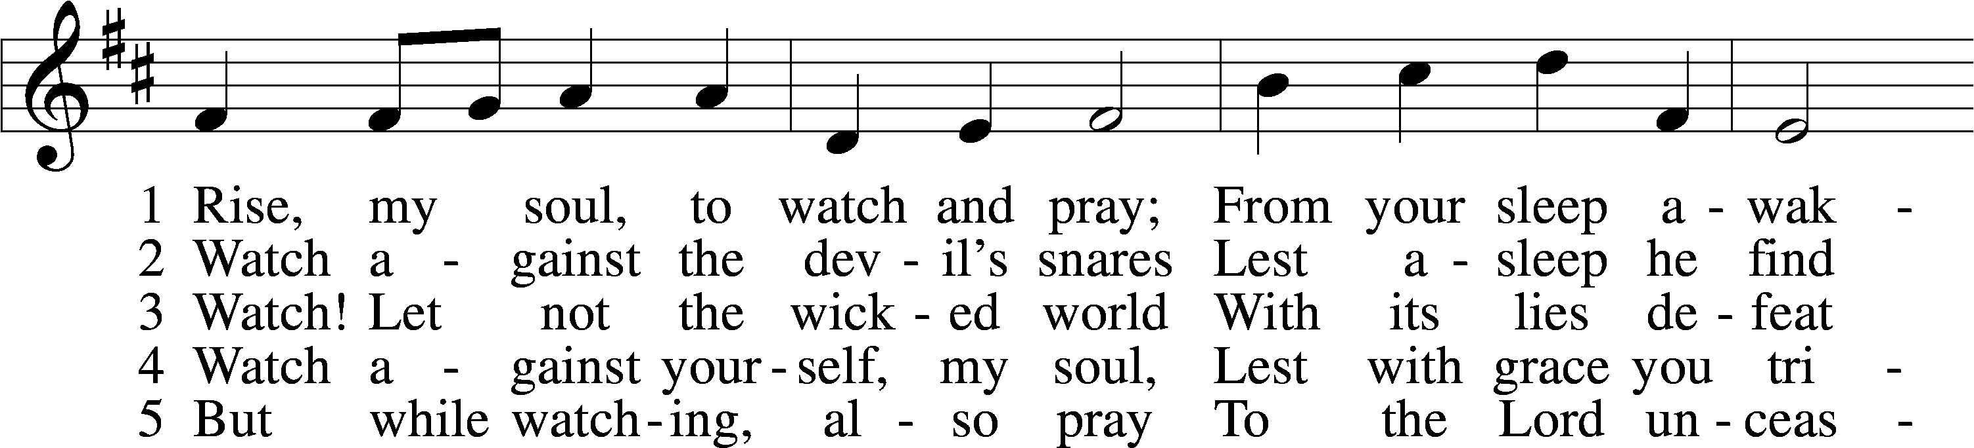
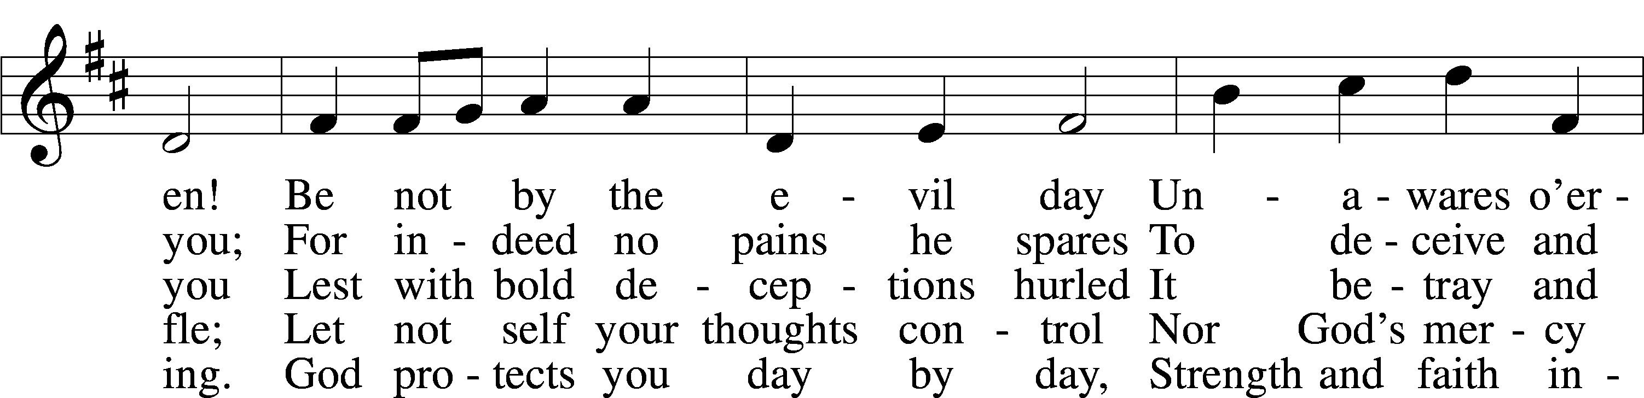
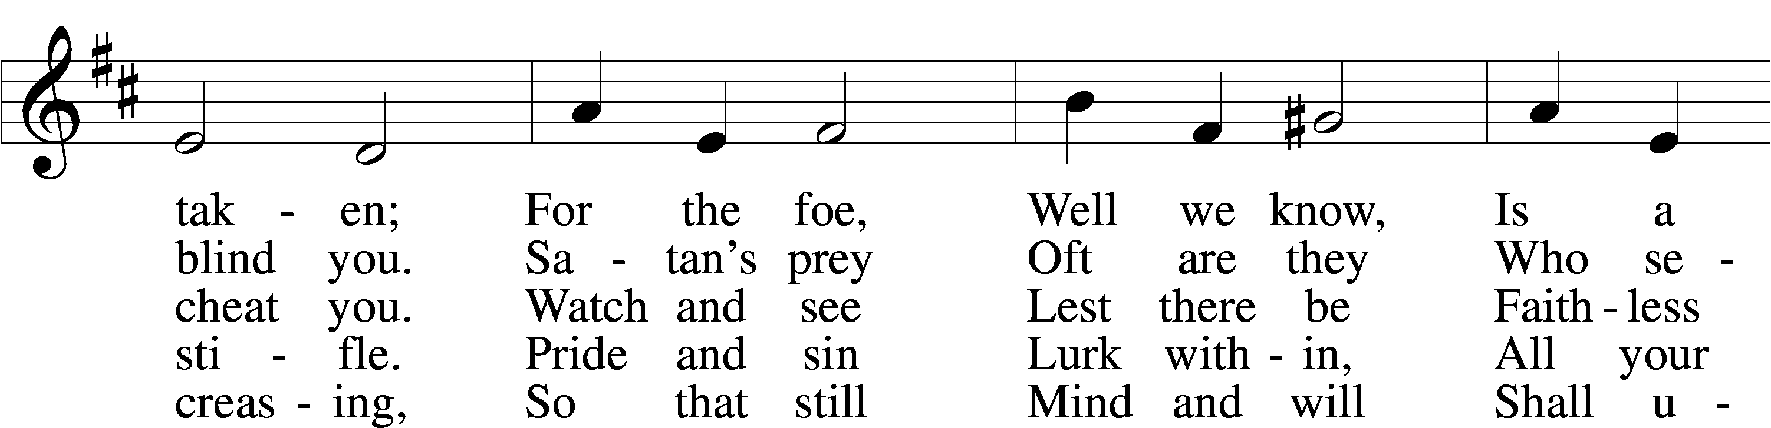
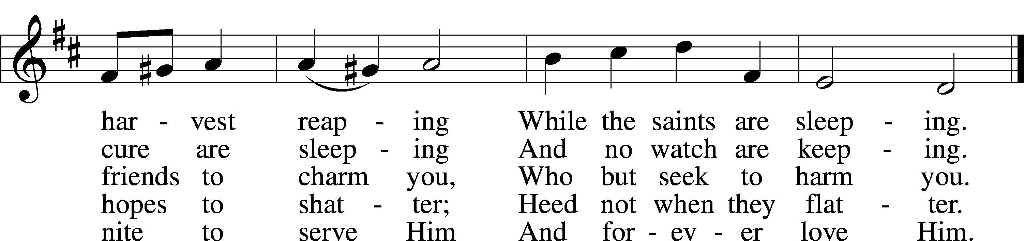
Tune and text: Public domain

In dismissing the communicants, the following is said:

P The body and blood of our Lord Jesus Christ strengthen and preserve you in body and soul to life everlasting. Depart T in peace.
C Amen.

Stand

Nunc Dimittis LSB 182

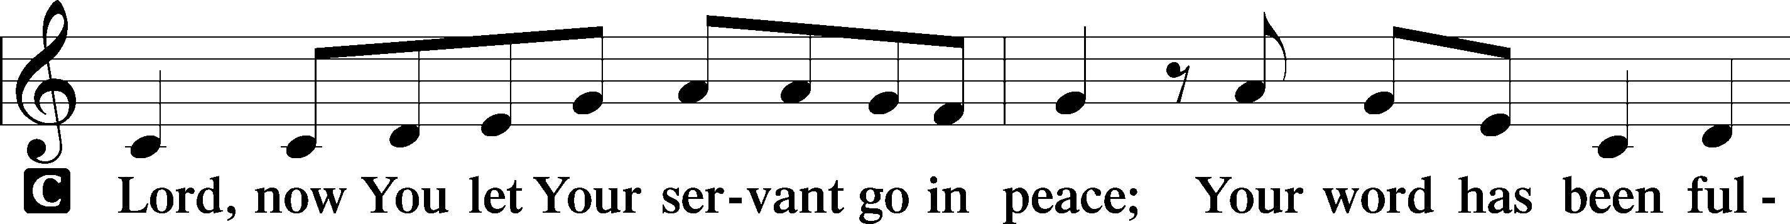
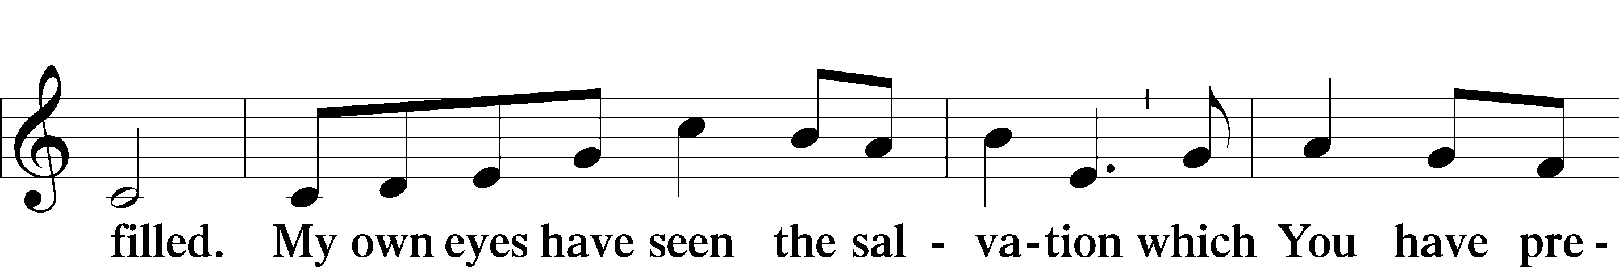
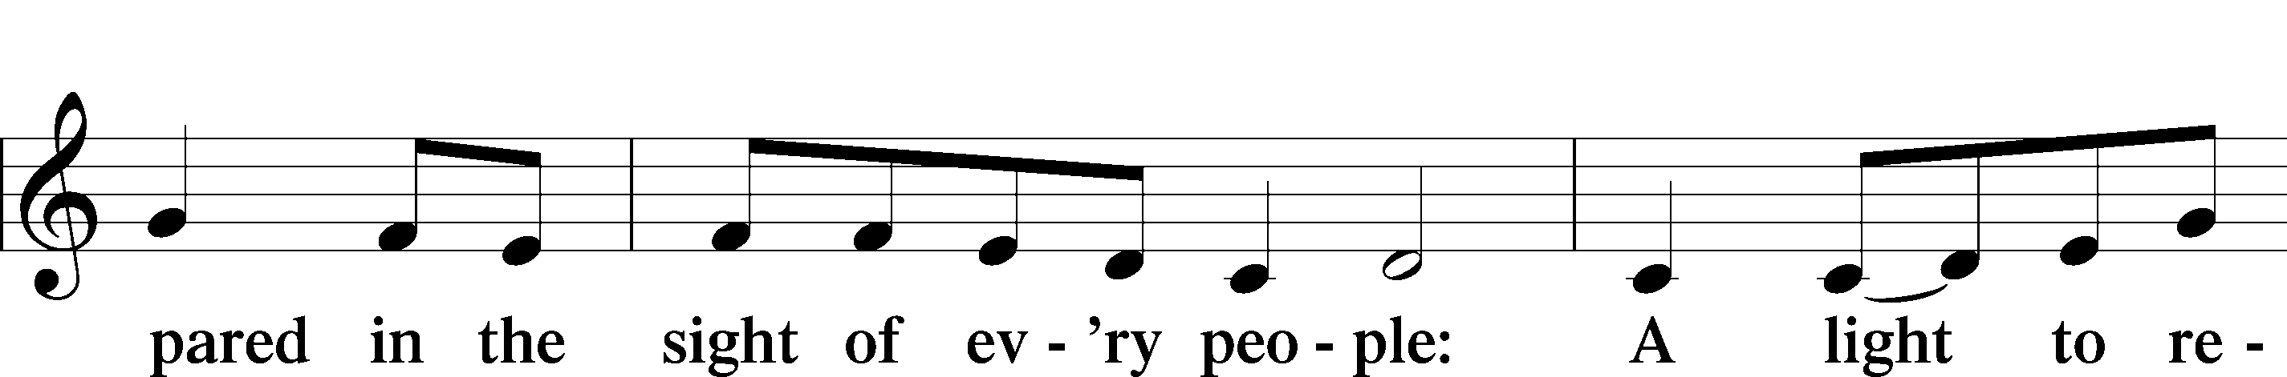
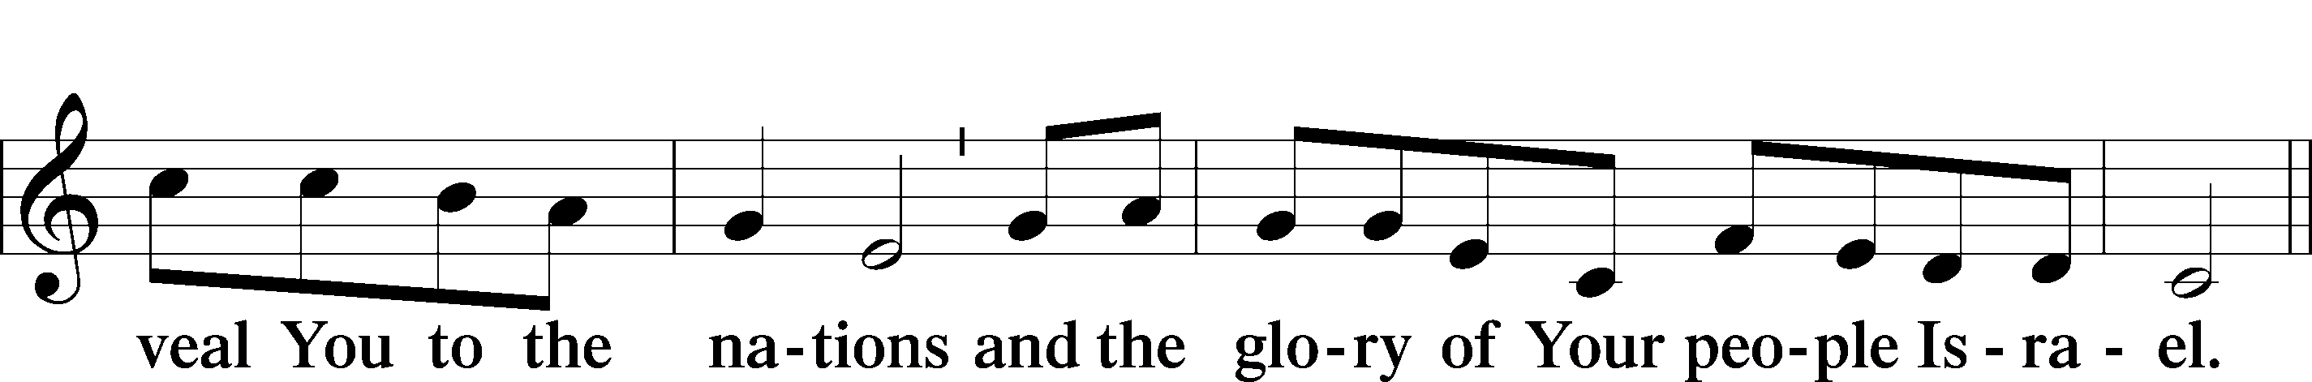
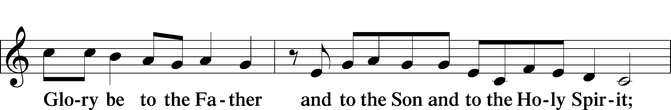
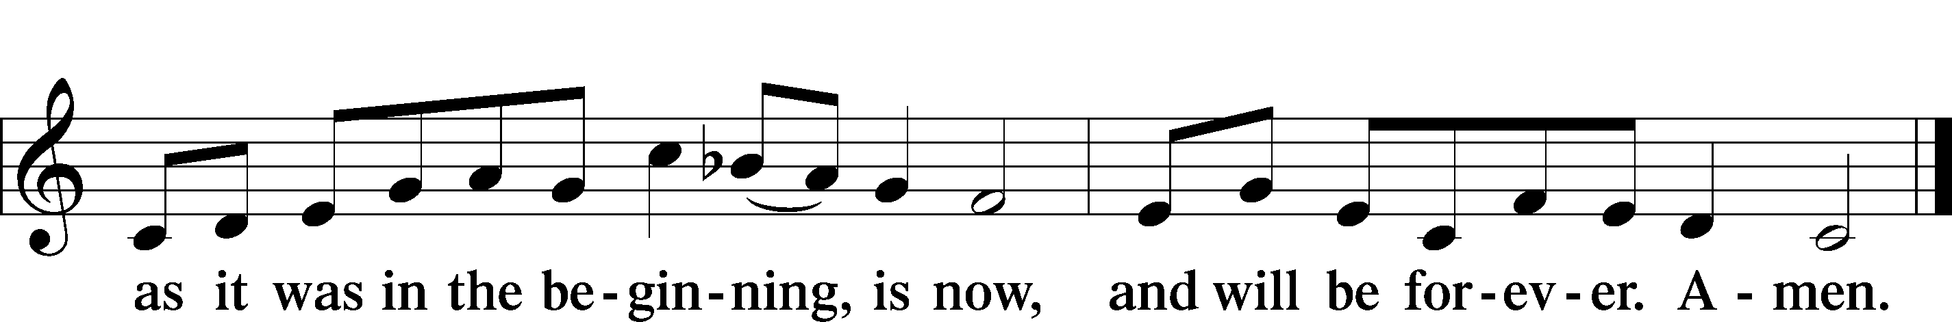

Post-Communion Collect
A Let us pray.
Gracious God, our heavenly Father, You have given us a foretaste of the feast to come in the Holy Supper of Your Son’s body and blood. Keep us firm in the true faith throughout our days of pilgrimage that, on the day of His coming, we may, together with all Your saints, celebrate the marriage feast of the Lamb in His kingdom which has no end; through Jesus Christ, Your Son, our Lord, who lives and reigns with You and the Holy Spirit, one God, now and forever.

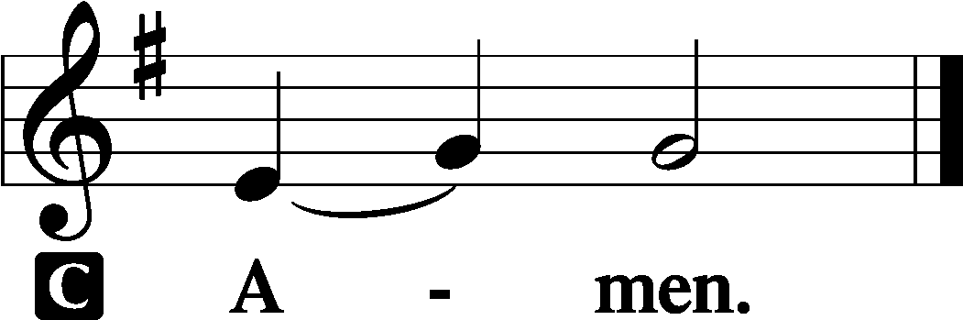
Benediction LSB 183

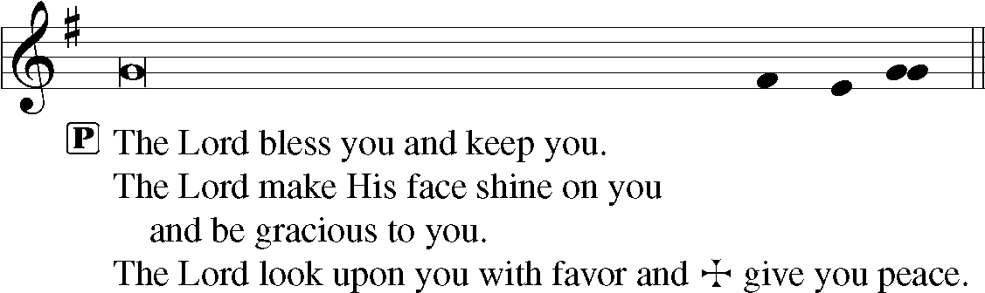

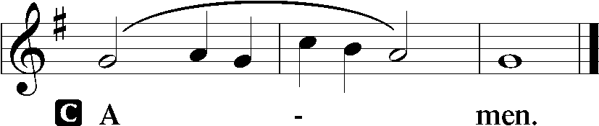

Closing Hymn -- Praise to You and Adoration LSB 692

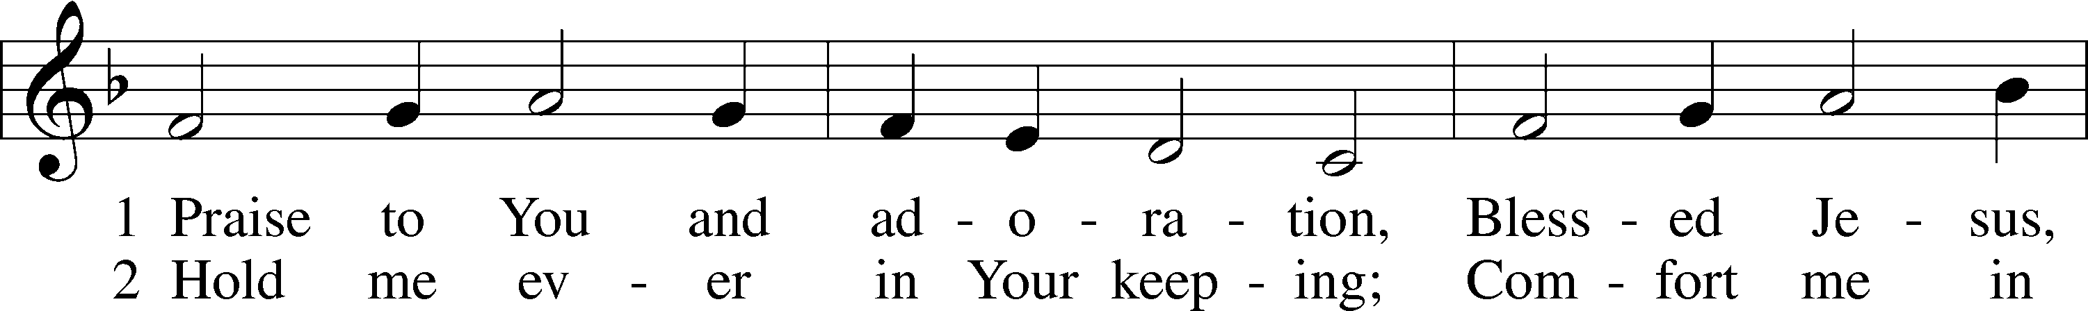
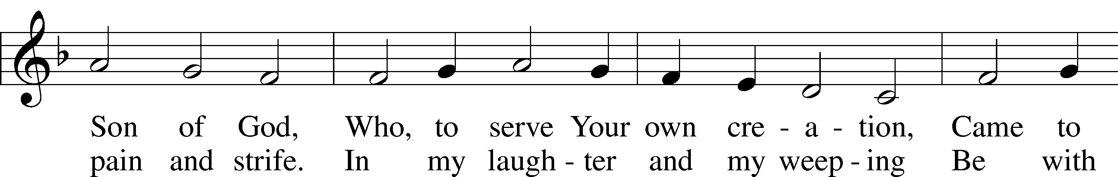
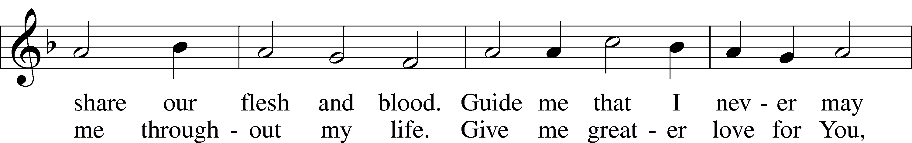
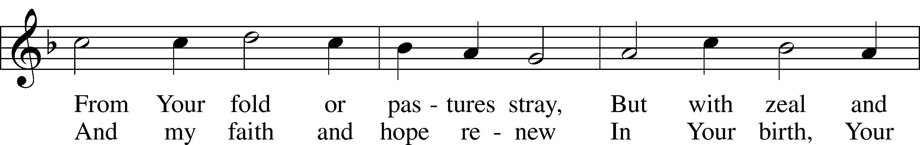
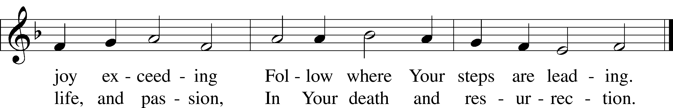
Text and tune: Public domain

Trinity Family Prayer Page
Week of November 8-14, 2020

Name | Information
Carol Etherton | Prayers for healing following a fall, rehabilitation
Sharon Hackley | Prayers for healing & strength
Loretta Morelock | Prayers for healing and strength
Pam Osterloh | Stage 3 kidney disease
Nathan Rader | Prayers for strength-cancer has returned, chemo treatments upcoming
Chuck Rovey | Prayers for strength & continued improvements
Joshua Scheiderer | Thanksgiving for successful hip surgery; continuing rehab for 6 months
Paula Spalding | Recovery from infection
Virginia Sproule | Diagnosed with lung and liver cancer, undergoing treatments
Jerry Williams | Diagnosed with cancer, undergoing treatments
Bernie Zeigler | Prayers for recovery following torn rotator cuff surgery
Friends and Family:
Eli Applegate | Grandson of Ben & Deb Schroeder, treatments for Aplastic Anemia
Marvin Bachtold | Brother of Bernie Zeigler, thyroid and lung cancer, stable, continued monitoring
Rev. Dave Benson | Father of Sarah Buerck, undergoing treatments for lymphoma
Mary Burns | Sister-in-law of John Albert, lost everything in the Oregon fires
Debbie Curtis | Friend of Doug & Michelle Powell, stage 4 lung cancer
Rachel Duff | Daughter-in-law of Ed & Mary Ann Dorris, diagnosed with cancer; chemo & radiation
Dorothy Geyer | Aunt of Paul Schultz, suffering from blood clots in her legs
Mark Johnson | Brother of Diane Lewis, diagnosed with cancer, chemo treatments
Charlie Jones | Father in law of Leslie Jones, diagnosed with throat cancer, undergoing treatments
Mike Jones | Friend of Carl & Linda Oughton, liver cancer, chemo treatments
Vernon Kowalke | Father of Carmen Dorman, continued dialysis
Jim Krieg | Uncle of Mary Brockman, on hospice care at home
Cross Kubik | 16-year-old friend of the Scheer families and many others, cancer treatments at St. Jude
Becky Moyer | Friend of many Trinity members, brain cancer
Georgia Ohly | Friend of Nancy Servis, undergoing treatment for kidney disease
Sandy Reese | Friend of Carmen Boyd, kidney cancer returned, spread, treatments
Jeann Roed | Friend of Terry Wright, unknown cancer, beginning intense chemo treatments
Ian Romano | Nephew (10-yr-old) of Paul Hambrick, T-cell ALL leukemia, stroke, chemo continues
Robert Stillings | Grandson (5 yr old) of Bob & Mary Stillings, home, recovering from appendicitis
Jeremy Summers | Nephew of Ernie Lewis, rare type of bone cancer, tests, treatments
Lin & Kelly Thompson | Uncle & Aunt of Lanie Thompson, COVID-19
Carol Wendel | Grandmother of Tara Barger, successful removal of tumor, no chemo treatments needed
David Westmeyer | Brother of Karen Vaughan, prayers for comfort/strength, late stage Parkinson's Disease
Military: | Major Robert Stillings, currently assigned to the U.S. Cyber Command at Ft. Meade, MD
Bereavement: | For the family of Howard Peters. Please keep Bonnie and the rest of Howard's family in your prayers as they mourn this loss.
Birthdays
Nov. 9 | Pam Osterloh, Joshua Scheiderer
Nov. 10 | Easton Fitzgearlds, Rhonda Penn, Alex Schafer, Laura Snow
Nov. 11 | Emily Fitzgearlds, Ranae Roepke
Nov. 12 | Anna Schultz, Maggie Schultz, Nancy Servis, Grace St. Pierre
Anniversaries
No Anniversaries this week

Baptism Remembrance
Nov. 9 | William Rader
Nov. 10 | Philip Winter
Nov. 11 | Evan Flattem, Zeke Young
Nov. 12 | Matthew Gaede, Ainsley Roesslet
Nov. 14 | Bob Quebbeman

Acknowledgments
Divine Service, Setting Two from Lutheran Service Book
Unless otherwise indicated, Scripture quotations are from the ESV® Bible (The Holy Bible, English Standard Version®), copyright © 2001 by Crossway, a publishing ministry of Good News Publishers. Used by permission. All rights reserved.
Created by Lutheran Service Builder © 2018 Concordia Publishing House.

