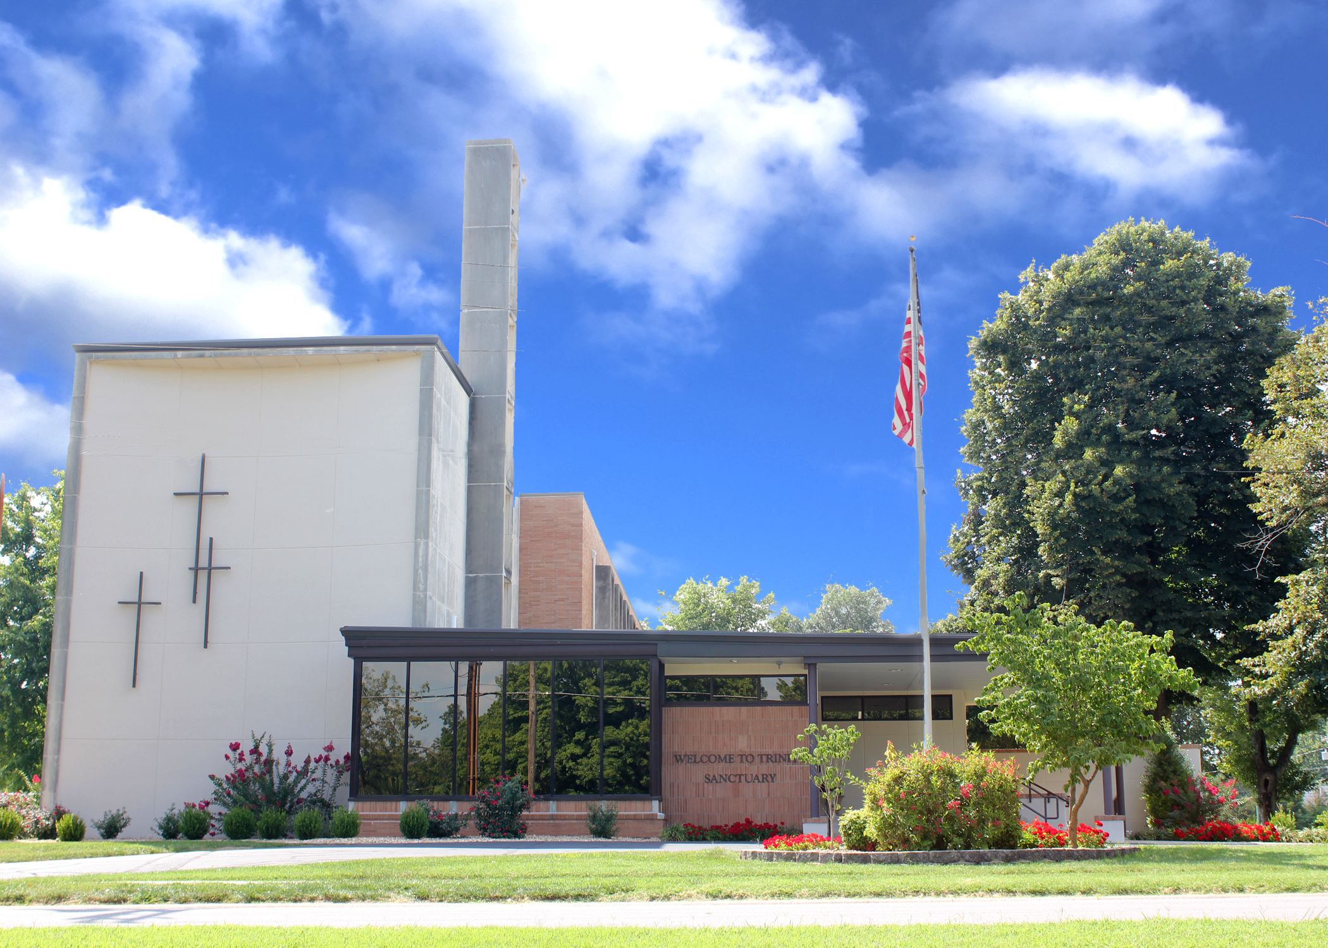

Trinity Lutheran Church
The Lutheran Church—Missouri Synod
1415 S. Holland
Springfield, MO 65807
417-866-5878

tlcoffice@trinitylutheranspfd.org
www.trinity-springfield.org

Divine Services:
8:15 a.m.
11:00 a.m.
3:00 p.m.

All Saints’ Day
November 1, 2020
WELCOME TO TRINITY LUTHERAN CHURCH!
_________________________________________________
A Congregation of The Lutheran Church - Missouri Synod

Pastor Rev. Nicholas Hagerman
Director of Music Ministry Dr. Grace St. Pierre
Office Manager Angela Bruton
Director of FamilyLife Intern Hannah Knehans
Custodian Ron Shepard
Nursery Attendant Emily Jones

Serving in Today’s Divine Services

Organist Edith Buchert

Vocalist Jacob Luellen

Guest Preacher Rev. Dr. Dave Benson
Elders 8:15 Joe Western
11:00 Adam Breshears
3:00 Tom McClain

Ushers 8:15 Chris Straw
11:00 Kevin Scheer
3:00 Daniel Straw

Acolytes 8:15 Anna McCune
11:00 Weston Cline
Video Chris Straw
Altar Guild Amy Viets-Cooper, Sherry Jones

CLOSE COMMUNION AT TRINITY
Trinity congregation practices close Communion in accordance with what the Holy Scriptures teach about the administration of the Sacrament of the Lord’s Body and Blood. Confirmed members of Trinity and of other congregations of The Lutheran Church-Missouri Synod and of denominations in declared doctrinal fellowship with the LCMS are welcome to the Lord’s Table. Visitors and guests are asked to speak to one of our Pastors or Elders. Our Pastors also encourage visitors desiring to commune at Trinity to make an appointment with one of them before your next visit. A brief statement of our church’s doctrinal confession on the Lord’s Supper may be found in the narthex.

Welcome and Announcements

Ringing of the Bells
Calling the Baptized People of God to the Hour of Divine Service

Prelude
Stand

Processional Hymn -- For All the Saints LSB 677 sts. 1–5
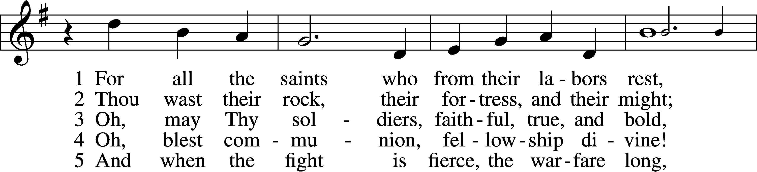
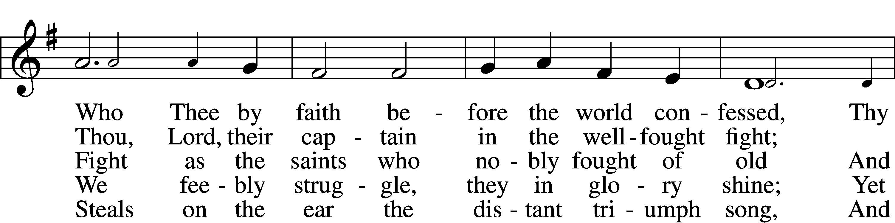
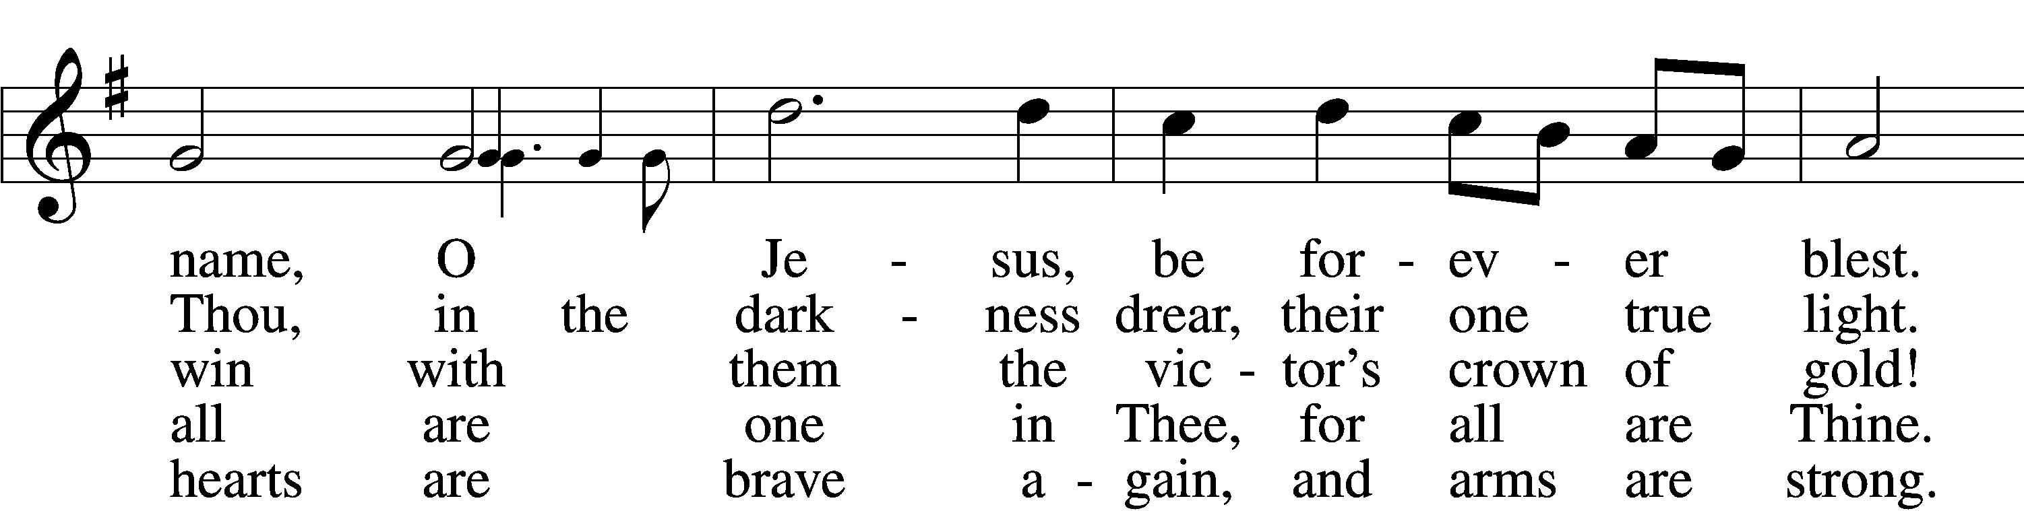
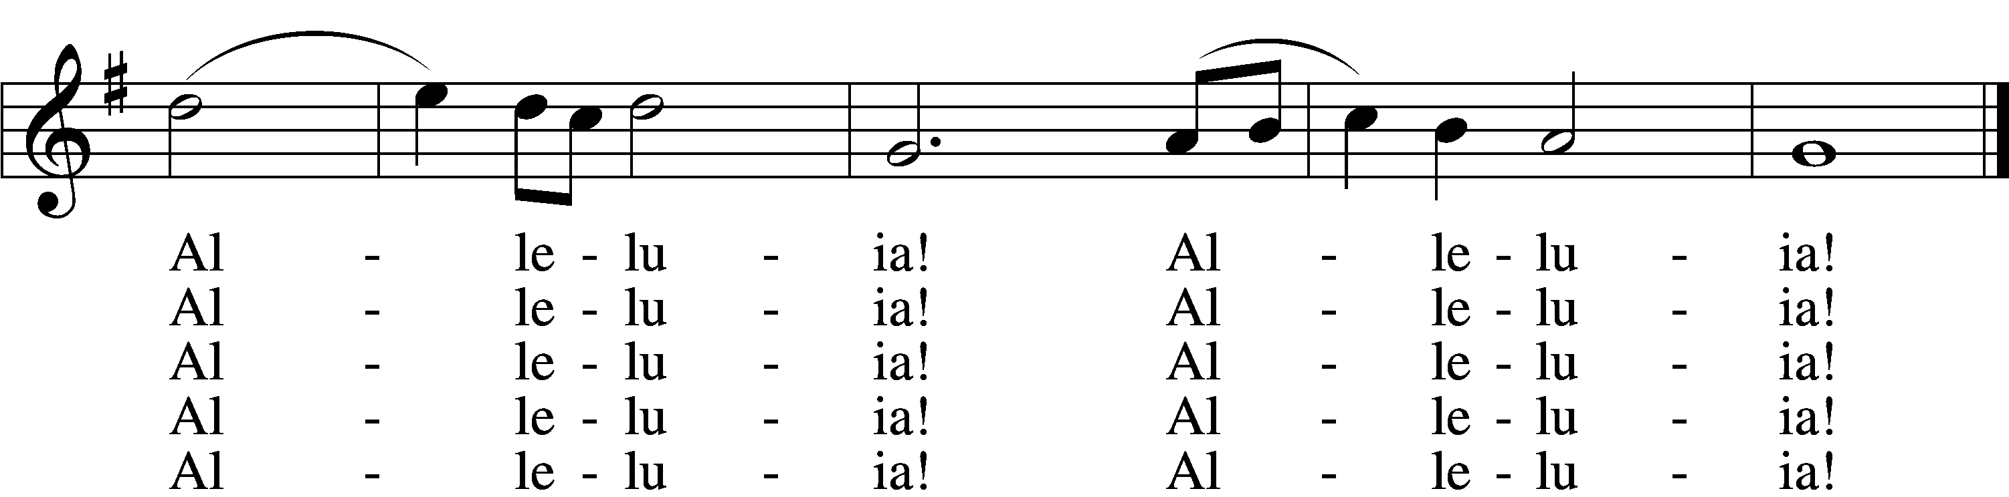
Tune and text: Public domain

Confession and Absolution
The sign of the cross may be made by all in remembrance of their Baptism.

P In the name of the Father and of the T Son and of the Holy Spirit.
C Amen.

P If we say we have no sin, we deceive ourselves, and the truth is not in us.
C But if we confess our sins, God, who is faithful and just, will forgive our sins and cleanse us from all unrighteousness.

P Let us then confess our sins to God our Father.
C Most merciful God, we confess that we are by nature sinful and unclean. We have sinned against You in thought, word, and deed, by what we have done and by what we have left undone. We have not loved You with our whole heart; we have not loved our neighbors as ourselves. We justly deserve Your present and eternal punishment. For the sake of Your Son, Jesus Christ, have mercy on us. Forgive us, renew us, and lead us, so that we may delight in Your will and walk in Your ways to the glory of Your holy name. Amen.

P Almighty God in His mercy has given His Son to die for you and for His sake forgives you all your sins. As a called and ordained servant of Christ, and by His authority, I therefore forgive you all your sins in the name of the Father and of the T Son and of the Holy Spirit.
C Amen.

Service of the Word

Introit
P These are the ones coming out of the great tribu- | lation.*
They have washed their robes and made them white in the blood | of the Lamb.
C In you, O Lord, do I take refuge; let me never be | put to shame;*
in your righteousness de- | liver me.
P For you are my rock and my | fortress;*
and for your name’s sake you lead me and | guide me.
C Into your hand I commit my | spirit;*
you have redeemed me, O Lord, | faithful God.

All: Glory be to the Father and | to the Son*
and to the Holy | Spirit;
as it was in the be- | ginning,*
is now, and will be forever. | Amen.
P These are the ones coming out of the great tribu- | lation.*
They have washed their robes and made them white in the blood | of the Lamb.

Kyrie LSB 152
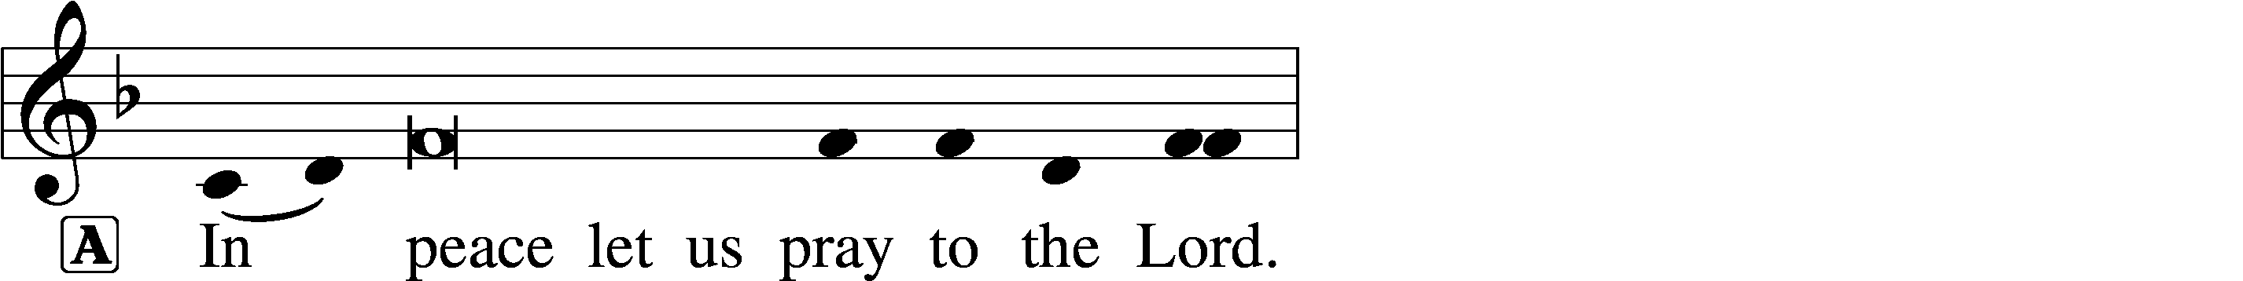
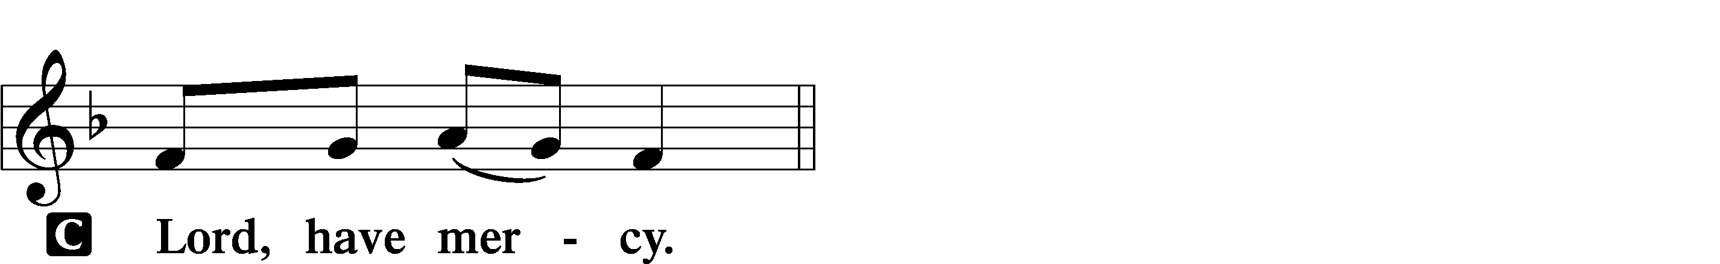

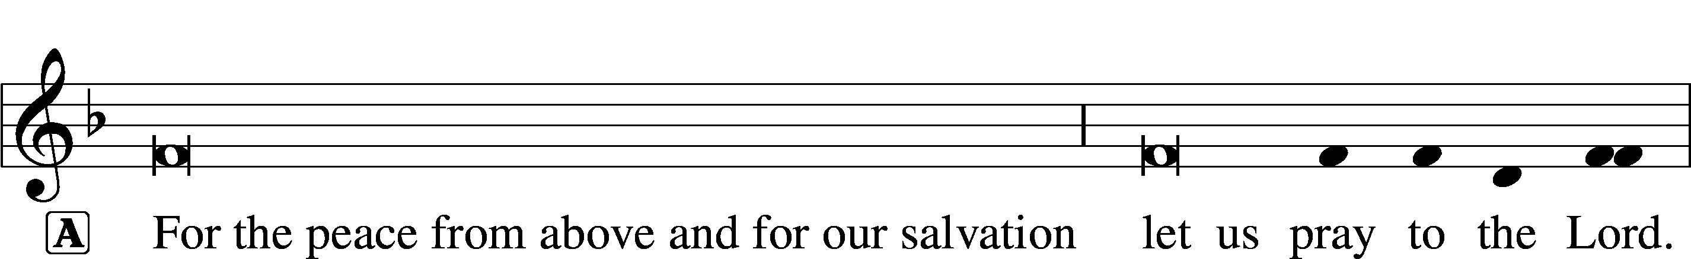
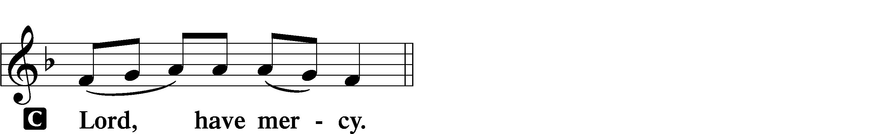

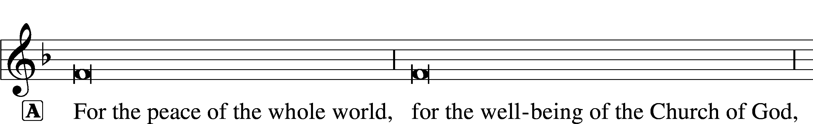
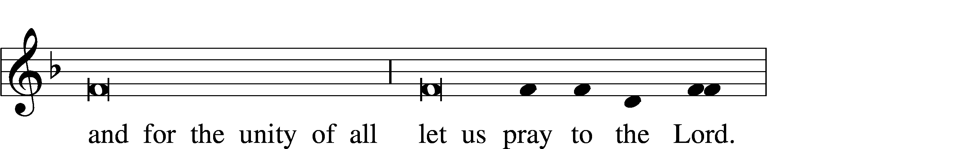
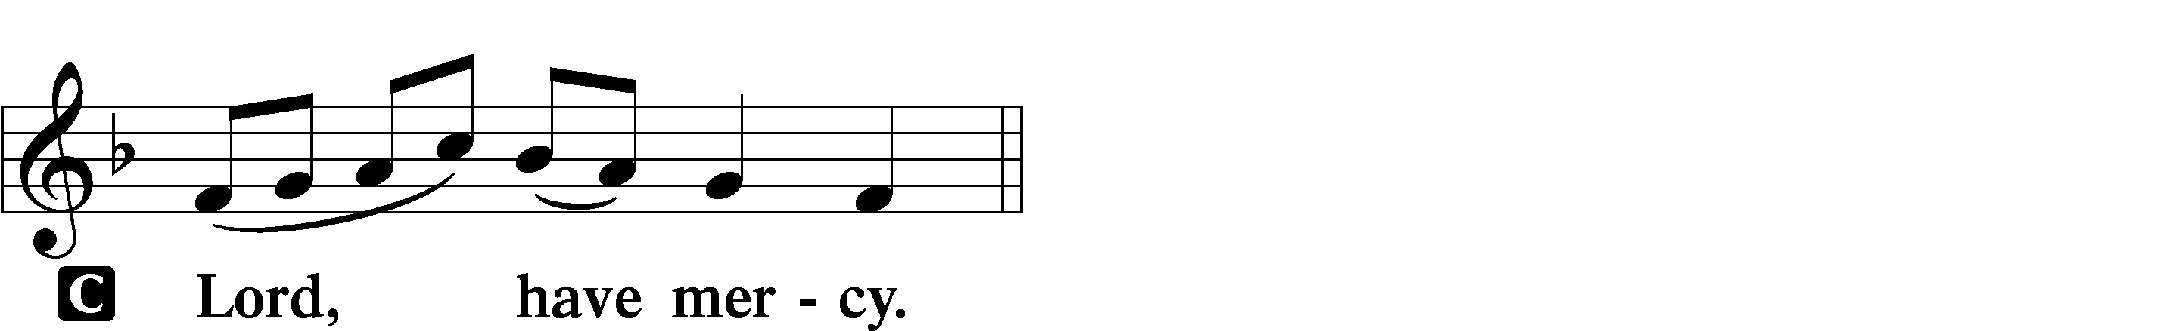

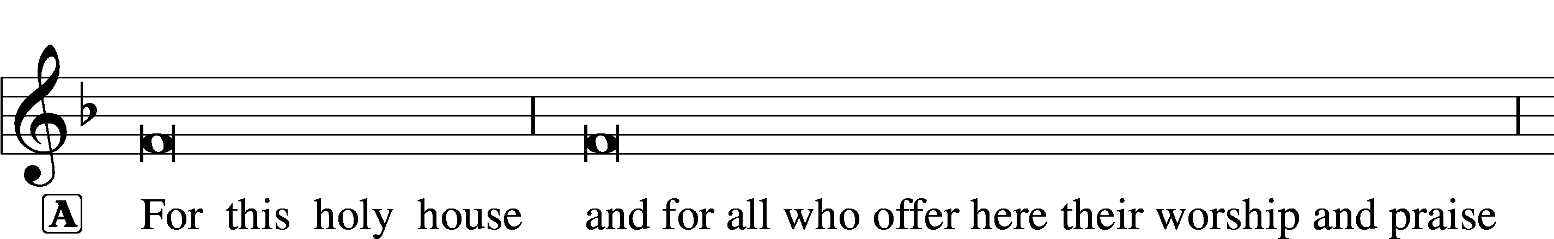
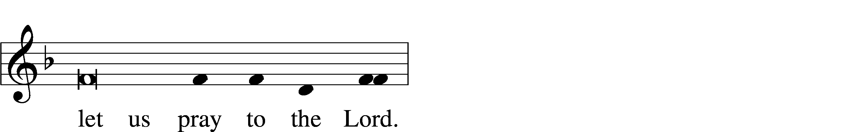
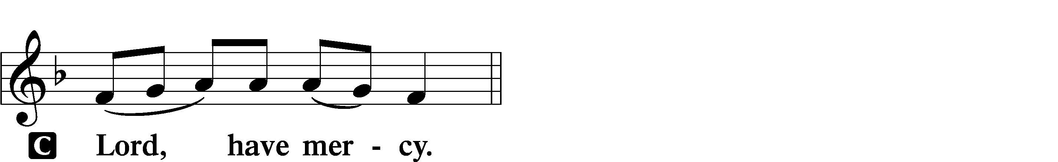

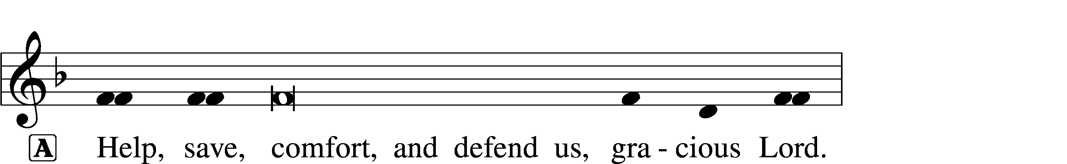

This Is the Feast LSB 155

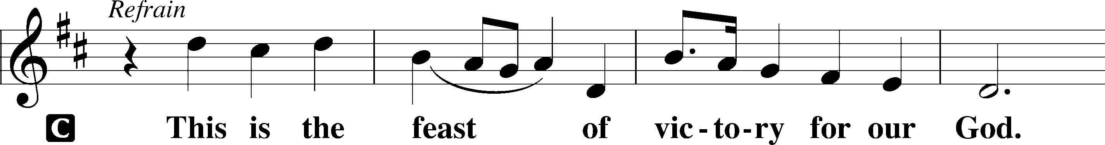
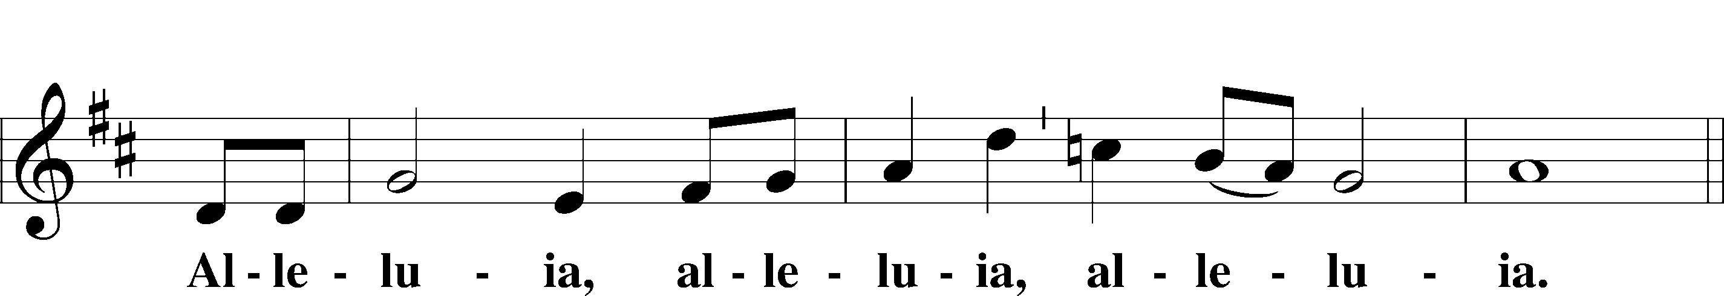
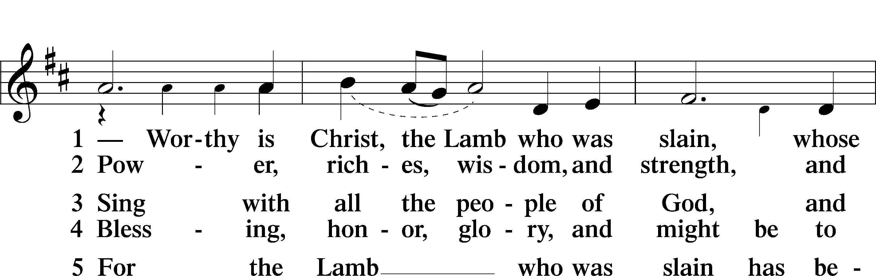
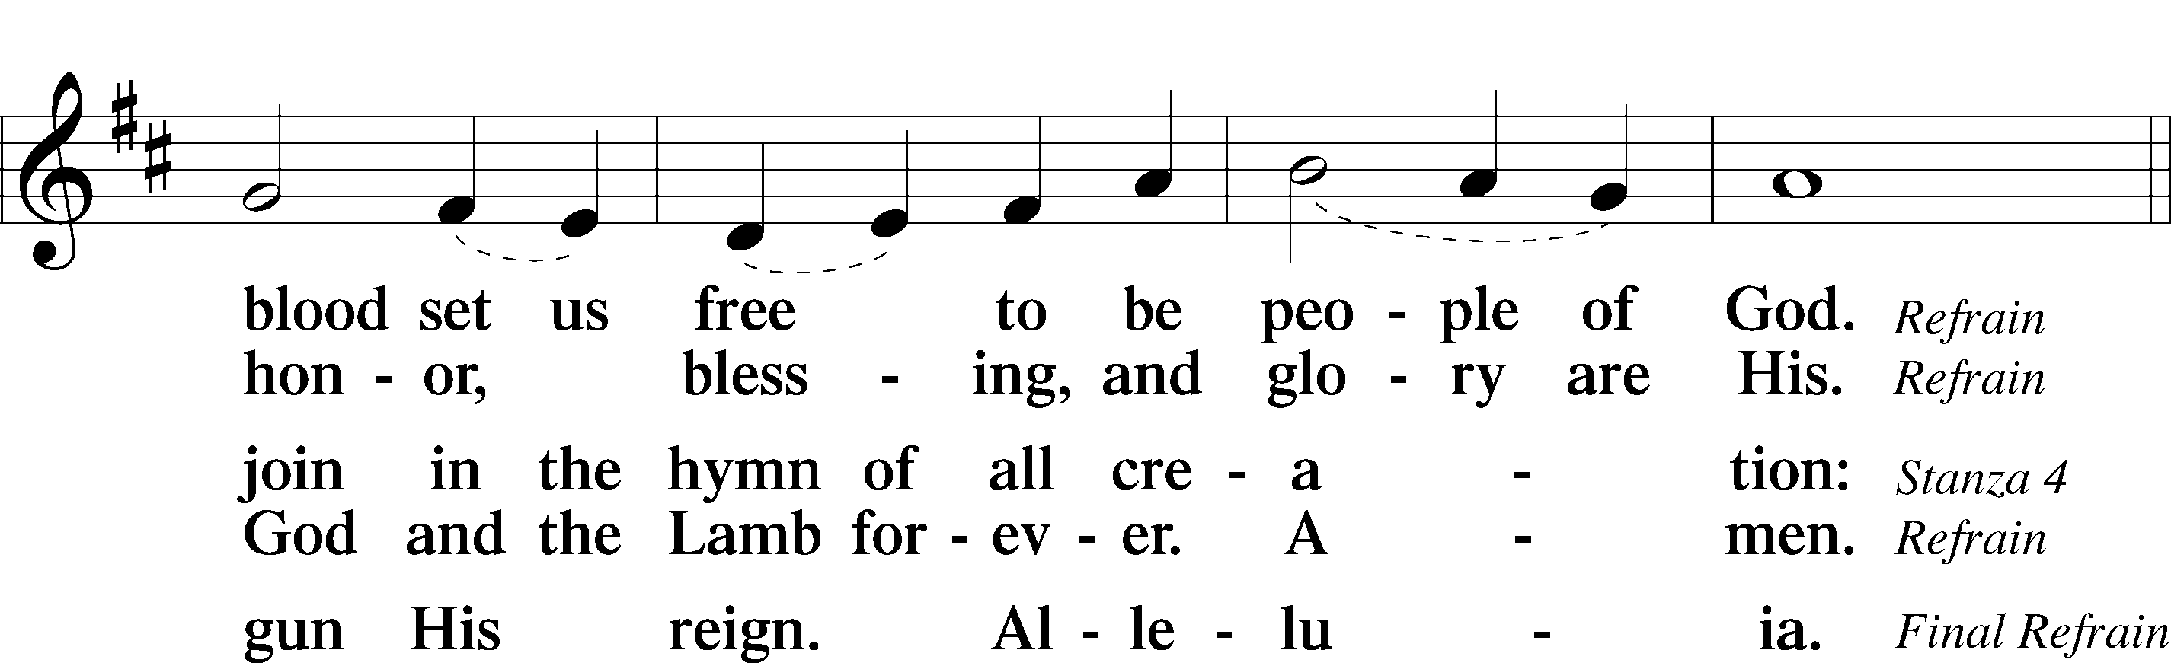
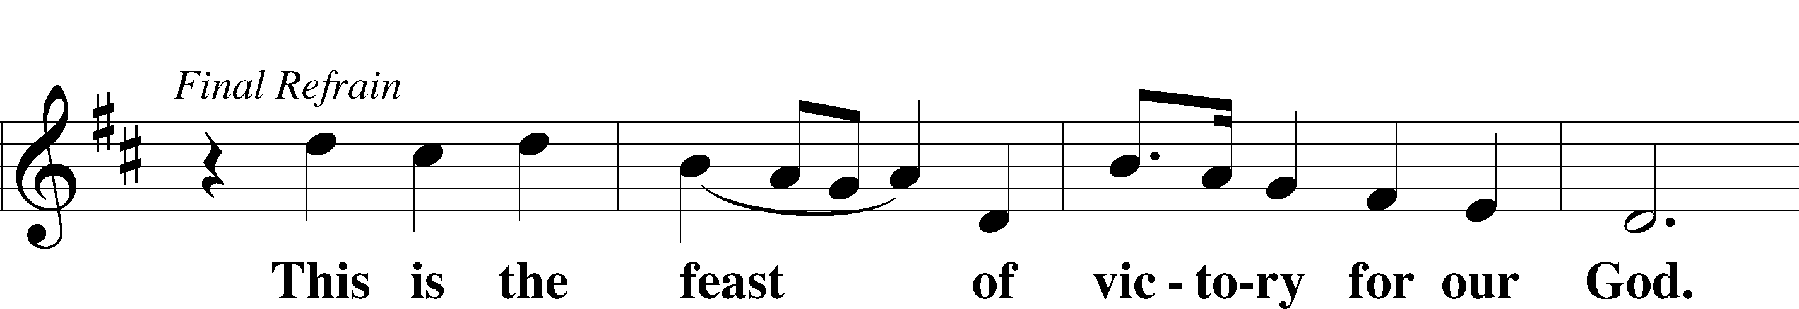
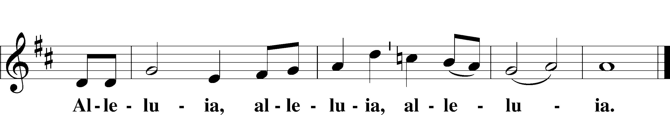

Salutation and Collect of the Day

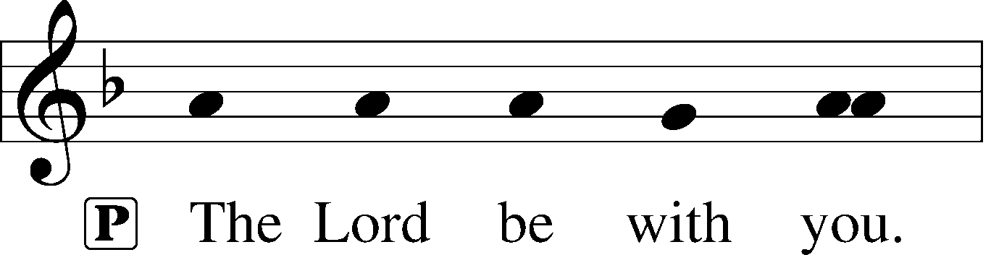
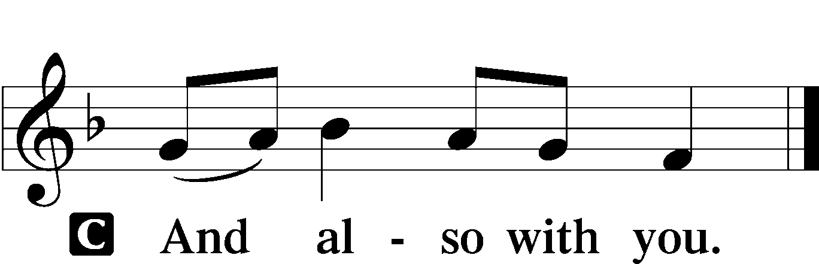

P Let us pray.
Almighty and everlasting God, You knit together Your faithful people of all times and places into one holy communion, the mystical body of Your Son, Jesus Christ. Grant us so to follow Your blessed saints in all virtuous and godly living that, together with them, we may come to the unspeakable joys You have prepared for those who love You; through Jesus Christ, our Lord, who lives and reigns with You and the Holy Spirit, one God, now and forever.

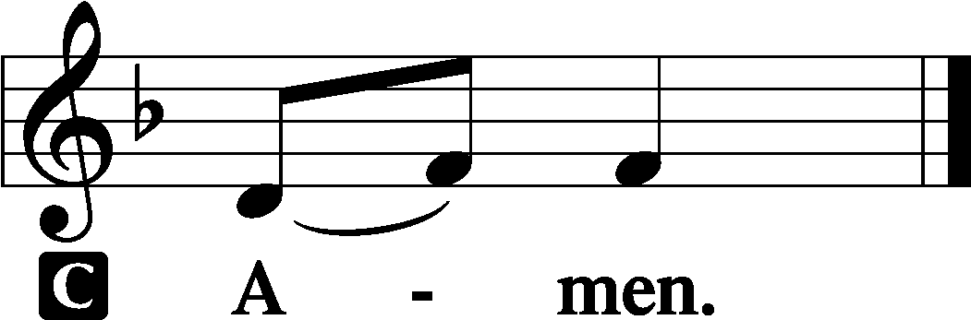
Sit

First Reading Revelation 7:9–17
After this I looked, and behold, a great multitude that no one could number, from every nation, from all tribes and peoples and languages, standing before the throne and before the Lamb, clothed in white robes, with palm branches in their hands, and crying out with a loud voice, “Salvation belongs to our God who sits on the throne, and to the Lamb!” And all the angels were standing around the throne and around the elders and the four living creatures, and they fell on their faces before the throne and worshiped God, saying, “Amen! Blessing and glory and wisdom and thanksgiving and honor and power and might be to our God forever and ever! Amen.”
Then one of the elders addressed me, saying, “Who are these, clothed in white robes, and from where have they come?” I said to him, “Sir, you know.” And he said to me, “These are the ones coming out of the great tribulation. They have washed their robes and made them white in the blood of the Lamb.
“Therefore they are before the throne of God,
and serve him day and night in his temple;
and he who sits on the throne will shelter them with his presence.
They shall hunger no more, neither thirst anymore;
the sun shall not strike them,
nor any scorching heat.
For the Lamb in the midst of the throne will be their shepherd,
and he will guide them to springs of living water,
and God will wipe away every tear from their eyes.”
A This is the Word of the Lord.
C Thanks be to God.

Gradual
P These are the ones coming out of the great tribu- | lation.*
They have washed their robes and made them white in the blood | of the Lamb.
Blessèd are those whose strength is | in you,*
in whose heart are the highways to | Zion.

Epistle 1 John 3:1–3
See what kind of love the Father has given to us, that we should be called children of God; and so we are. The reason why the world does not know us is that it did not know him. Beloved, we are God’s children now, and what we will be has not yet appeared; but we know that when he appears we shall be like him, because we shall see him as he is. And everyone who thus hopes in him purifies himself as he is pure.

A This is the Word of the Lord.
C Thanks be to God.
Stand

Alleluia and Verse LSB 156
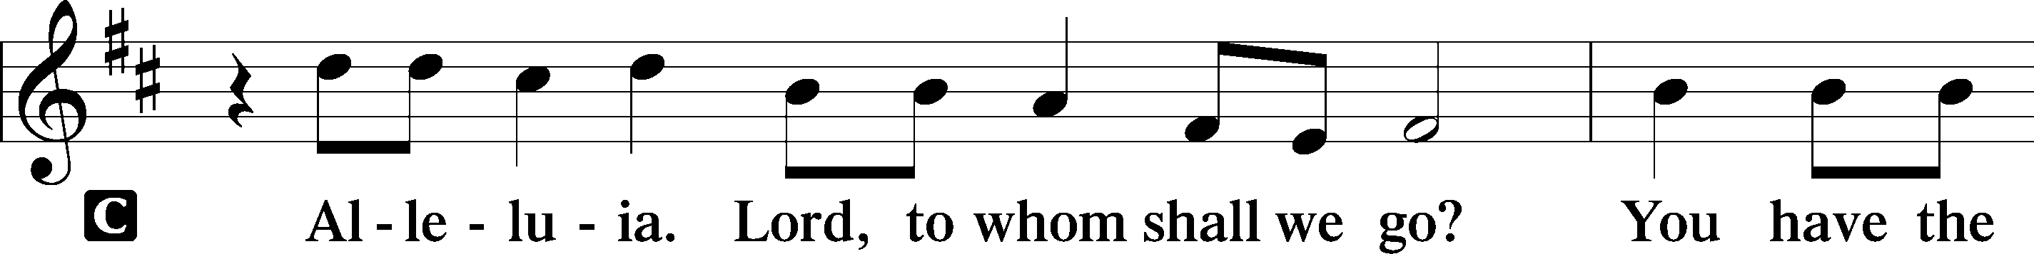
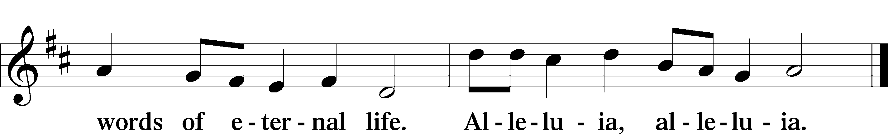

Holy Gospel Matthew 5:1–12

P The Holy Gospel according to St. Matthew, the fifth chapter.

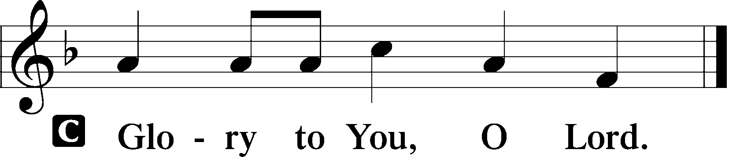

Seeing the crowds, [Jesus] went up on the mountain, and when he sat down, his disciples came to him.
And he opened his mouth and taught them, saying:
“Blessed are the poor in spirit, for theirs is the kingdom of heaven.
“Blessed are those who mourn, for they shall be comforted.
“Blessed are the meek, for they shall inherit the earth.
“Blessed are those who hunger and thirst for righteousness, for they shall be satisfied.
“Blessed are the merciful, for they shall receive mercy.
“Blessed are the pure in heart, for they shall see God.
“Blessed are the peacemakers, for they shall be called sons of God.
“Blessed are those who are persecuted for righteousness’ sake, for theirs is the kingdom of heaven.
“Blessed are you when others revile you and persecute you and utter all kinds of evil against you falsely on my account. Rejoice and be glad, for your reward is great in heaven, for so they persecuted the prophets who were before you.”

P This is the Gospel of the Lord.

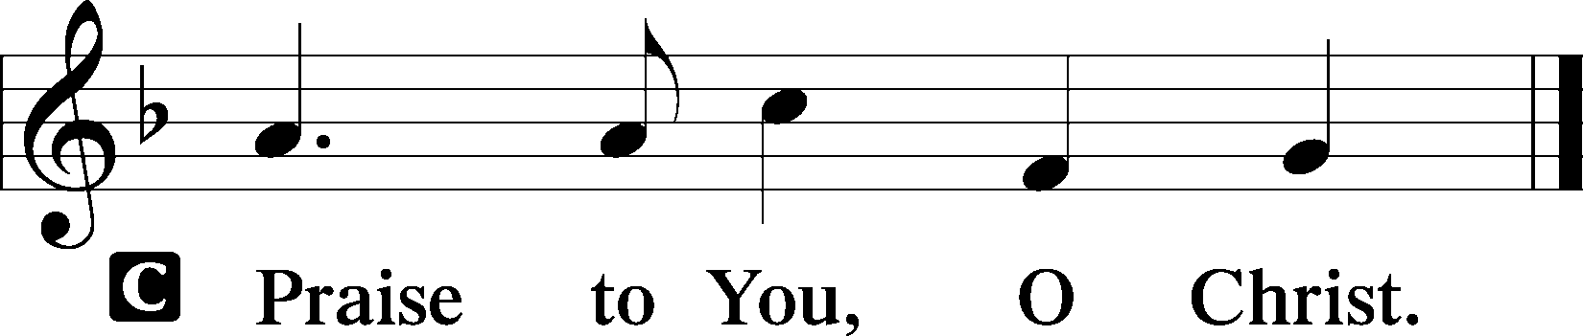

Sit

Hymn of the Day -- Blest Are They LSB 982
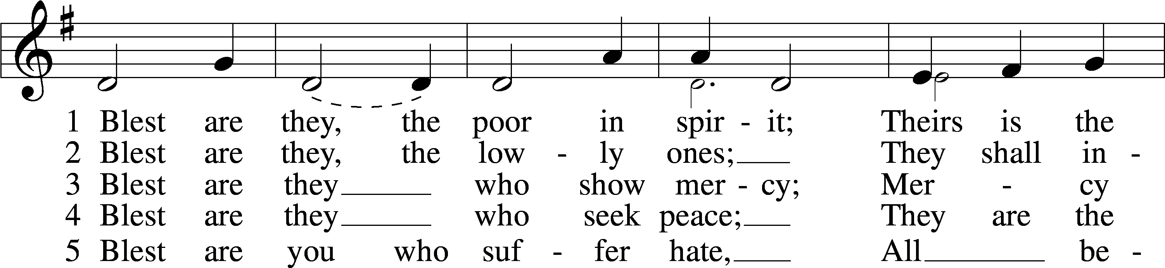
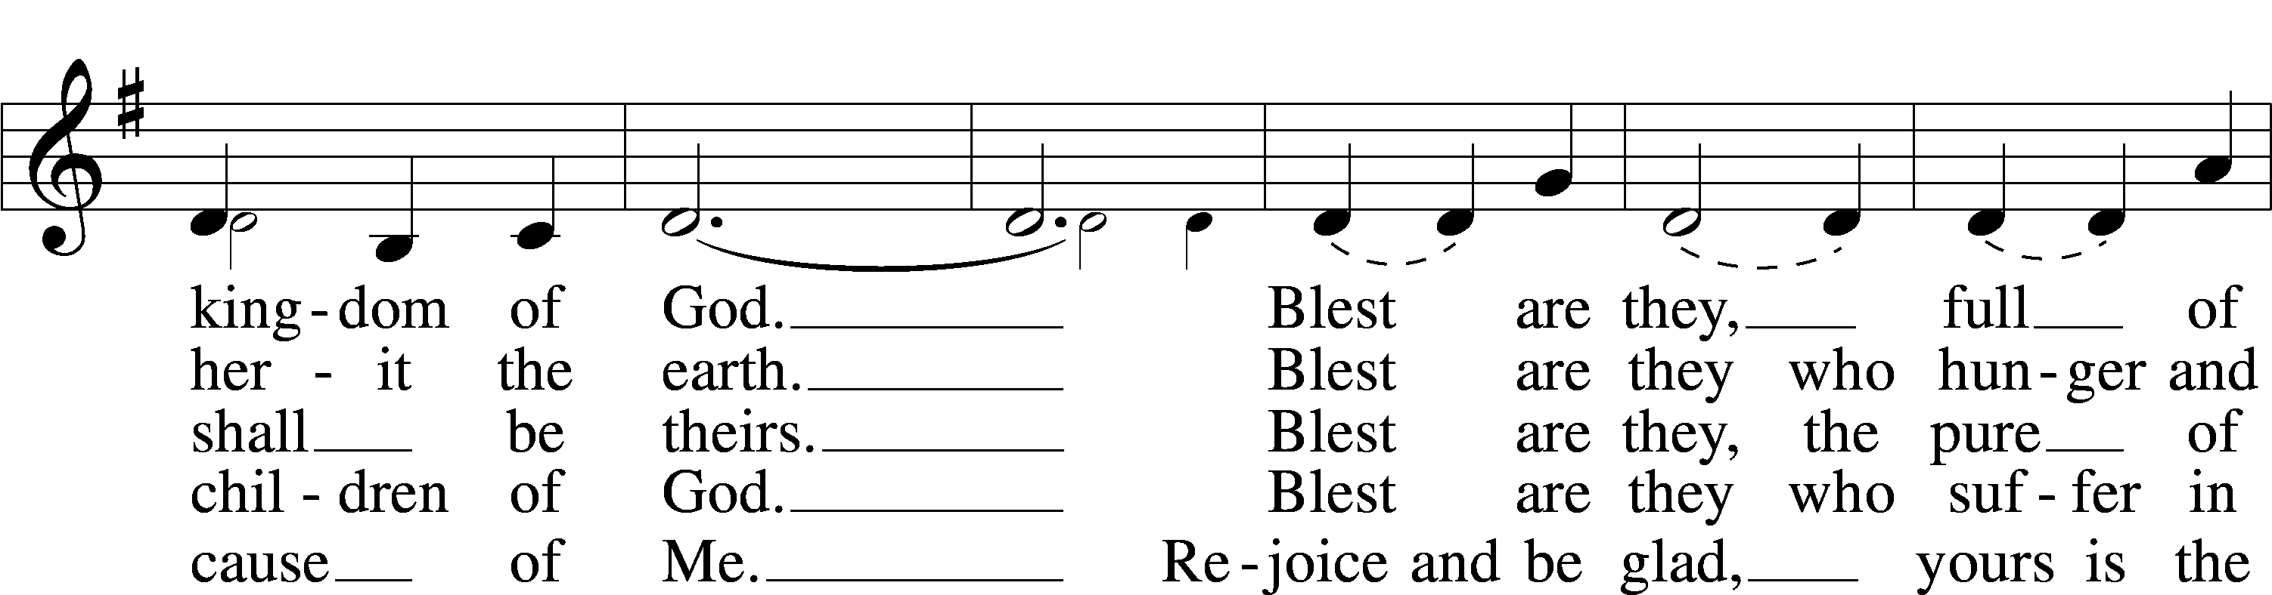
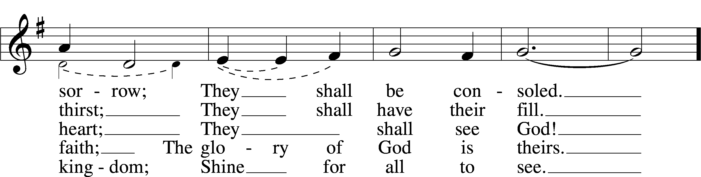
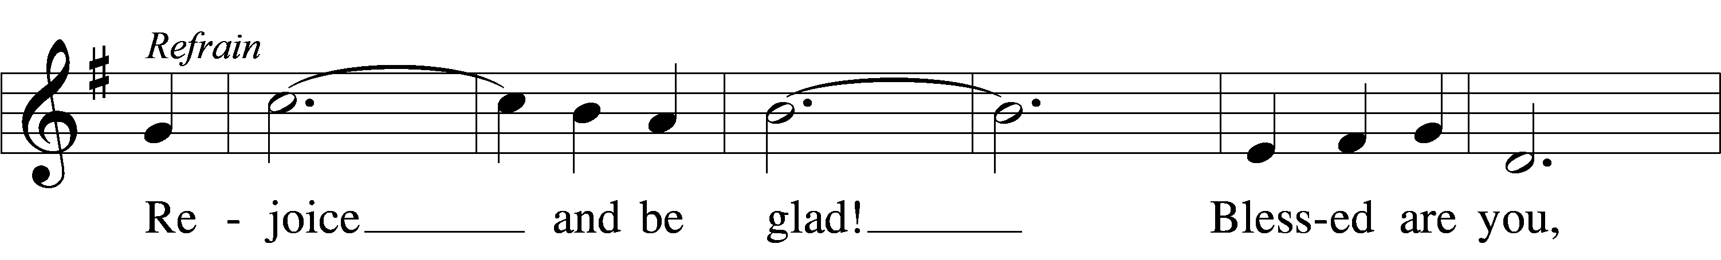
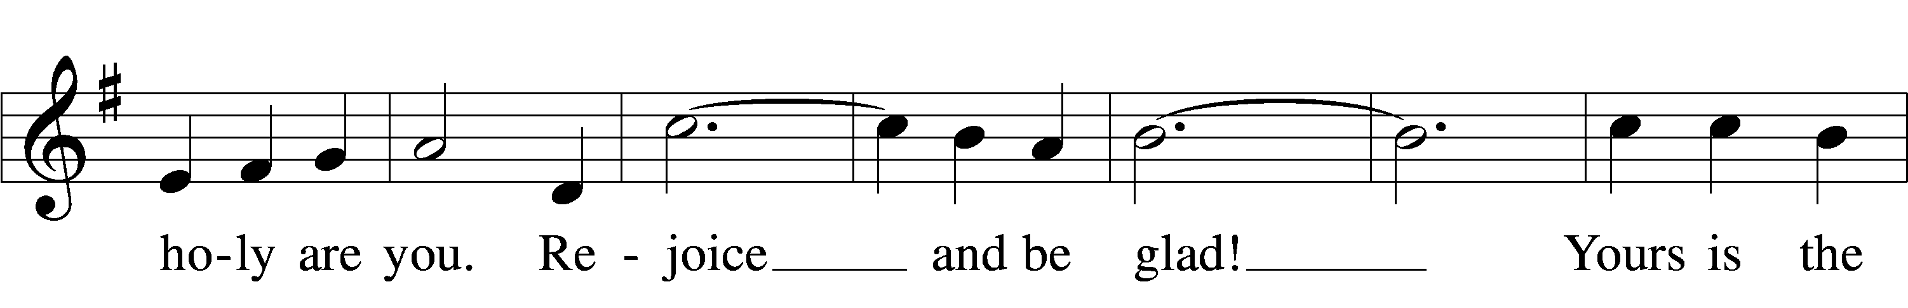
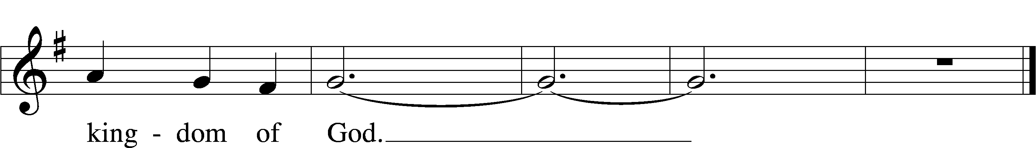
Text and tune: © 1985 GIA Publications, Inc. Used by permission: LSB Hymn License no. 110003539

Sermon – Healthy Saints: Blessed to be a Blessing

Stand

Nicene Creed
C I believe in one God,
the Father Almighty,
maker of heaven and earth
and of all things visible and invisible.

And in one Lord Jesus Christ,
the only-begotten Son of God,
begotten of His Father before all worlds,
God of God, Light of Light,
very God of very God,
begotten, not made,
being of one substance with the Father,
by whom all things were made;
who for us men and for our salvation came down from heaven
and was incarnate by the Holy Spirit of the virgin Mary
and was made man;
and was crucified also for us under Pontius Pilate.
He suffered and was buried.
And the third day He rose again according to the Scriptures
and ascended into heaven
and sits at the right hand of the Father.
And He will come again with glory to judge both the living and the dead,
whose kingdom will have no end.

And I believe in the Holy Spirit,
the Lord and giver of life,
who proceeds from the Father and the Son,
who with the Father and the Son together is worshiped and glorified,
who spoke by the prophets.
And I believe in one holy Christian and apostolic Church,
I acknowledge one Baptism for the remission of sins,
and I look for the resurrection of the dead
and the life T of the world to come. Amen.

Prayer of the Church
P Standing with the great multitude of saints before the throne of God and the Lamb, let us join in prayer, praise and thanksgiving to the God of our salvation.

Brief silence

P Mighty and eternal God, we remember before You the saints and martyrs of every generation, who trusted in You in the face of terror and threat. Grant that when facing persecution and trial in our own day, we may be steadfast in faith. Deliver those whom You have washed in Baptism, granting the new life that death cannot overcome. Lord, in Your mercy,
C hear our prayer.

P Mighty and eternal God, You established the Church and have granted her Your aid and protection through these many years. Continue to pour out upon us Your Spirit and grace, that we may accomplish Your bidding and proclaim Your saving name to every corner of the earth. Lord, in Your mercy,
C hear our prayer.

P Mighty and eternal God, we give You thanks for the faithful pastors who have spoken to us Your Word and the church workers who have served us in Your name. Grant that we may continue to receive their ministry of Word and Sacrament with willing ears and open hearts. Lord, in Your mercy,
C hear our prayer.

P Mighty and eternal God, we beg Your grace that our lives may be ordered by Your commands, and we ask You to bless those who govern us in Your name. Bless our president, the Congress, our governor, the legislature and all local officials, that pursuing the path of justice they may act with humility and honor for the good of all people. Give wisdom to all who vote this week, and bless its result, that our nation may elect our leaders peacefully and orderly. Lord, in Your mercy,
C hear our prayer.
P Mighty and eternal God, we rejoice that You have rescued us from the power of death and raised us in Christ to dwell with Him in everlasting life. Give to those who grieve the comfort of the promise of the resurrection of the dead and eternal life, and bestow Your peace upon the dying, that they may fall asleep here and awaken in Your glory. Lord, in Your mercy,
C hear our prayer.

P Mighty and eternal God, You have made us Your children, and You continue to guard us as Your own possession. According to Your will, give healing to the sick, calm to the troubled in mind, and patience to those facing sorrow and struggle. Give health and peace to our nation. Hear us especially on behalf of _____________. Lord, in Your mercy,
C hear our prayer.

P Mighty and eternal God, show forth Your kindness to the poor and Your compassion to those who suffer injustice. Deliver us from the scourge of racism and prejudice, and help us to acknowledge our common life from Your creative power and our common redemption in Christ, our Savior. Lord, in Your mercy,
C hear our prayer.

P Mighty and eternal God, we are unworthy of all Your blessings and do not deserve the mercies new every morning of our earthly lives. Give us the will and desire to care responsibly for all that You have entrusted to us and to be generous with those in need and for the support of Your Church and the work of Your Kingdom. Lord, in Your mercy,
C hear our prayer.

P Mighty and eternal God, Your Son has set His table among us in the presence of our enemies, giving us a foretaste of the eternal feast to come. Prepare us in heart and mind to come to this Sacrament and receive the blessing of His body and blood for our benefit. Deliver us from divisions that prevent our communion together, and bring us soon to the day when we will be fully united in doctrine and life to the glory of Your holy name. Lord, in Your mercy,
C hear our prayer.

P Mighty and eternal God, bring us to that day when every tear shall be wiped from our eyes and we shall hunger and thirst no more. Knowing You now by faith, we yearn for the day when we shall know You face to face. Until the dawn of that eternal day, keep us in Your faith and fear through our Good Shepherd and Lord, Jesus Christ, who lives and reigns with You and the Holy Spirit, one God, now and forever.
C Amen.

Remembrance of the Faithful Departed

The faithful departed are remembered before the service, after the sermon or creed, or during the Prayer of the Church.

P In joyful expectation of the resurrection to life eternal, we remember before the Lord our departed family and friends who have gone before us in faith and all those who are in our hearts and minds this day.

A bell may be tolled following the reading of each name.
Wes Ohrenberg Nov. 17, 2019
Carlene Allard Nov. 23, 2019
Lorna Flowers Nov. 25, 2019
Nelda Graham Dec. 23, 2019
Beverly Beyer Jan. 8, 2020
Phyllis Miller Jan. 19, 2020
Harold Pfeiffer Jan. 26, 2020
James Kollmeyer Feb. 25, 2020
Marcella Gieseke March 4, 2020
Ruth Wyssmann July 3, 2020
Ernest Harvey Aug. 19, 2020
Melvin Marion Sept. 13, 2020
Bill Fair Sept. 22, 2020
Salem Hagewood Oct. 1, 2020
Harvey Jorgensen Oct. 22, 2020

P Let us pray.
Almighty God, we remember with thanksgiving those who loved and served You in Your Church on earth and who now rest from their labors. Keep us in fellowship with all Your saints, and bring us at last to the joy of Your heavenly kingdom; through Jesus Christ, Your Son, our Lord, who lives and reigns with You and the Holy Spirit, one God, now and forever.
C Amen.

Offertory LSB 159

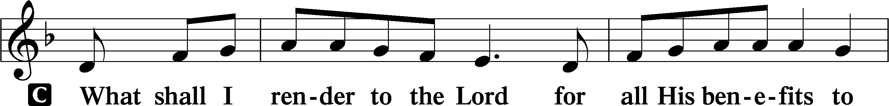
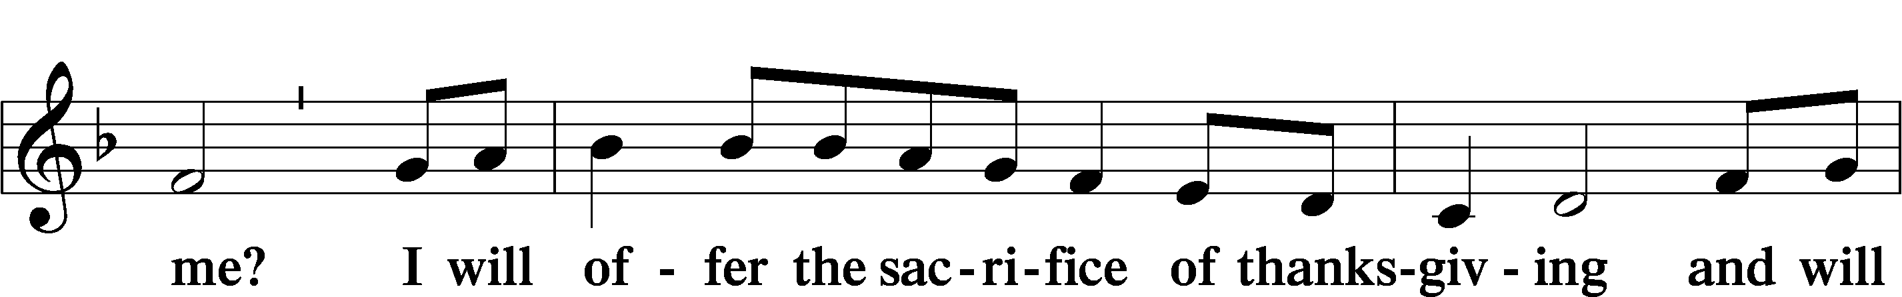
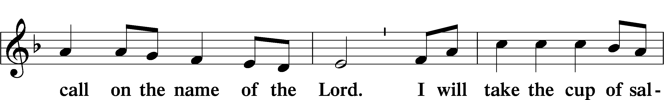
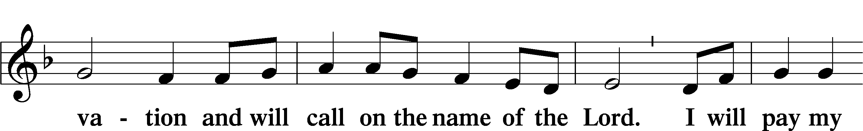
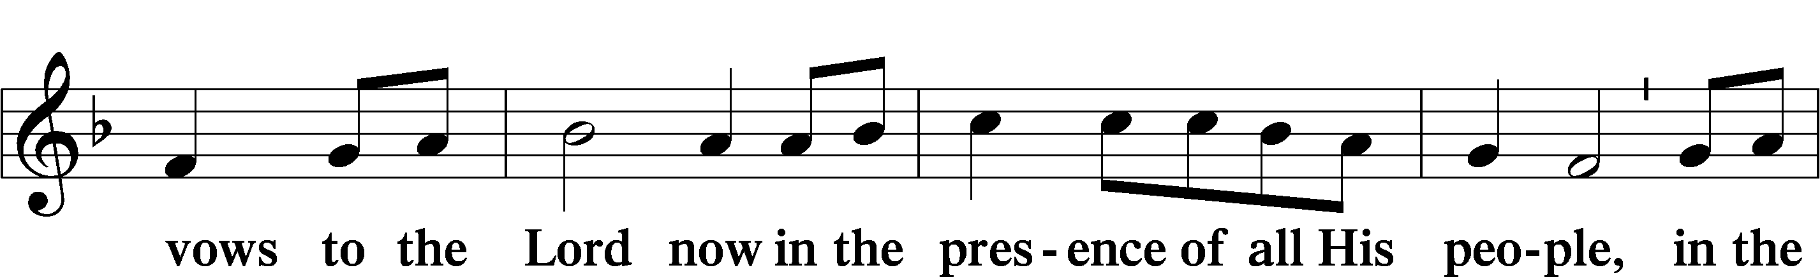
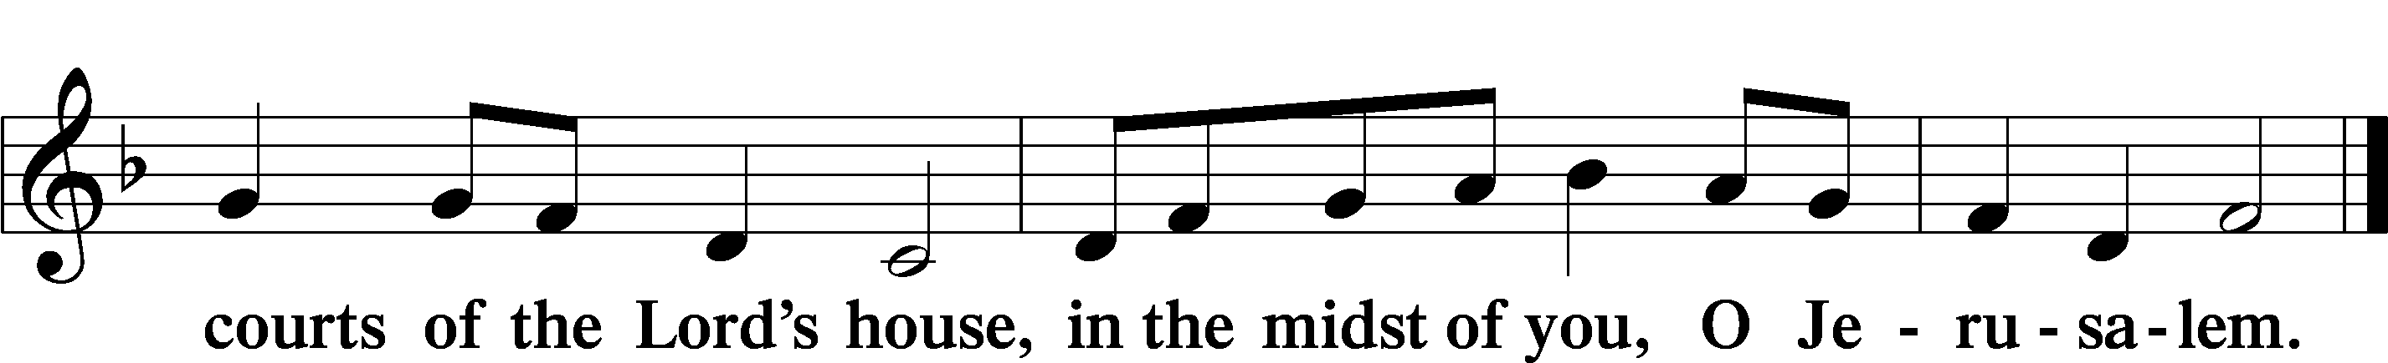

Service of the Sacrament

Preface LSB 160
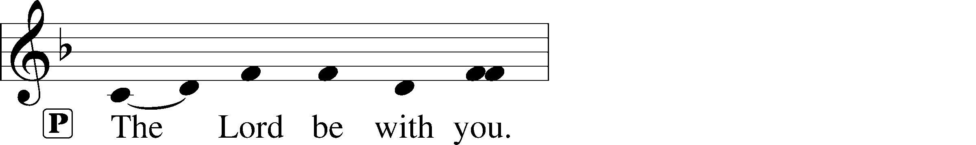
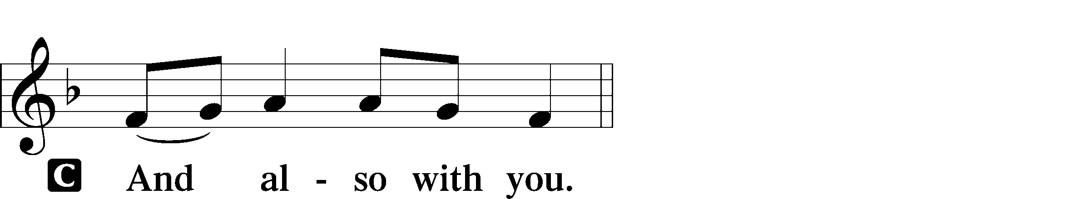
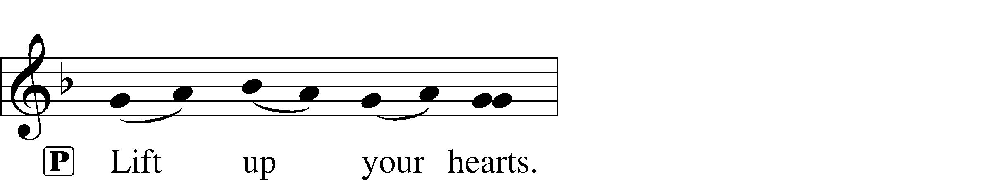
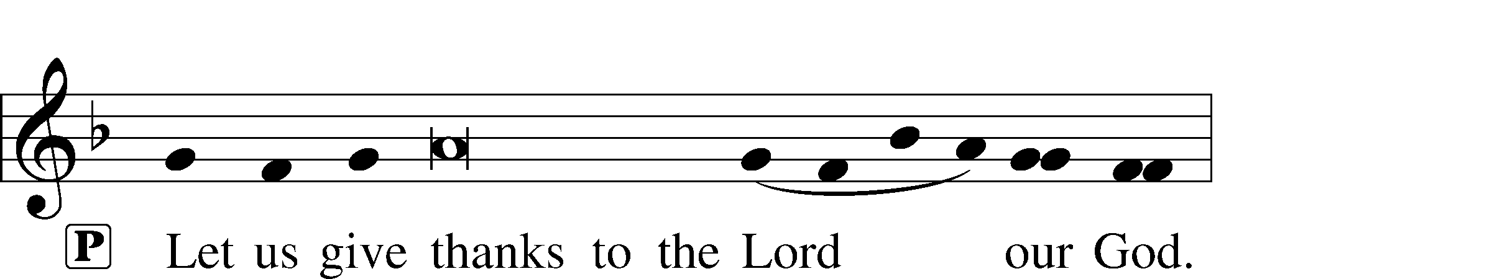
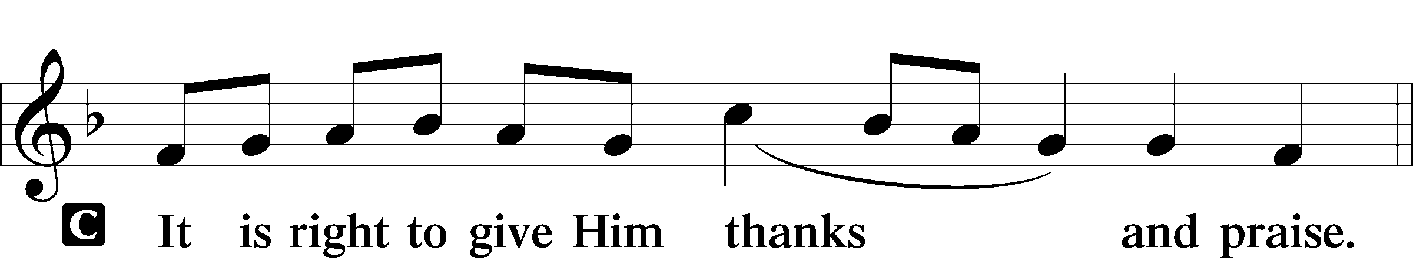

P It is truly good, right, and salutary that we should at all times and in all places give thanks to You, holy Lord, almighty Father, everlasting God. In the communion of all Your saints gathered into the one body of Your Son, You have surrounded us with so great a cloud of witnesses that we, encouraged by their faith and strengthened by their fellowship, may run with perseverance the race that is set before us and, together with them, receive the crown of glory that does not fade away. Therefore with angels and archangels and with all the company of heaven we laud and magnify Your glorious name, evermore praising You and saying:

Sanctus LSB 161
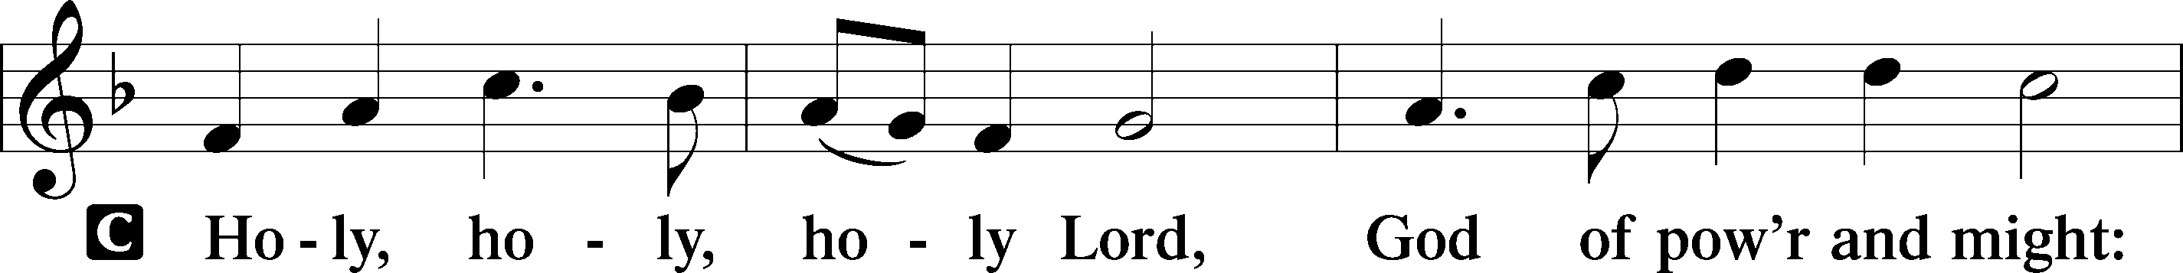
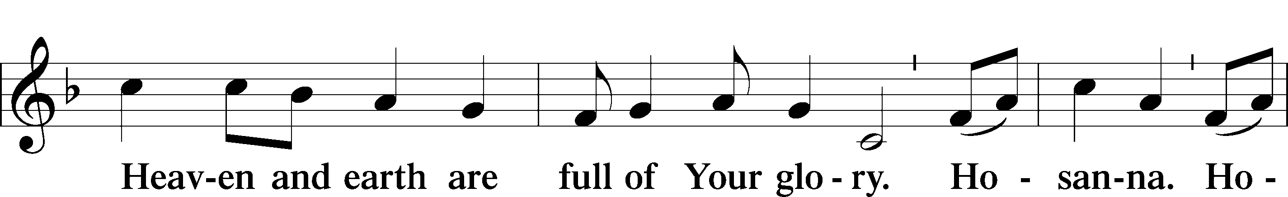
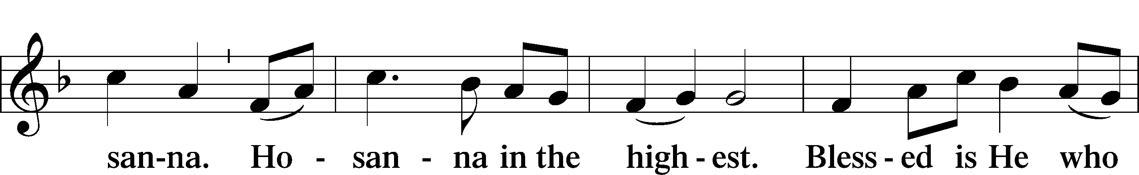
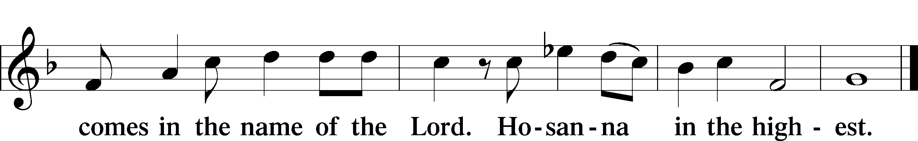

Prayer of Thanksgiving LSB 161
P Blessed are You, Lord of heaven and earth, for You have had mercy on those whom You created and sent Your only-begotten Son into our flesh to bear our sin and be our Savior. With repentant joy we receive the salvation accomplished for us by the all-availing sacrifice of His body and His blood on the cross.

Gathered in the name and the remembrance of Jesus, we beg You, O Lord, to forgive, renew, and strengthen us with Your Word and Spirit. Grant us faithfully to eat His body and drink His blood as He bids us do in His own testament. Gather us together, we pray, from the ends of the earth to celebrate with all the faithful the marriage feast of the Lamb in His kingdom, which has no end. Graciously receive our prayers; deliver and preserve us. To You alone, O Father, be all glory, honor, and worship, with the Son and the Holy Spirit, one God, now and forever.
C Amen.

Lord’s Prayer LSB 162
P Lord, remember us in Your kingdom and teach us to pray:
C Our Father who art in heaven,
hallowed be Thy name,
Thy kingdom come,
Thy will be done on earth
as it is in heaven;
give us this day our daily bread;
and forgive us our trespasses
as we forgive those
who trespass against us;
and lead us not into temptation,
but deliver us from evil.
For Thine is the kingdom
and the power and the glory
forever and ever. Amen.

The Words of Our Lord
P Our Lord Jesus Christ, on the night when He was betrayed, took bread, and when He had given thanks, He broke it and gave it to the disciples and said: “Take, eat; this is My T body, which is given for you. This do in remembrance of Me.”

In the same way also He took the cup after supper, and when He had given thanks, He gave it to them, saying: “Drink of it, all of you; this cup is the new testament in My T blood, which is shed for you for the forgiveness of sins. This do, as often as you drink it, in remembrance of Me.”

Pax Domini LSB 163
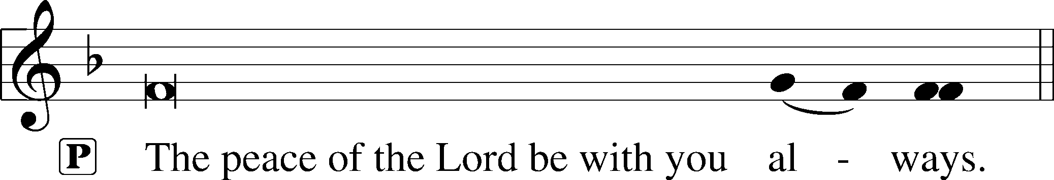

Agnus Dei LSB 163

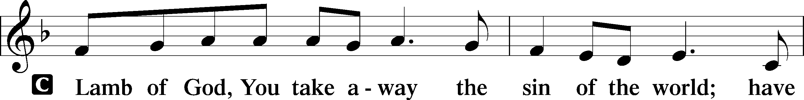
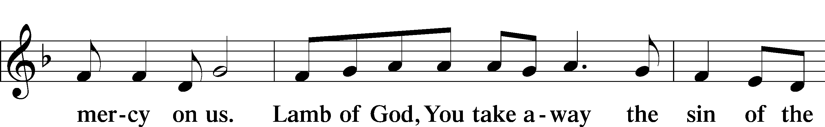
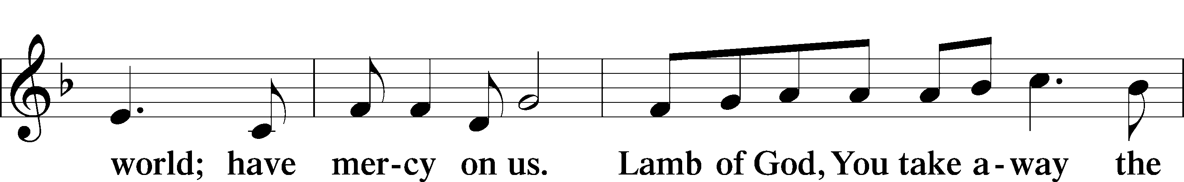
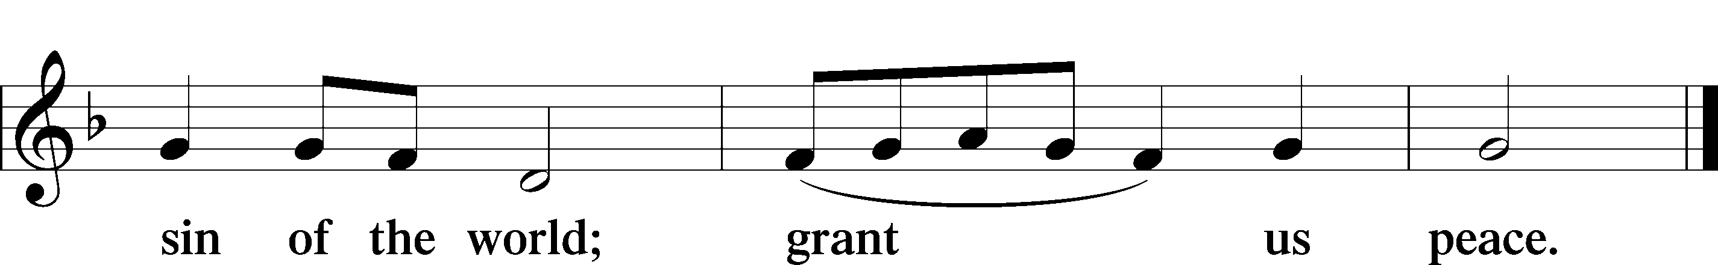

Sit

Distribution

Jesus Sat with His Disciples LSB 932
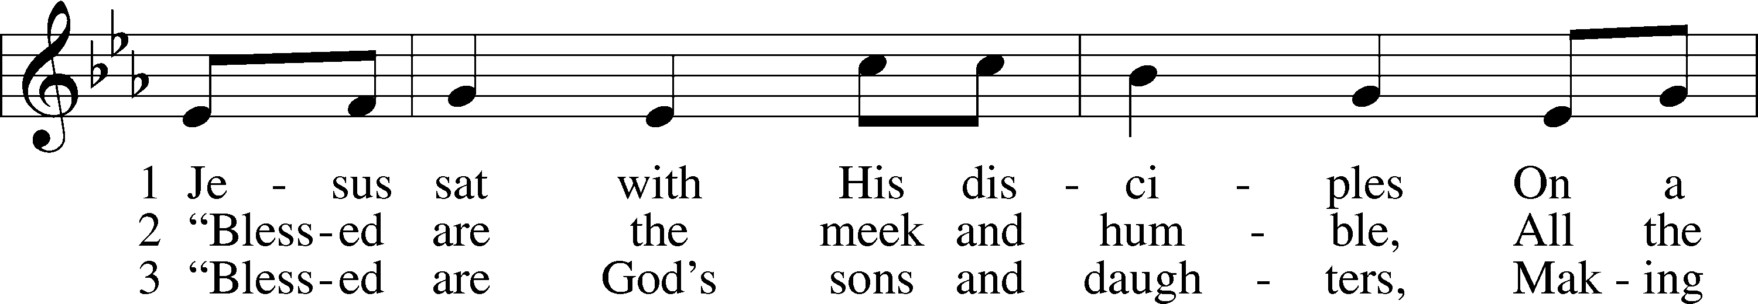
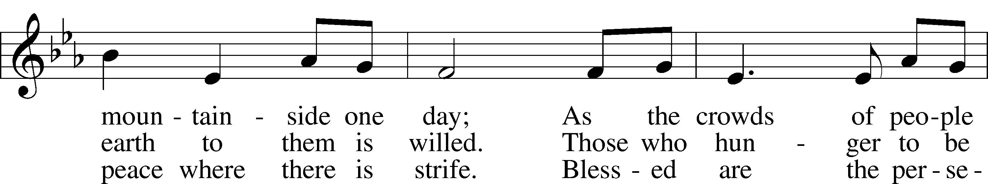
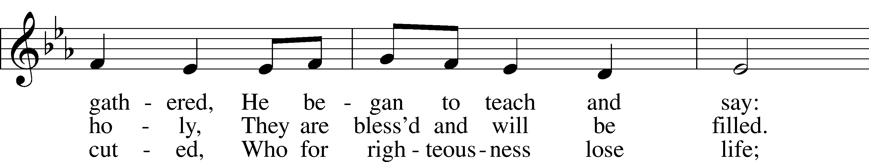
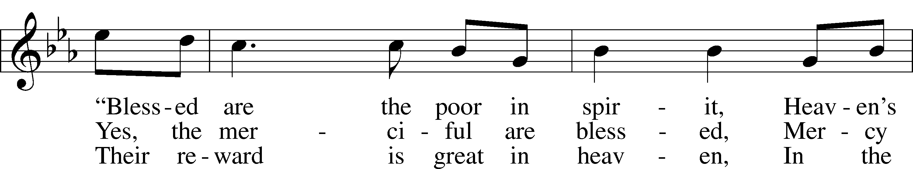
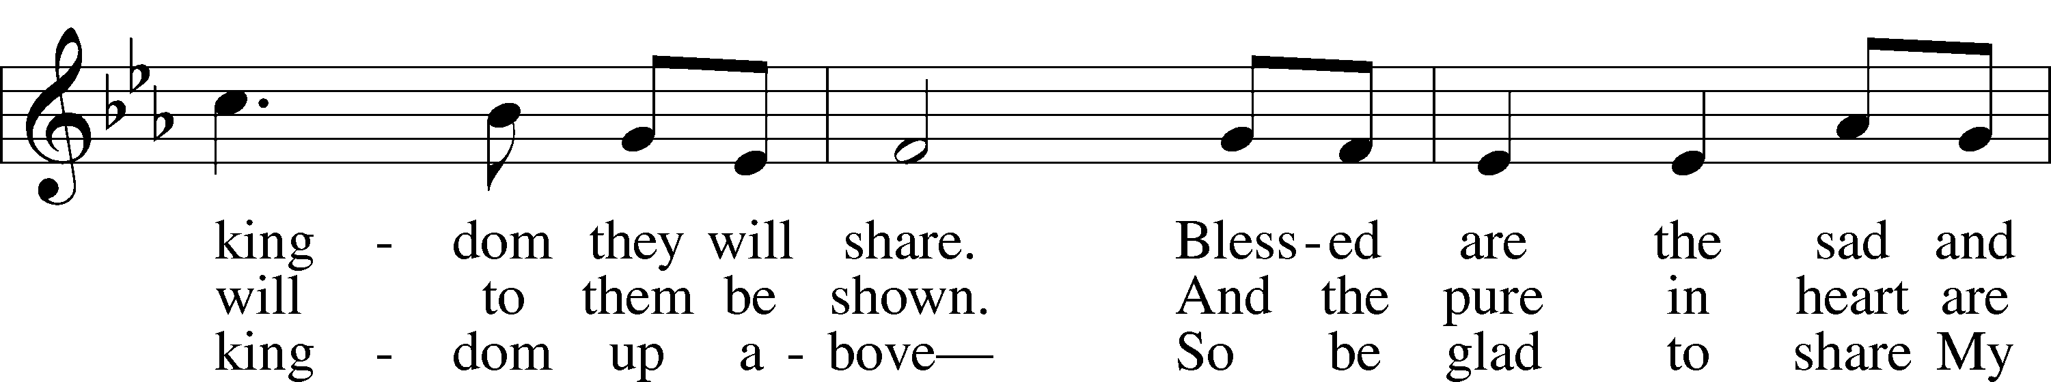
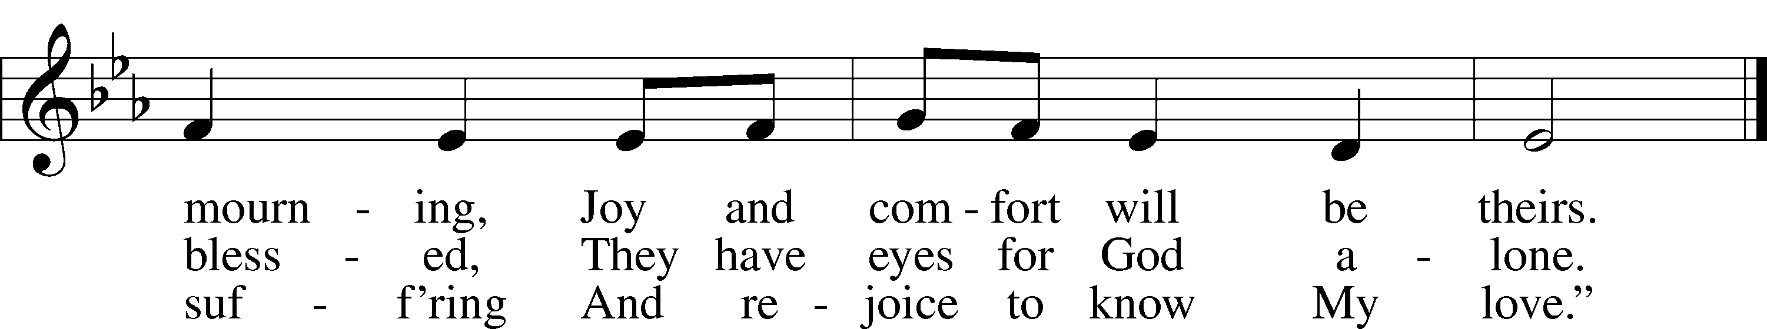
Text: © 1997 Stephen P. Starke, admin. Concordia Publishing House. Used by permission: LSB Hymn License no. 110003539
Tune: © 1987 GIA Publications, Inc. Used by permission: LSB Hymn License no. 110003539

Behold a Host, Arrayed in White LSB 676
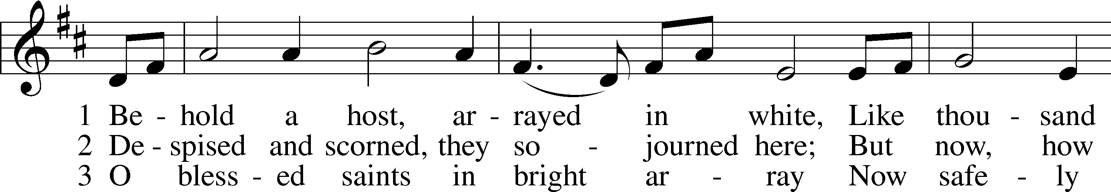
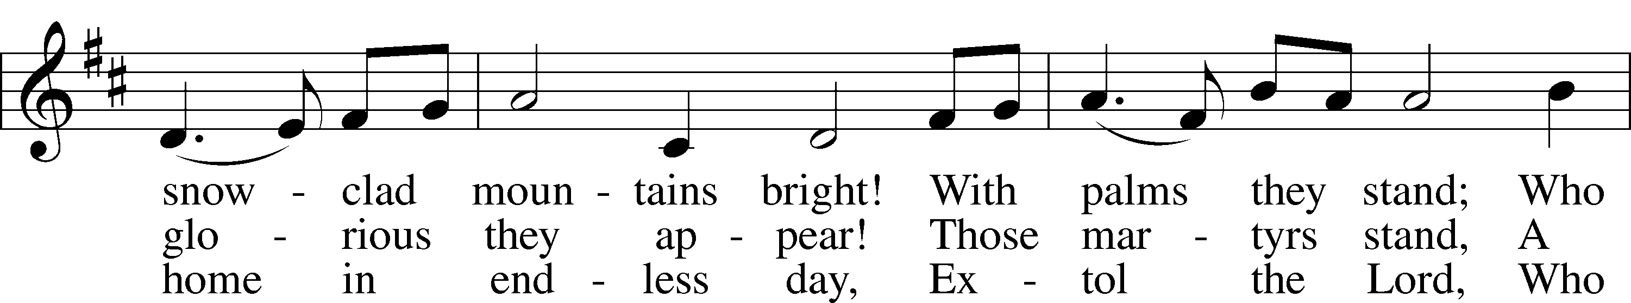
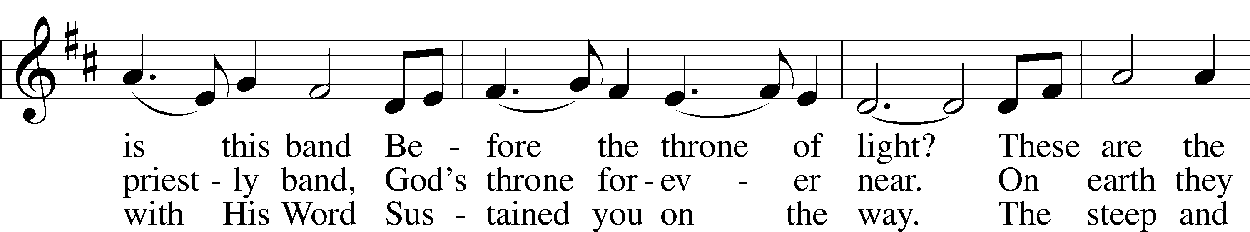
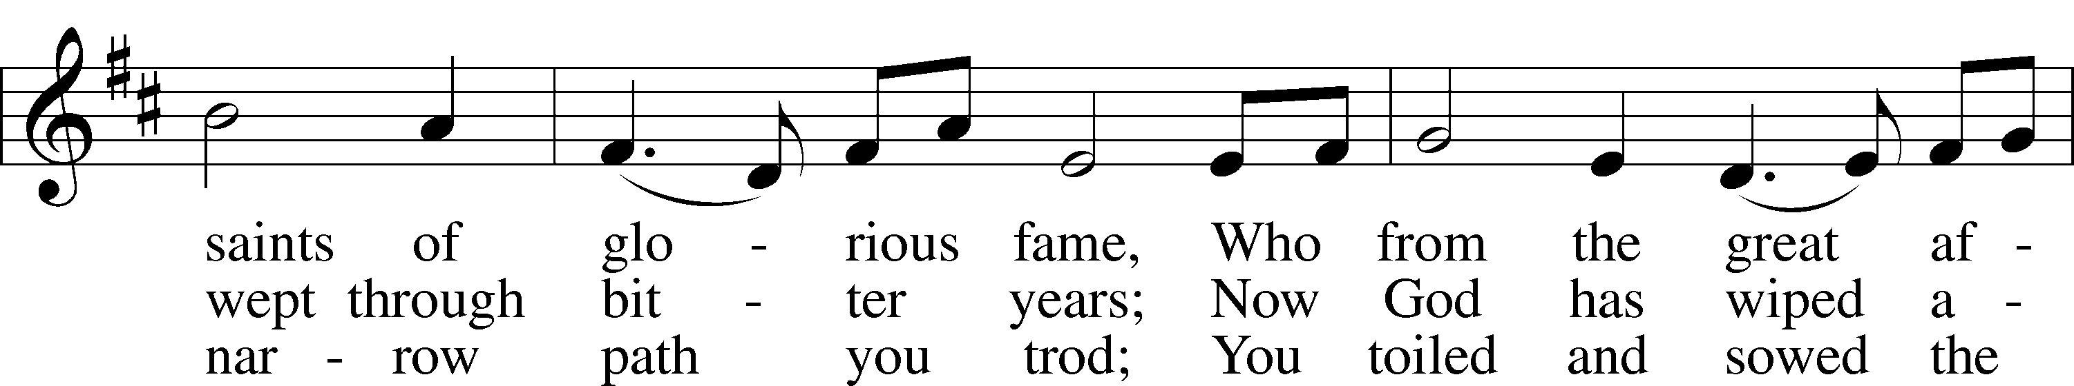
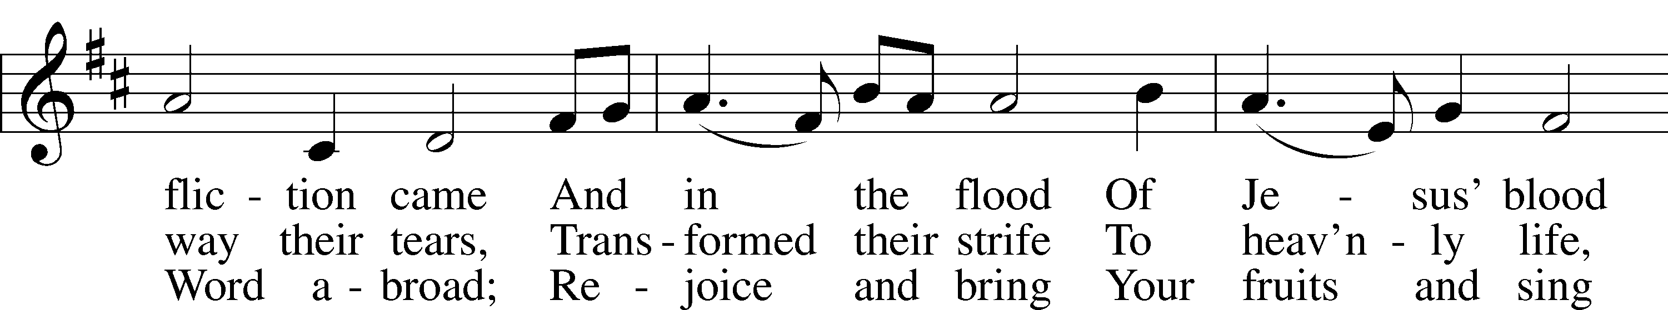
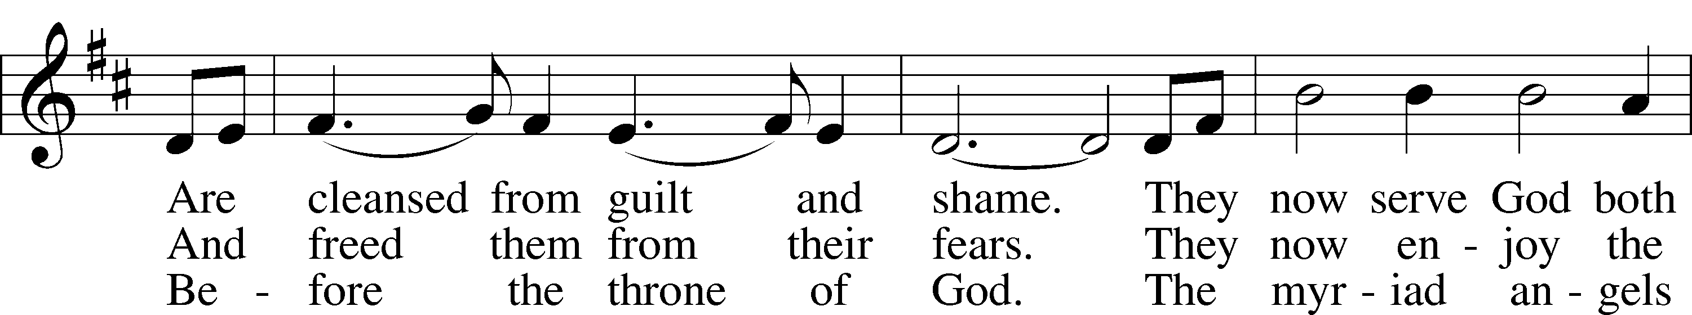
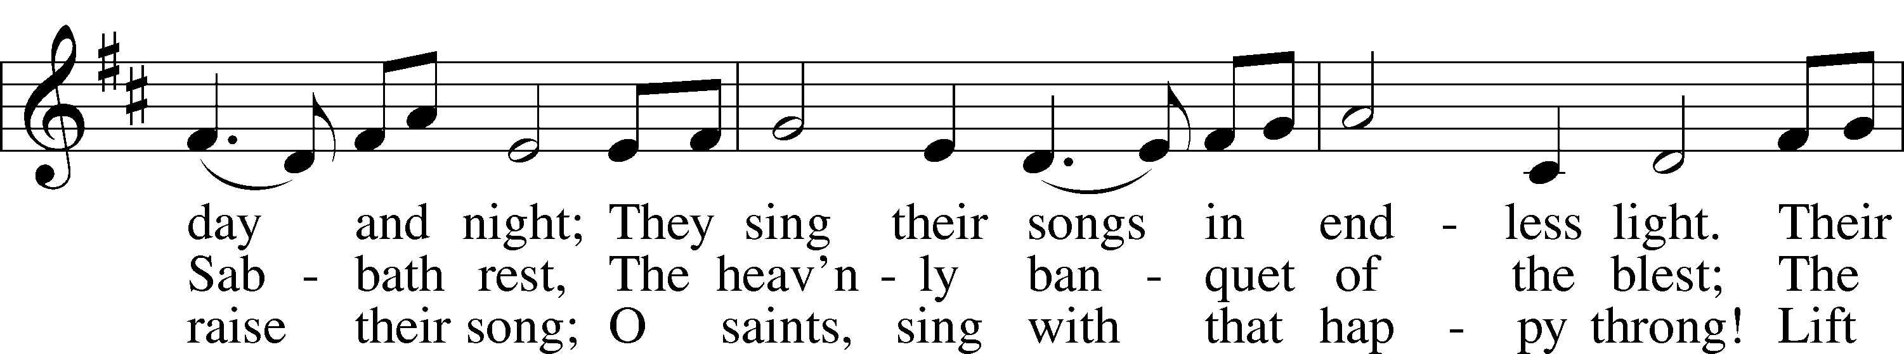
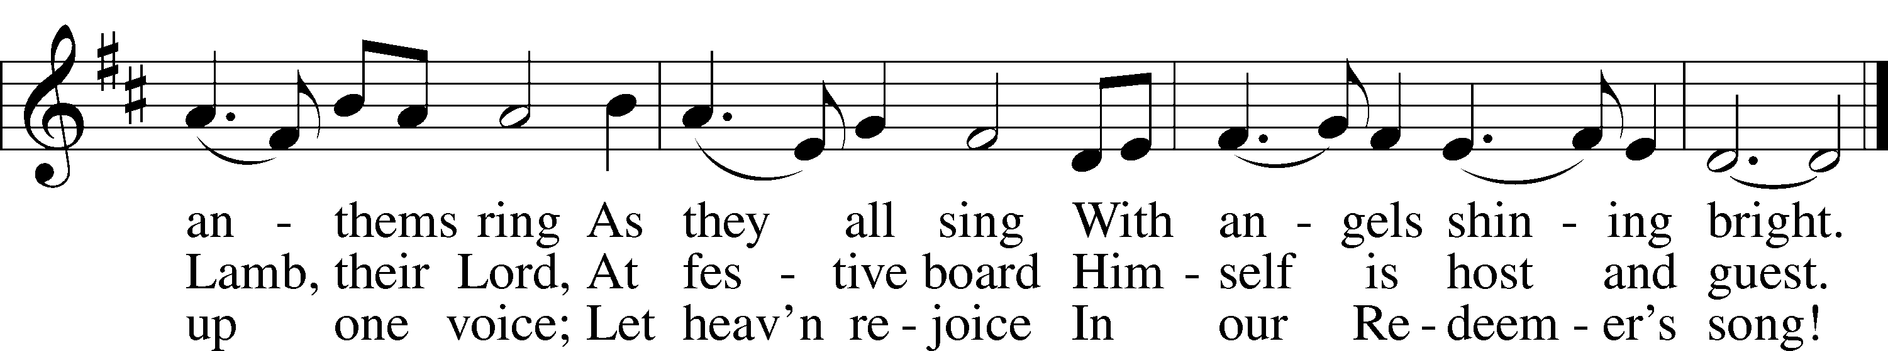
Tune and text: Public domain

In dismissing the communicants, the following is said:

P The body and blood of our Lord Jesus Christ strengthen and preserve you in body and soul to life everlasting. Depart T in peace.
C Amen.

Stand

Nunc Dimittis LSB 165
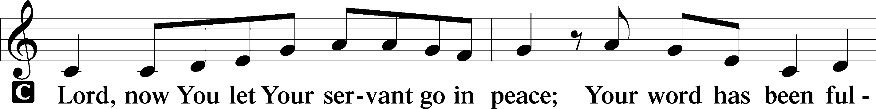
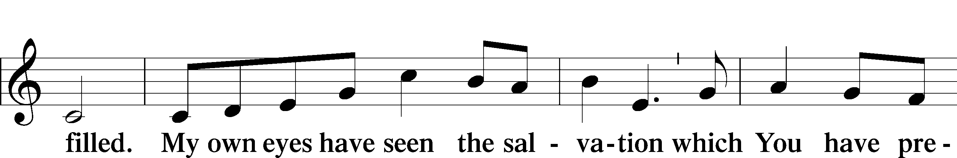
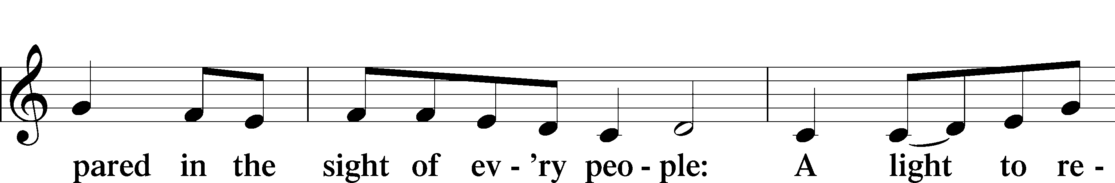
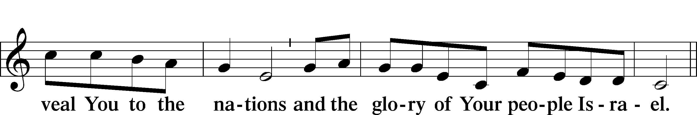
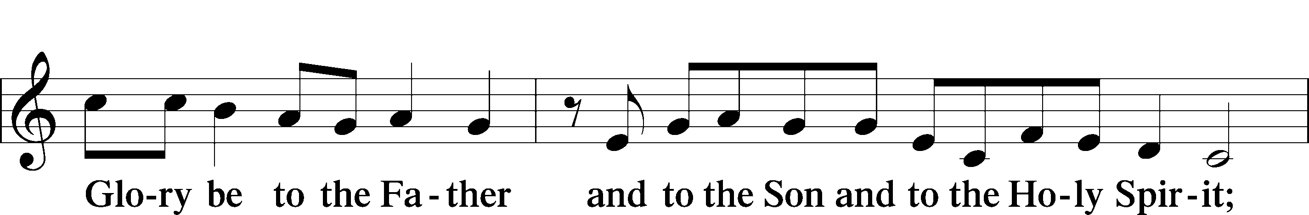
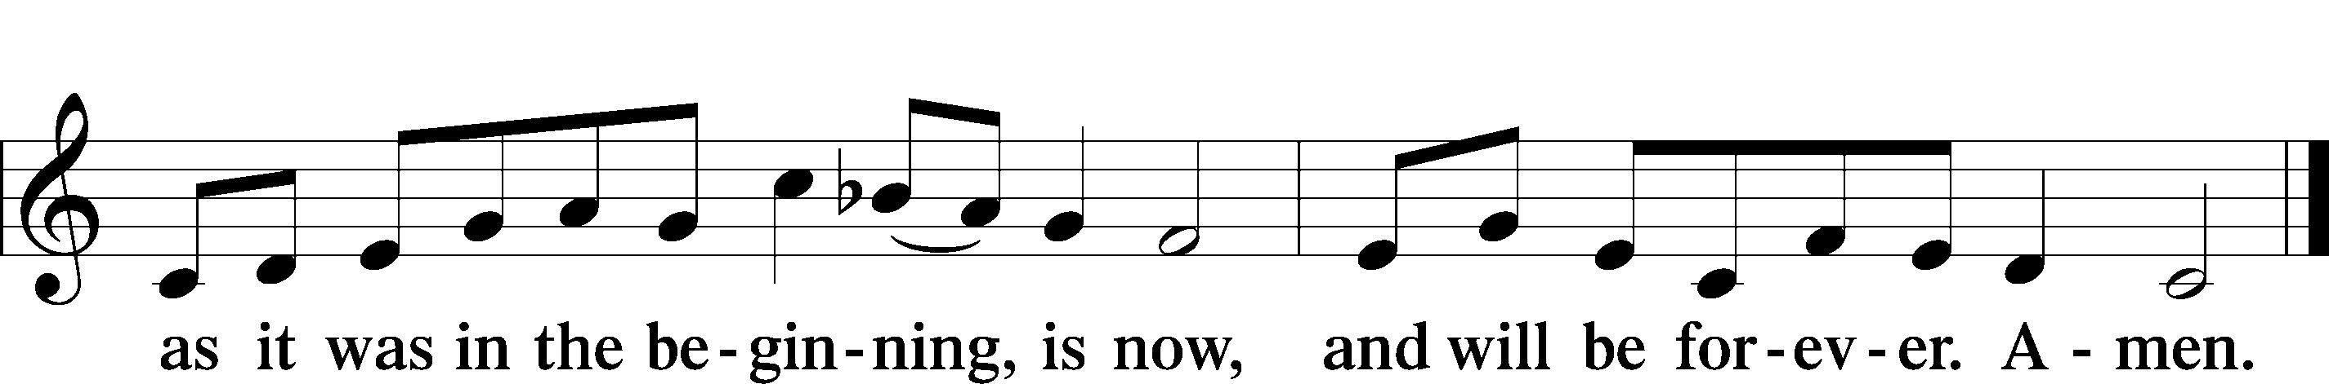

Post-Communion Collect
A Let us pray.
Gracious God, our heavenly Father, You have given us a foretaste of the feast to come in the Holy Supper of Your Son’s body and blood. Keep us firm in the true faith throughout our days of pilgrimage that, on the day of His coming, we may, together with all Your saints, celebrate the marriage feast of the Lamb in His kingdom which has no end; through Jesus Christ, Your Son, our Lord, who lives and reigns with You and the Holy Spirit, one God, now and forever.

Benediction LSB 166
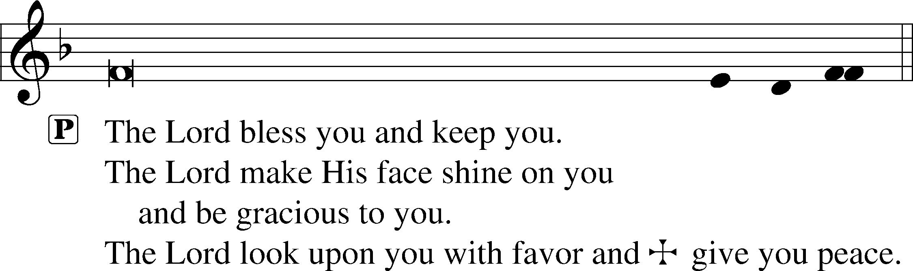

Recessional Hymn -- For All the Saints LSB 677 sts. 6–8

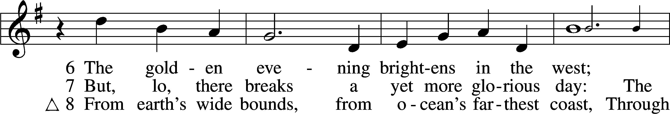
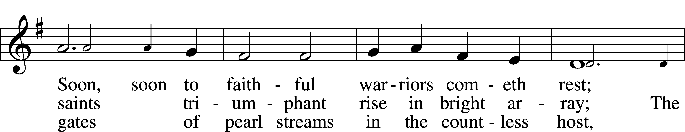
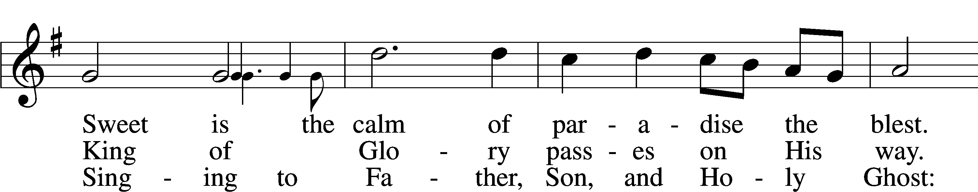
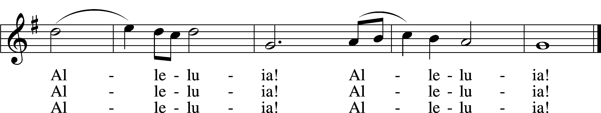
Tune and text: Public domain

Trinity Family Prayer Page
Week of November 1-7, 2020

Name | Information
Carol Etherton | Prayers for healing following a fall, rehabilitation
Sharon Hackley | Prayers for healing & strength
Loretta Morelock | Prayers for healing and strength
Pam Osterloh | Stage 3 kidney disease
Nathan Rader | Prayers for strength-cancer has returned, chemo treatments upcoming
Chuck Rovey | Prayers for strength & continued improvements
Joshua Scheiderer | Thanksgiving for successful hip surgery; continuing rehab for 6 months
Paula Spalding | Recovery from infection
Virginia Sproule | Diagnosed with lung and liver cancer, undergoing treatments
Jerry Williams | Diagnosed with cancer, undergoing treatments
Bernie Zeigler | Prayers for recovery following torn rotator cuff surgery
Friends and Family:
Eli Applegate | Grandson of Ben & Deb Schroeder, treatments for Aplastic Anemia
Marvin Bachtold | Brother of Bernie Zeigler, thyroid and lung cancer, stable, continued monitoring
Rev. Dave Benson | Father of Sarah Buerck, undergoing treatments for lymphoma
Mary Burns | Sister-in-law of John Albert, lost everything in the Oregon fires
Debbie Curtis | Friend of Doug & Michelle Powell, stage 4 lung cancer
Rachel Duff | Daughter-in-law of Ed & Mary Ann Dorris, diagnosed with cancer; chemo & radiation
Dorothy Geyer | Aunt of Paul Schultz, suffering from blood clots in her legs
Mark Johnson | Brother of Diane Lewis, diagnosed with cancer, chemo treatments
Charlie Jones | Father in law of Leslie Jones, diagnosed with throat cancer, undergoing treatments
Mike Jones | Friend of Carl & Linda Oughton, liver cancer, chemo treatments
Vernon Kowalke | Father of Carmen Dorman, continued dialysis
Jim Krieg | Uncle of Mary Brockman, on hospice care at home
Cross Kubik | 16-year-old friend of the Scheer families and many others, cancer treatments at St. Jude
Becky Moyer | Friend of many Trinity members, brain cancer
Georgia Ohly | Friend of Nancy Servis, undergoing treatment for kidney disease
Sandy Reese | Friend of Carmen Boyd, kidney cancer returned, spread, treatments
Jeann Roed | Friend of Terry Wright, unknown cancer, beginning intense chemo treatments
Ian Romano | Nephew (10-yr-old) of Paul Hambrick, T-cell ALL leukemia, stroke, chemo continues
Robert Stillings | Grandson (5 yr old) of Bob & Mary Stillings, home, recovering from appendicitis
Jeremy Summers | Nephew of Ernie Lewis, rare type of bone cancer, tests, treatments
Lin & Kelly Thompson | Uncle & Aunt of Lanie Thompson, COVID-19
Carol Wendel | Grandmother of Tara Barger, successful removal of tumor, no chemo treatments needed
David Westmeyer | Brother of Karen Vaughan, prayers for comfort/strength, late stage Parkinson's Disease
Military: | Major Robert Stillings, currently assigned to the U.S. Cyber Command at Ft. Meade, MD
Birthdays
Nov. 3 | Jan Schultz
Nov. 4 | Stan Blohm
Nov. 5 | Paula Spalding
Nov. 7 | Katie Jones, Jen Gabathuler
Anniversaries
Nov. 1 | Amy & Dennis Cooper
 | Lee & Jacob Waters
Nov. 2 | Doug & Michelle Powell
Nov. 5 | Dennis & Martha Mitchell
Nov. 6 | Bill & Gaye Otto
Baptism Remembrance
Nov. 1 | Sylvia Dulin, Bonnie Eggerman, Laura Stinnett
Nov. 2 | Kenny Hagerman, Nancy Spencer
Nov. 3 | Janet Pfeiffer
Nov. 4 | Olen Waters, Dick Wills
Nov. 5 | Ethan Quasius, Larry Roesslet, Owen Schafer
Nov. 6 | Carroll Scheiderer
Nov. 7 | Brooks Lozano, Claire McCune, Katie McCune

Acknowledgments
Divine Service, Setting One from Lutheran Service Book
Unless otherwise indicated, Scripture quotations are from the ESV® Bible (The Holy Bible, English Standard Version®), copyright © 2001 by Crossway, a publishing ministry of Good News Publishers. Used by permission. All rights reserved.
Created by Lutheran Service Builder © 2018 Concordia Publishing House.

