HOW ODD OUR GOD. . .HOW ABOVE HIS LOVE

The Eighth Sunday After Pentecost
Trinity Lutheran Church
Springfield, Missouri
26 July Anno Domini 2020

Certainly what we need the most in uncertain times: grace, mercy, and peace from our Lord and Savior Jesus Christ. Amen.

The great 20th century British historian Paul Johnson, who wrote mammoth and monumental, comprehensive accounts of the world and of the nations, including a history of the Jewish people that may never be surpassed, and whose reading of “The History of the Twentieth Century,” and “The History of America” should be mandatory before every presidential election here, began the latter book with these words: “The creation of the United States of America became and still is today the most unique, most significant, and the greatest contribution to political life in the history of the world.”

As regards to earthly political philosophy and systems, constitutions, and the results produced in the real lives of individual citizens and society, anyone who studies the facts for themselves, would have to agree with Johnson. No monarchy, no theocracy, no experiment in Marxist socialism, no dictatorship—none of these governments with their utopian promises succeeded. The facts clearly show these movements and nations proved to be radical extremes that used deceptive propaganda to take away their people’s freedoms, brought economic ruin, and ended up murdering their own citizens. If for no other reason, including among the many parliamentary democracies in our world, still it is only the U.S. Declaration of Independence and Constitution in which the citizens’ rights are not granted by the government, but by the endowment of the Creator. Yet it’s amazing that Johnson, a brilliant and good man, a devoted Roman Catholic Christian, didn’t add, at least as a footnote, “except, of course, for the creation of Israel around 3500 years ago.”

Deuteronomy chapter seven: [Israel] The Lord your God has chosen you to be a people for His treasured possession, out of all the peoples who are on the face of the earth.

Ancient Israel was the one-time, only, and unique nation that was actually built by God. It is the only nation ever that was His chosen and treasured people over all the nations of the earth. Their very existence He used not to just establish a free people whose beliefs and morality would be a “light to the world,” but through whom, He would free all the nations of the earth from the worst kind of slavery, and actually create a true utopia that would never fall.

But, wait, you might say. The ancient Jewish people lost their political freedom in a series of invasions and conquests by the Empires of Assyria, Babylon, Persia, Alexander the Great, and Rome. In A.D. 70 its capitol city Jerusalem and the Temple were annihilated, and they weren’t even a nation in any sense from then until 1948. And they still don’t have a Temple in Jerusalem.
PENTECOST 8—page 2

A former Springfield rabbi and colleague at Missouri State always presented the origins of Israel to her classes with this little story: once there was a Jewish man named Moses who was exiled from the place of his birth, Egypt. He ran far away into the Arabian desert where he found a foreign wife and a job as a shepherd on her daddy’s farm. About this time, God was in the process of choosing a nation to be His own, a nation He could make great and use for His purposes. YHWH first went to the most powerful empire in the world at that time, and made His pitch to the Pharaoh in Egypt. Sounding like a good deal, the Pharaoh asked, “What do we have to do to be your nation?” God answered, “Obey My commandment.” To which the Pharaoh replied, “What is your commandment.” “Thou shalt have no other gods before My face.” “Hmm,” the Pharaoh said, “We have a lot of gods, here, Lord, and I’m even considered divine. Can’t give that one up. Sorry.” So the Lord goes north to the Hittite Empire and speaks to the king, who asks the same question, “What do we have to do to become your chosen nation?” “Obey My commandment.” “What is your commandment?” “Thou shalt not kill.” The king paused a moment. “Not going to sell. Fighting and killing and butchering, that’s our national pastime. No deal.” So the Lord next gathered a coalition of the kings of all the smaller nations in the land of Canaan, and made His offer. After a joint session, they asked about the commandment thing. “Thou shalt not commit adultery and fornication.” Slam dunk. “No deal, Lord, after all this is Canaan!” Now feeling a bit dejected, the Lord was floating over the desert in Arabia, when He spotted a lone shepherd; it was Moses tending his flock, so He approached and said, “How would you like to join me in gathering a population of people to make into a great nation with you as their leader?” Moses thought a moment and said, “Well, I did grow up in a palace where I got a good education, and it sure would beat this gig, so what’s the catch?” “Obey My commandment.” “Well, Lord, as you can see, I’m in a bad way here, and I don’t have much to give you.” “No, no,” said the Lord, “this commandment doesn’t cost anything, all that I give to you and to My people is free.” Moses was overjoyed and said, “Then give us ten of them!” And that’s how the nation of Israel was born.

Actually that’s how the rabbi hooked his students. That’s not exactly how God created His chosen nation. But listen to Deuteronomy again; it’s not completely off: It was not because you were more in number than any other people that the Lord set His love on you and chose you, for you were the fewest of all peoples, but it was because the Lord loves you and [it is because] He is keeping the oath that He swore to your fathers [Abraham, Isaac, and Jacob].

It is true. Israel was the most pitiful people group on earth. From a place of great power and influence under one of their own, Joseph, the second man in charge of the great Egyptian Empire, after his death the entire lot of Hebrews were enslaved. Four hundred years, forty generations of bondage! And in Egypt, slaves were not believed to be true human persons; it was taught that slaves lacked a human soul. The founder of our Religious Studies Department at MSU, Dr. Gerritt ten Zythoff, always said, “How odd that God would choose the Jews.”
PENTECOST 8—page 3

He could say that and get away with it even in today’s politically correct environment. When he was a boy back in his home in Holland, his family, as many of their Christian neighbors did, smuggled Jewish prisoners from Hitler’s concentration camps, and hid them in his home. Dr. T sustained a life-long injury in that struggle, and as an educator and as a Christian, could present the story of God’s Old Testament people as well as anyone.

As an earthly kingdom, Israel had its good moments of glory, especially during the reigns of King David and King Solomon. But they were never the greatest nation on earth. They never became an empire. And most of their existence, they were in some ways more pitiful than they were as slaves, because they willingly gave up their blessings and help from God, and turned to atrocious idolatries and immoralities. They abdicated from being the “light of the world,” and joined the darkness of the rest of the nations. They even practiced child sacrifice at times, even though in their covenant with God, He had warned them that the consequences of their disobedience to the covenant would impact their children and grandchildren.

The historical theological dilemma was “why would God continue to call these awful people His chosen treasure?” It is because of two things. He had sworn an oath that He would bring rescue and freedom from sin, from the devil and his dark evil, and from death itself, through the people of Israel. God keeps His promises, period.
He was not influenced an iota by their weaker, unfaithful, sinful wants, wishes, desires, philosophies, or practices. And in spite of the worst they did and were, He still loved them with a steadfast love. He saw His plan through all the way to the end, even if the nation of Israel fell to only one man left standing.

And that’s what happened. It all whittled down, the whole plan of salvation, to One, true Israelite. The Last Man Standing. He came into the world in His own generation and place. He grew up under the Law of Moses, attending synagogue services and school. He lived a thirty-three year lifetime, and was the only child of Israel ever to obey all Ten Commandments and the whole law and will of God perfectly, in thought, word, and deed. And for the sake of the entire population of God’s chosen people, Israel, and all their sins, He kept God’s promise. He could do that because He was divine, the Son of God. At the time of His execution, on that Friday as He hung in shame on a Roman cross, it was thought that He was just one more of the many would-be utopian saviors who promised to change the world and turned out to be another loser. That Friday was the most hopeless Sabbath day in all of Jewish history. After all, if this Jesus couldn’t do it, who could?

But God had kept His promise. And within 40 hours, the evidence started pouring in to that tiny group of folks hiding out in a Jerusalem upper room. Jesus of Nazareth had risen from death! He was with them again, eating and teaching and celebrating with them again. On the cross, He didn’t just suffer and die a physical death. On the cross, He experienced the Father YHWH in heaven forsake Him. On the cross, when He had cried out the last word, “It is finished,” it was. The Father in heaven God accepted His sacrifice, and counted His punishment and death as
PENTECOST 8—page 4

sentence commuted for the whole of Israel and for the whole of humanity! Jesus in His resurrected Body took His victory right into the center of hell, where He
announced to the prince of darkness and his minions that they were toast. God was ready to create and gather a new chosen people, and the Holy Spirit would begin this work immediately, and He would not lose one soul who was chosen, predestined, called, sanctified, and preserved in the name of His Son. The very curse of sin was lifted, and the future promised was now the future realized. In God’s own time, the Utopia that humans were given to imagine and long for, but never come close to on this earth, would happen for God’s people, and in the newly created heavens and earth, there would be no Tree of the Knowledge of Good and Evil, where the devil would be given a piece of real estate. He and all his offspring would be completely shut out of this Second Paradise, totally separated from God and His chosen people of Old and New Testament churches, existence forgotten.

Sorry for this little insertion in the sermon, don’t take offense if you are a fan of classical music, but to quote the late Charlie Daniels, “the devil gets his due. . .”

And the God who received Charlie’s soul and all who die in that faith that alone justifies us by grace and not through our own performances and piety, but as a free gift, He always gets the last Word, a Word of absolute assurance to us living in this fallen, sinful, sometimes crazy world: I absolutely love you and have kept my promise. I have redeemed you from the slavery of sin and death, and have rescued you from the hand of hell’s pharaoh, and given you the life of My only beloved Son, so that you can know that I am the Lord, your creator and father, your God, a faithful God who will always keep His promise and steadfast love with you. I will never leave you.

Amen.

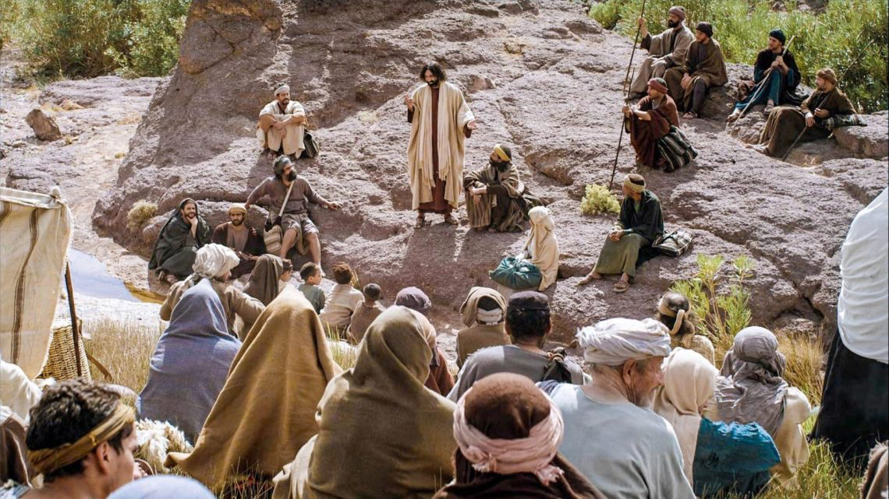

Reverend William R. Marler-Pentecost 8 anno Domini 2020

